Accruing P/H & PRL and Adjusting P/H, PRL, Hol & Vac for Part Time Nonpermanent

Nav>Global Payroll & Absence Management>Payee Data>Adjust Balances>Absences

Accruing P/H and PRL hours for use after the initial four months
1. Search for the person, select the correct Entitlement month for the balance adjustment (in this example October ENT2023M10).
2. P/H: take hours worked in the fourth month divided by working hours in month times 8 (e.g., 69/176*8=3.12)).
3. PRL: take hours worked in the fourth month divided by working hours in month times 24 (WPEA) (e.g., 69/176*24=9.36).
4. Adjust hours on the previous month Entitlement before the A Take (December will not work for P/H and June will not work for PRL because they are in a previous calendar and fiscal year, respectively).

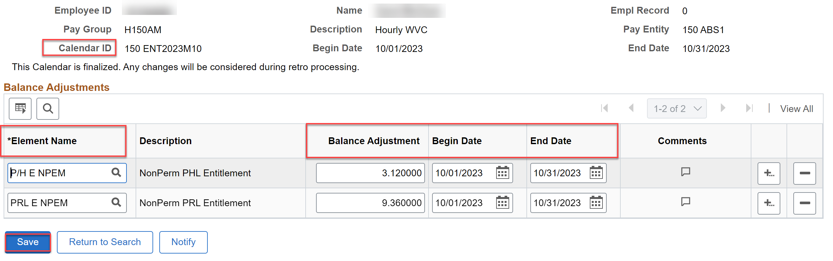

Adjusting P/H hours not used by December 31

1. If a P/H leave rule is set up like it is for WVC, the unused P/H hours will automatically be zeroed out on the 01A Take.

Adding P/H for January

1. Take hours worked in December divided by working hours in month times 8 (e.g., 69/168*8=3.29).
2. Adjust hours on the January 01A Take (this can be done on the January Entitlement, but the P/H hours won’t be available for use until February).

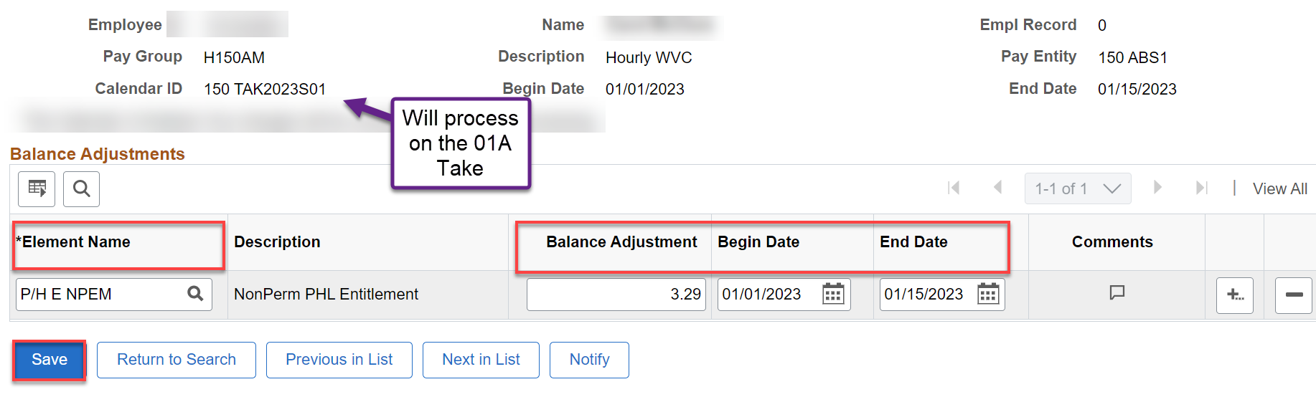

Adjusting PRL hours not used by June 30

1. If a PRL leave rule is set up like it is for WVC, the unused PRL hours will automatically be zeroed out on the 07A Take.

Adding PRL for July

1. Take hours worked in June divided by working hours in month times 24 (WPEA) (e.g., 69/168*24=9.36).
2. Adjust hours on the July 07A Take before it runs.

Adjusting and paying Vacation and Holiday Credit

Vacation and Holiday Credit hours must be paid when a part time nonpermanent employee terminates employment; Holiday Credit hours must be paid if not used by June 30 each year.

Adjusting VAC and or Holiday Credit hours

1. Check leave takes and balances in Absence Management.
2. Adjust (minus) the balance(s).
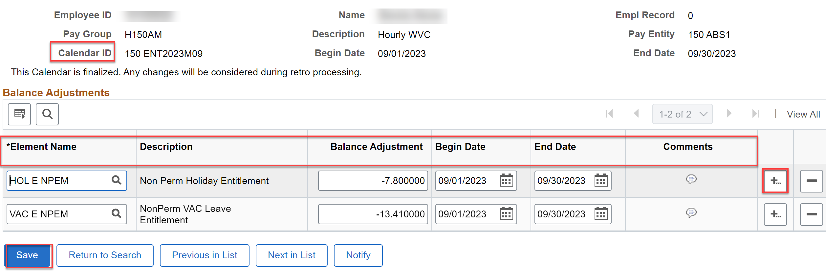

Pay employee for VAC and/or Holiday Credit hours

1. Look up the employee in Job Data for Empl ID, Combo Code and hourly pay for PSHUP file.
2. Create a PSHUP file (Nav>Payroll for North America>CTC Custom>Paysheet Holding Update).
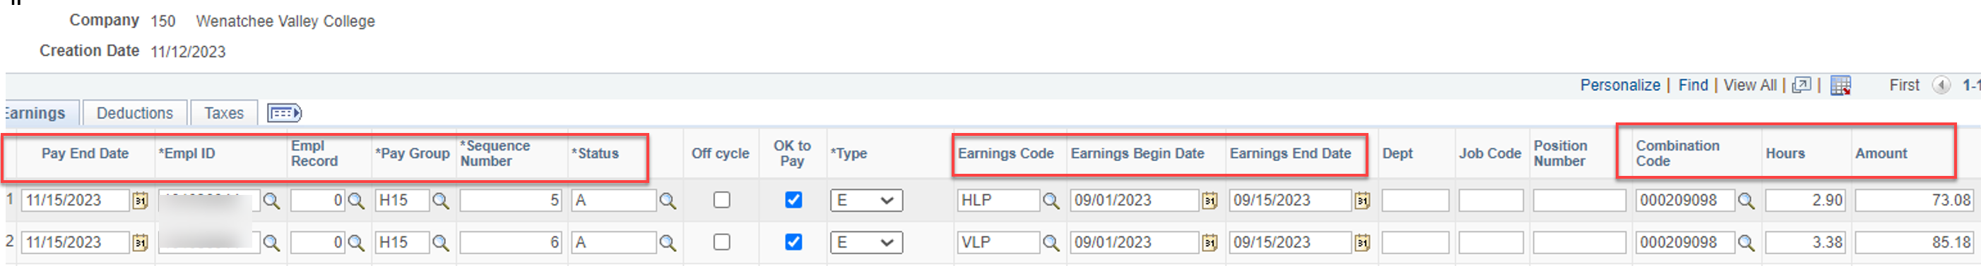

That’s it!

