Add A New Employee Instance

Nav>Workforce Administration>Job Information>Add Employment Instance

FT Exempt

Work Location tab: Put start date as effective date, Position Number then select “Override Position Data and it will change to “Use Position Data”, Company and Department should autofill with the rest of the data.

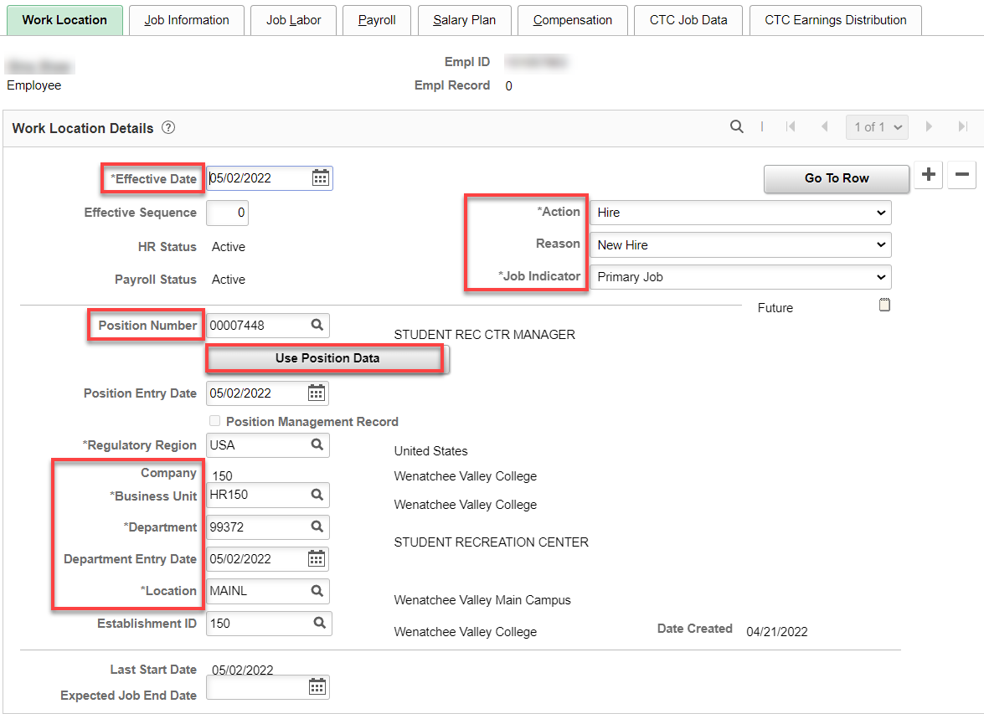

Job Information tab: Add Supervisor ID, double-check Regular/Temporary and Full/Part to see if correct, Work Period should be W522. If it is W, the Position Data Work Period and job code may need updated. Adjust the FTE back to 1.00. If less than FT, adjust Standard Hours and Standard Hours. If FTE is 0.00, The Position Data needs updated.

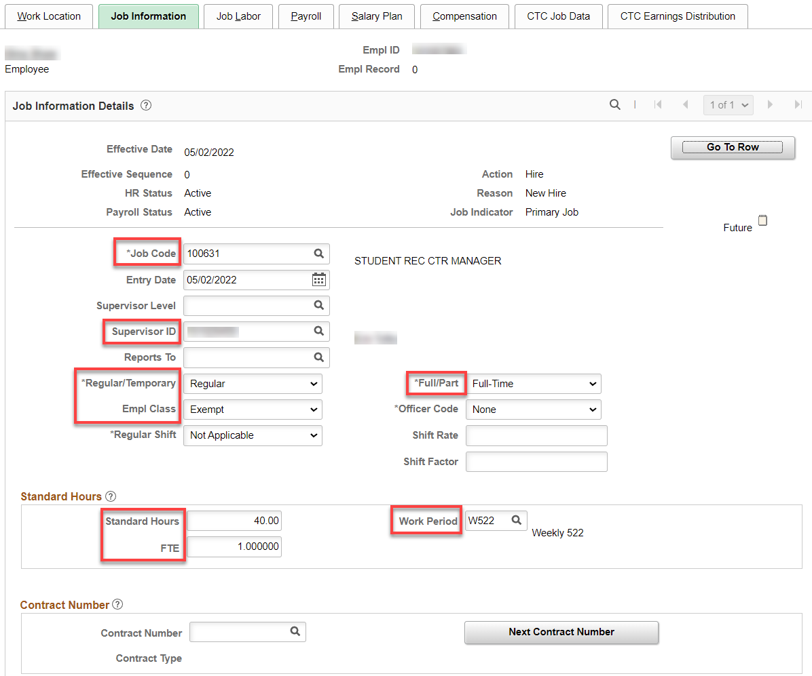

Nothing for Job Labor

Payroll tab: Add Absence System (Absence Management) and Pay Group (the rest will autofill).

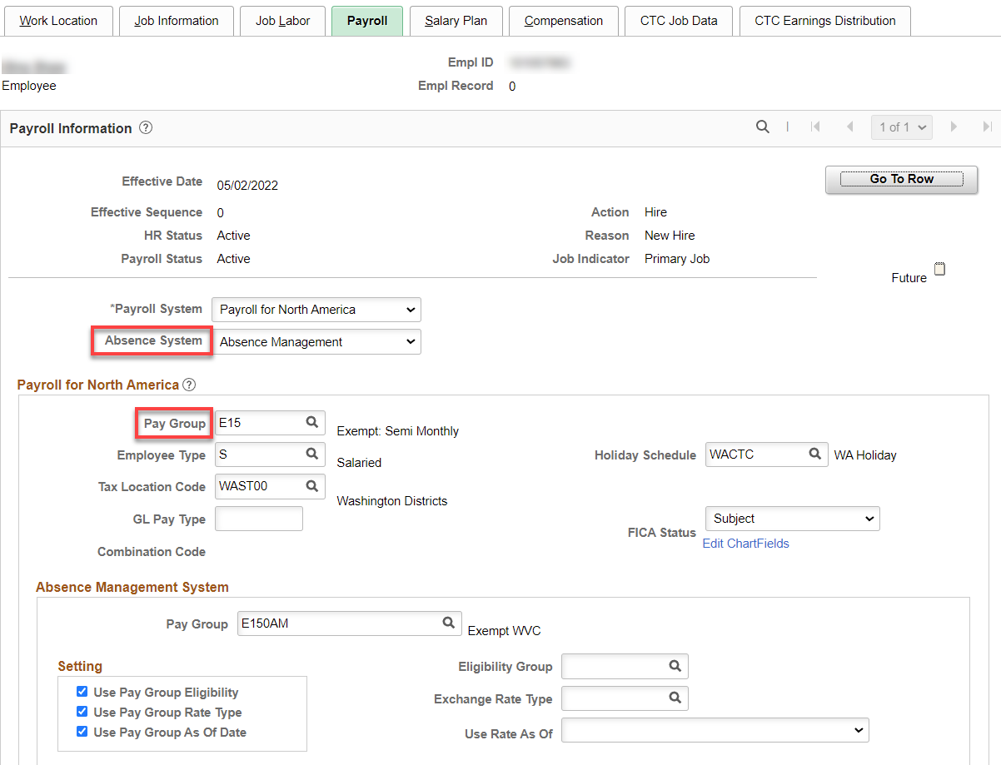

Nothing for Salary Plan

Compensation tab: Add Rate Code, Comp Rate (annual salary if FT), leave the Frequency at S and hit Calculate Compensation.

If less than full year, ctcLink can handle less than a full year by putting in the annual salary and Frequency of S. The hourly rate should also be correct.

If less than a full pay period: ctcLink should calculate the daily rate correctly, however, it is a good idea to calculate the daily rate x the number of days in the first pay period and let payroll know so they can correct the Payline if there is a difference. Calculation is: Annual salary/261 x # of days in pay period.

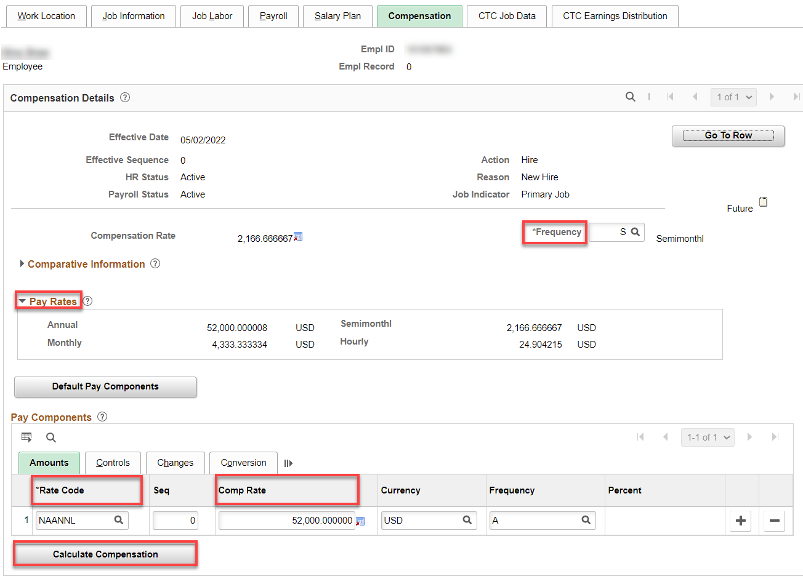

CTC Job Data tab: Add Leave Accrual Date (accrual date is the first of the month if the start date is 1-15, first of the next month if start date is after the 15th UNLESS there is 10 days or less of LWOP in the month, then use the first of the month) [THIS MAY CHANGE 7/1/22 IF WE MOVE TO PRORATED]. Add Leave Maximum Month (always 8 for exempt), Job Employment Type, DRS Calendar (not needed for exempt), Contract Units (261 FT; prorated 1-260), Contract Begin and End Dates.

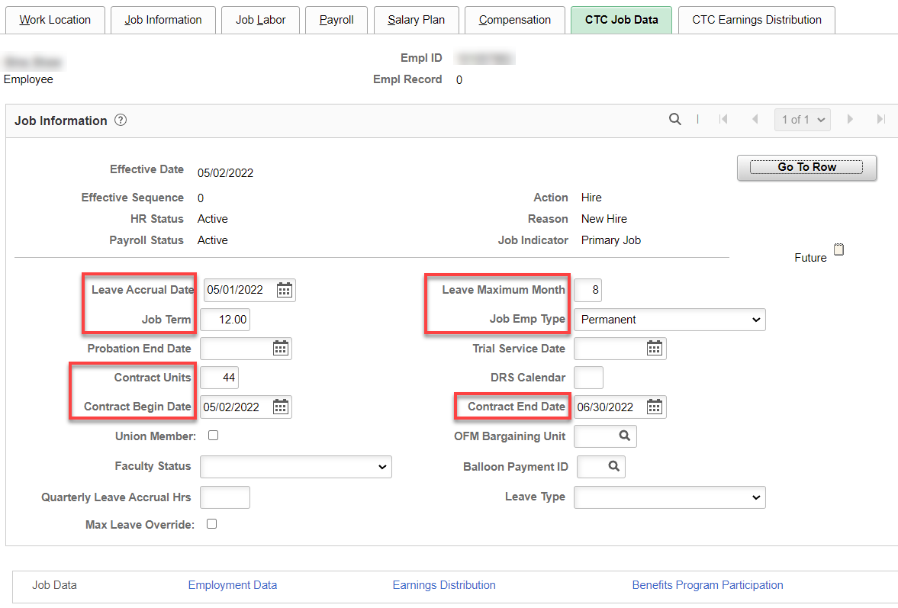

CTC Earnings Distribution tab: Add Earnings Code, Percent of Distribution, check Primary on all codes if more than one, click on Edit ChartFields to add Combination Code(s).

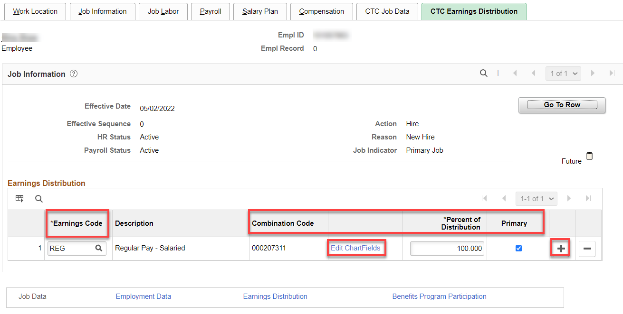

(hit enter and the ChartField Detail will populate, check budget to see if it matches what you need), Click OK.

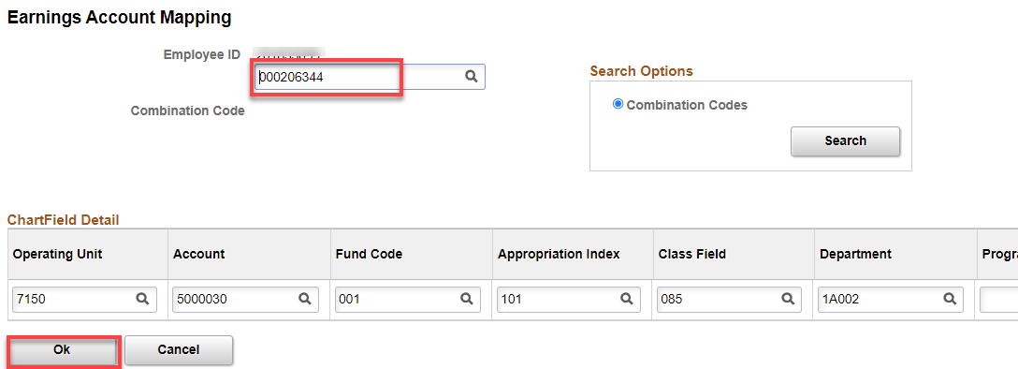

Click on Employment Data Hyperlink (Employment Information will autofill after filling out the Time Reporter Data).

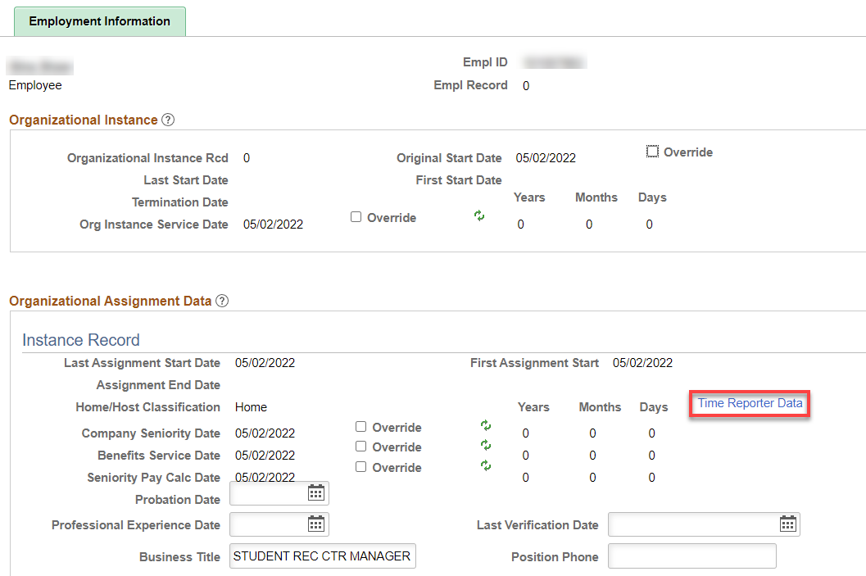

Click on Time Reporter Data First, change the effective date to the hire date, Time Reporter should already be Elapsed Time Reporter, Add Elapsed Time Template, Workgroup, Taskgroup, click OK. Employment Information should have filled in like above.

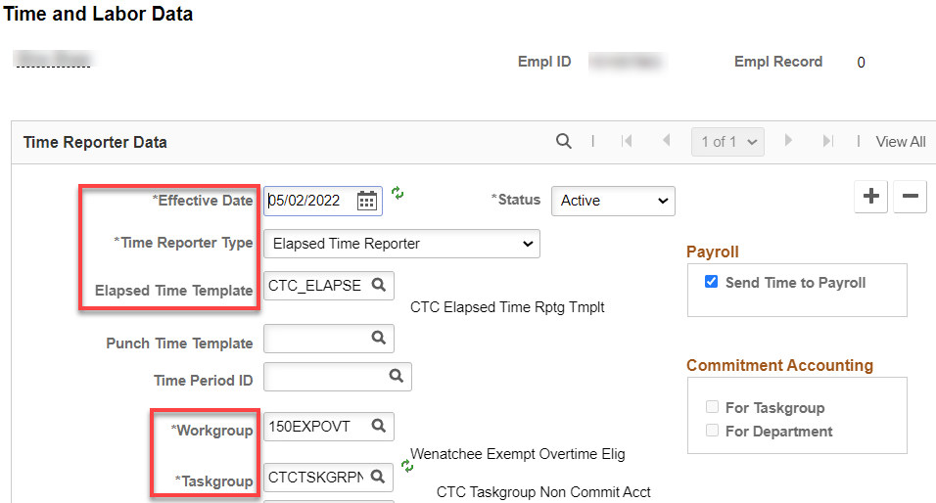

Click on the Benefit Program Participation hyperlink, add Benefit Record. Effective Date is the hire date.
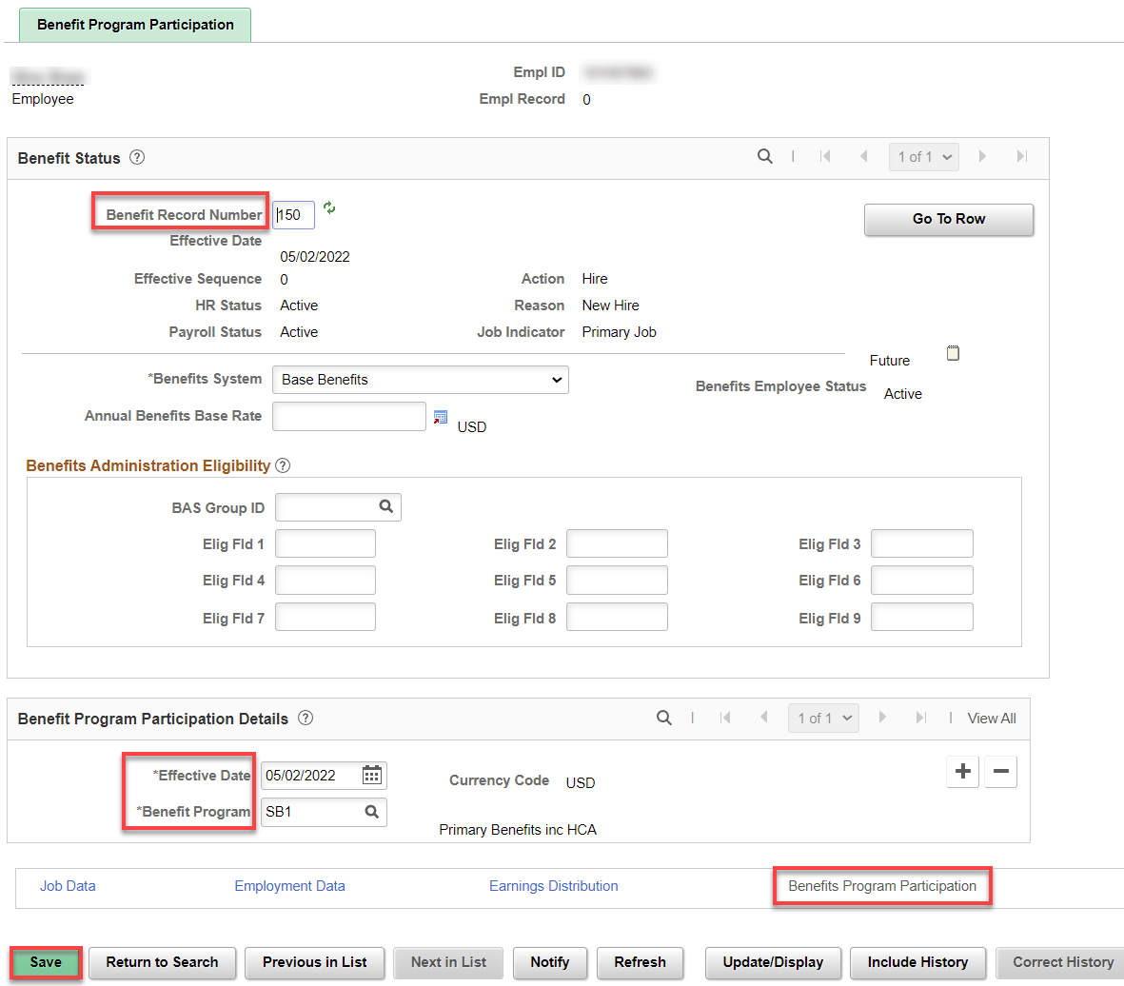

After you click save, you will see a couple of warnings, just read and click ok.

Assign ACA Status – Nav>Benefits>CTC Custom>Assign ACA Status

If they work more than 130 hours, use the 1st of the current month, otherwise, use the 1st of the next month.

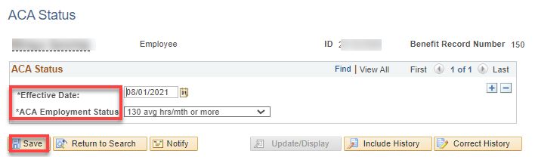

AFTER START DATE (I know, it’s frustrating to have to wait)

Check Compensatory Plan Enrollment to see if EE is enrolled in the correct compensatory time off plan*.

Nav>Time and Labor>Enroll Time Reporters>Comp Plan Enrollment OR Time & Labor tile

Add a Row if necessary, Effective Date, Compensatory Time Off Plan. Save.

*Key:
Exempt – no comp time plan
Exempt Overtime Eligible – WACOMP1
Classified – WPEACMP

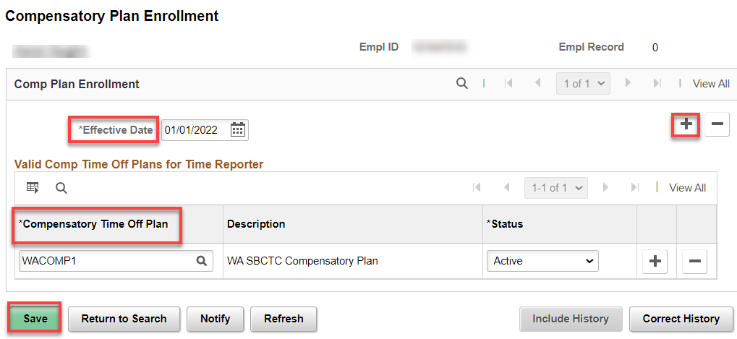

Assign Work Schedule - Nav>Time and Labor>Enroll Time Reporters>Assign Work Schedule OR Workforce Administrator, Time & Labor Admin Tile, Enroll/Maintain TL Data>Assign Work Schedule

In order for leave to accrue and holidays to work correctly, a work schedule must be assigned from Use Default Schedule to Select Predefined Schedule.

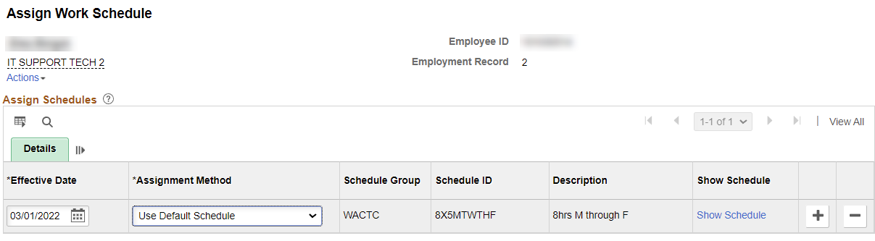

Add Effective Date (Start Date), Assignment method (change from Use Default Schedule to Select Predefined Schedule, Schedule Group (WACTC) and the schedule ID (choose from a long list or if it is 5 8s M-F, put in 8X5 to narrow the search). You can see the schedule by clicking on Show Schedule or add a new schedule (in the future) by adding a row.

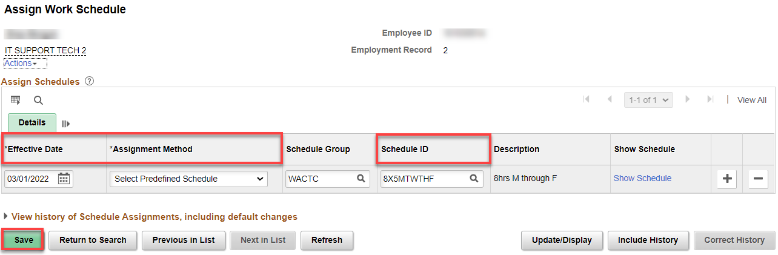

That’s it .

