Add A New Employee Instance

Navigator>Workforce Administration>Job Information>Add Employment Instance

Volunteer

Work Location tab: Put start date as effective date. Add Company and Department and hit tab and the rest will autofill. If the Last Start Date has a different date, it will update after you refresh or hit OK at the end of the process.

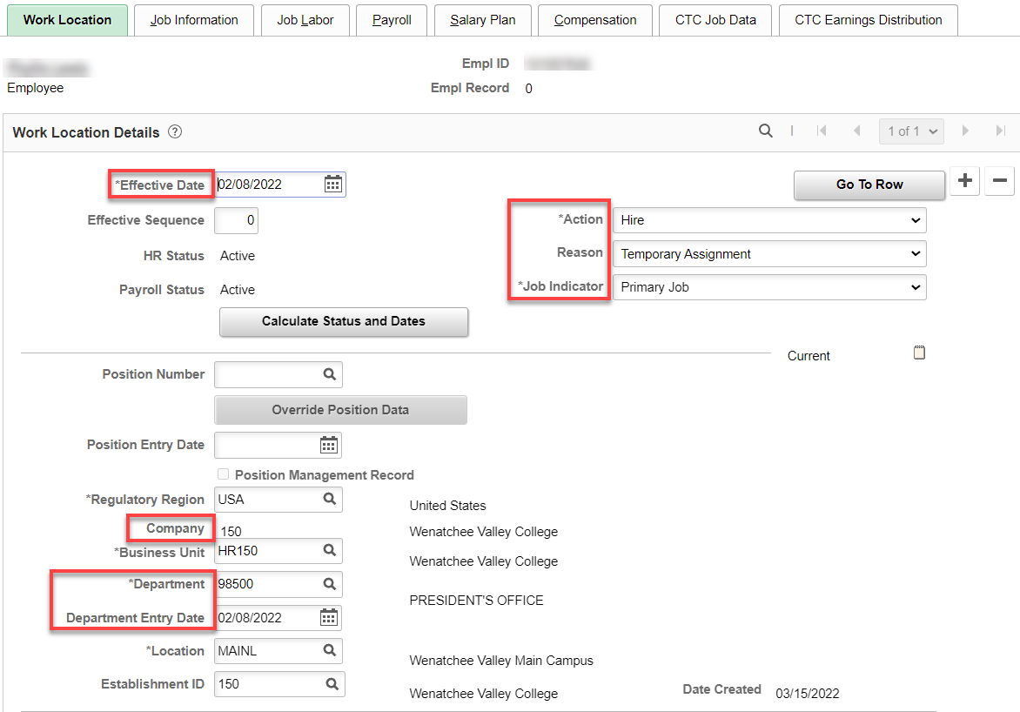

Job Information tab: Add Job Code, Supervisor ID, Temporary, Part-Time, Empl Class (Volunteer) and the rest is auto-filled. Work Period is W.

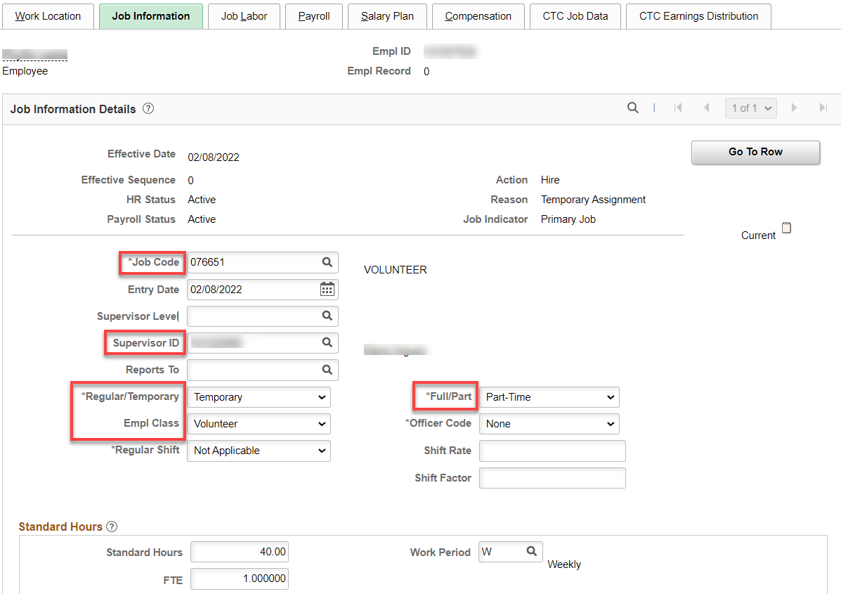

Nothing for Job Labor

Payroll tab: Absence System should be “Other”; add Pay Group (V15), the rest will autofill.
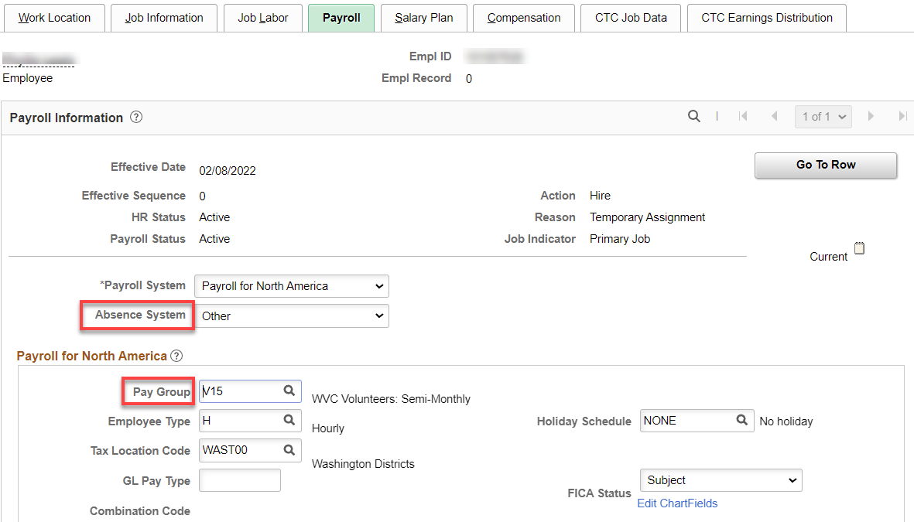

Nothing for Salary Plan

Compensation tab: Enter Rate Code, Hourly Rate (blank), change Frequency to H and hit Calculate Compensation. Compensation Rate should be 0.00000.

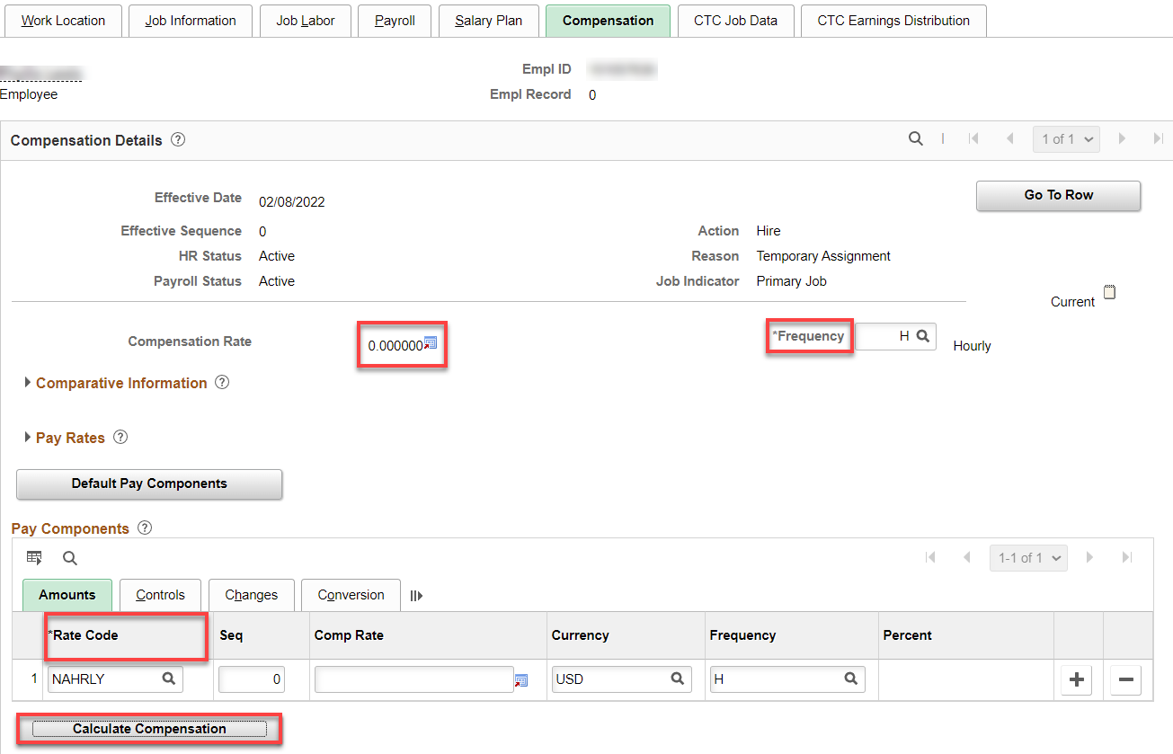

CTC Job Data tab: Add Job Emp Type (Temporary). You can put in start and end date (they are not necessary) but I like them.

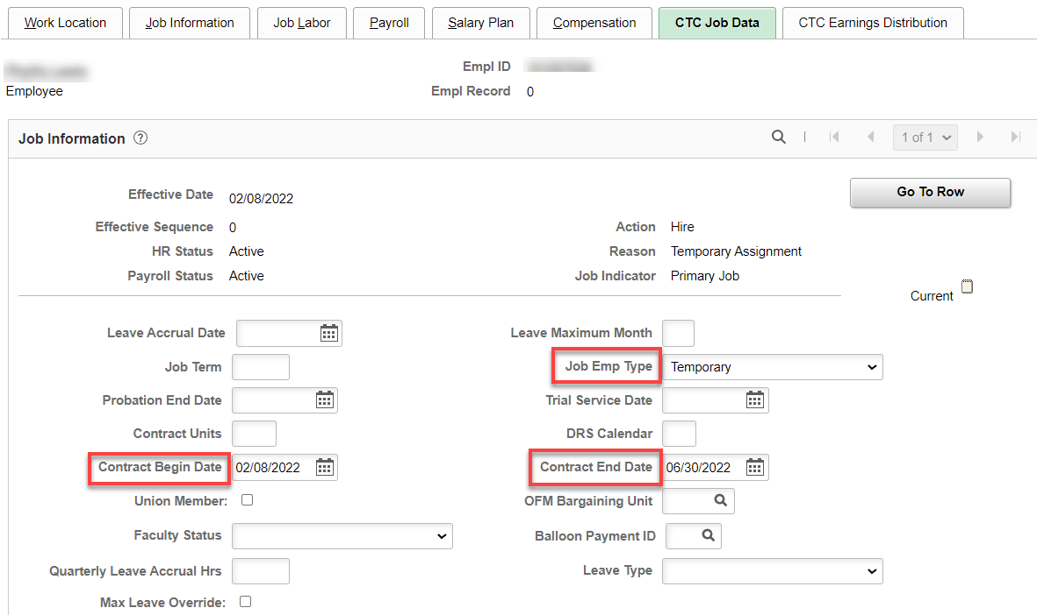

CTC Earnings Distribution tab: Enter the Earnings Code, Percent of Distribution, check Primary on all codes (if more than one); click on Edit Chart Field.

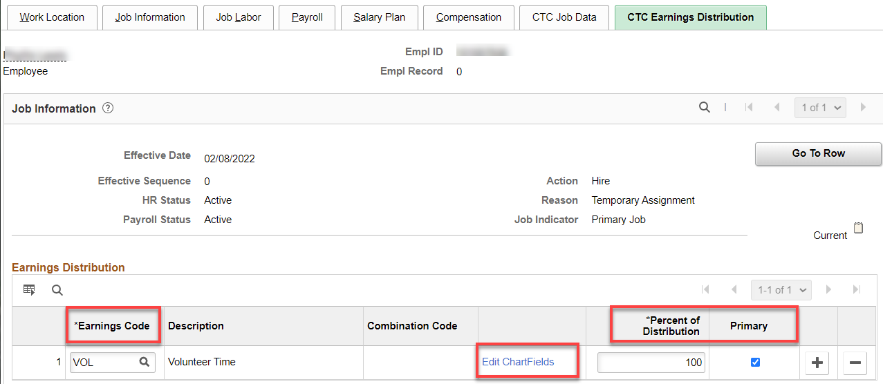

Enter the combo code (hit enter for the chart field to complete). Check the chart field (budget lines) to make sure it matches the PT hourly agreement.

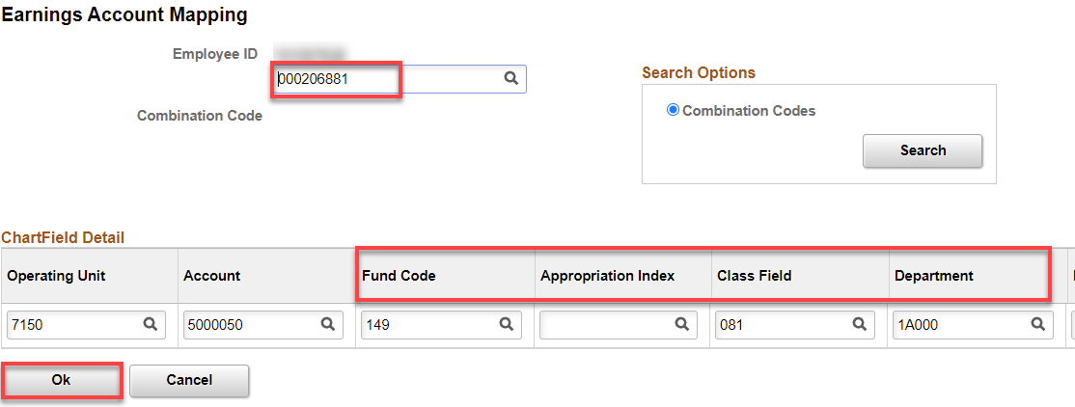

Click on Employment Data hyperlink

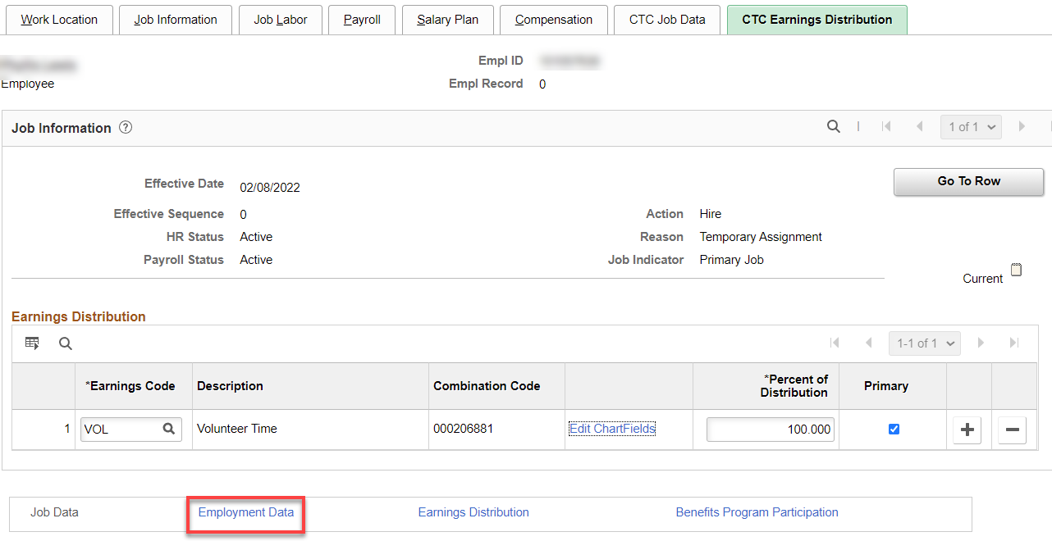

Click on Time Reporter Data link.

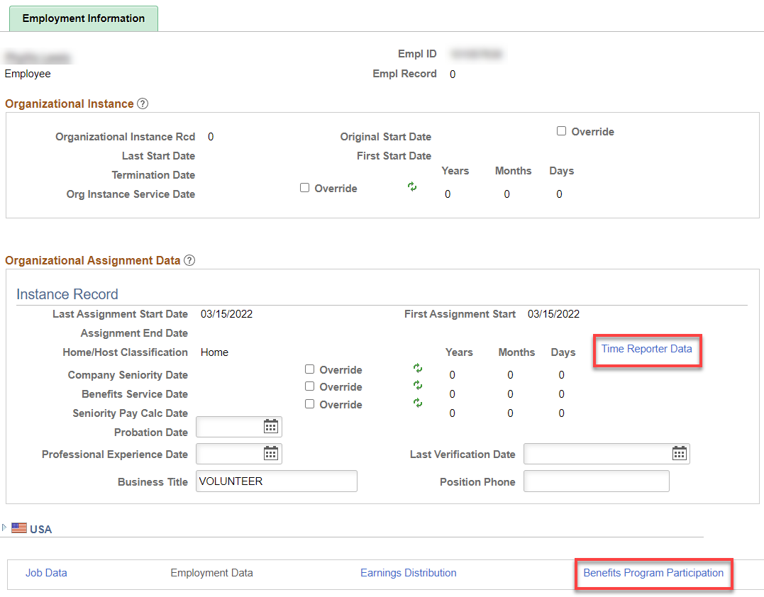

First, change the effective date to the hire date, if needed, put in the Time Reporter Type, Punch Time Template, Work Group, Task Group and hit refresh. That will update the Employment Information screen (above).

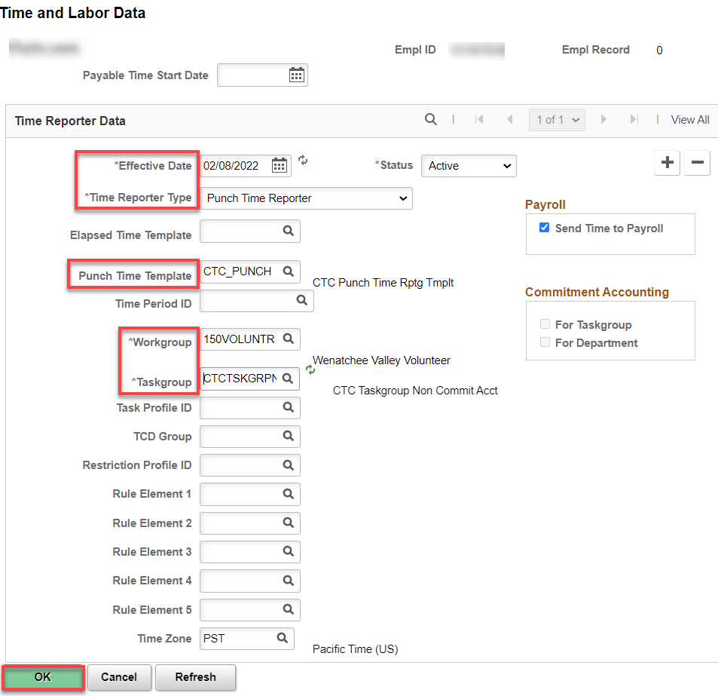

Click on Benefit Program Participation; all you have to do on the Benefit Program tab is put in Benefit Record Number (150). Click OK. A few Warnings will pop up, click through them.

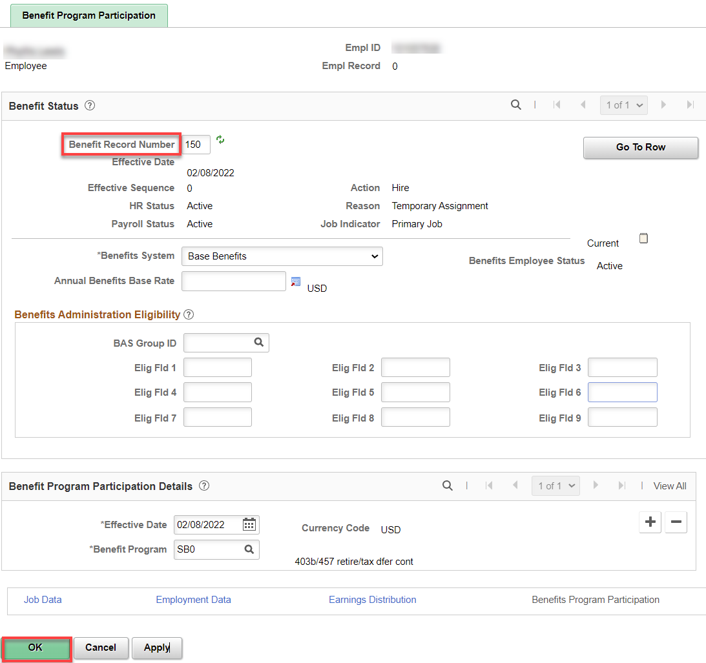

You will see three warnings about compensation, just click OK.

Note; L&I deductions will be taken if the volunteer employees are setup with deduction 000201, AND the employee puts in hours

Assign ACA Status

Nav>Benefits>CTC Custom>Assign ACA Status

Add Effective Date (hire date) and ACA Employment Status, Save.

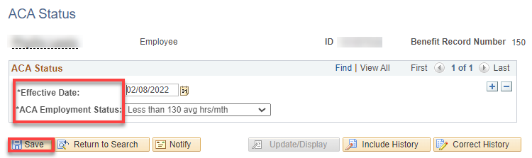

That’s It

