Enrolling, Changing, Terminating Savings Plans (Deferred Comp-457 and SBVIP-403B)-No QRG

Nav>Benefits>Enroll in Benefits>Savings Plans OR Benefits Admin tile>Enroll/Maintain Benefits>Savings Plans

Enrolling in Deferred Compensation (457 plan through DRS):
Enrolling can only happen after we receive information from DRS either employee initiated or autoenrollment. Once the document is put in My Documents on the DRS website, DRS will send an email to HR/Payroll, the person designated to get the document will retrieve it, save in the DCP Change Reports folder in the HR/Business shared drive (for WVC), and make the appropriate additions, changes or termination in ctcLink.

Both Savings Plans require a supplemental retirement deduction form.

Choose Plan Type (46 (403B), or 49 (Section 467), Add Coverage Begin Date, Deduction Begin Date, Election Date (all should be the same date), Benefit Plan, Before Tax and/or After Tax Investment, Save.
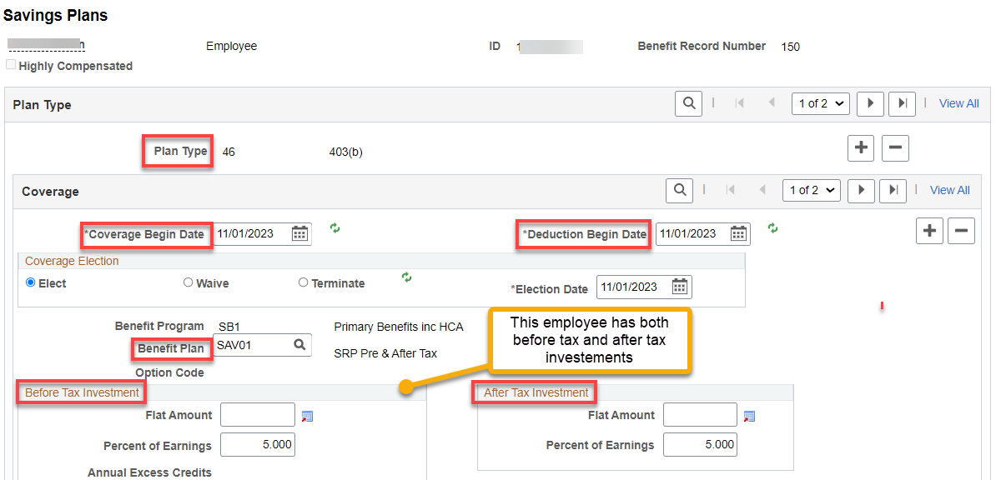

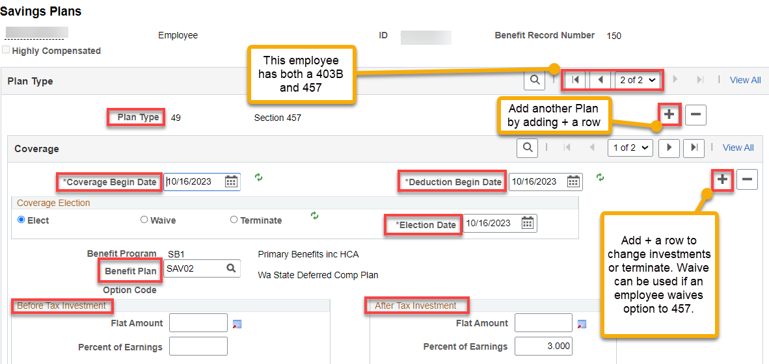
Terminating 457 or 403B

Add + a row to Coverage, put in the termination date (1st of the next month) and Refresh. The screen will update. Save. The system will automatically remove the Benefit Plan and any Before or After Tax Investments.

CHECK Plan type to make sure if the employee has both a 457 and 403B, you terminate both.

IF NO PLAN IS SELECTED, NO NEED TO DO ANYTHING.

That’s it!

