Change in Percent of Assignment - Exempt
Job Data
Work Location tab: Add + row, change the Effective Date, Add Action (Data Change), Reason (Status Change).

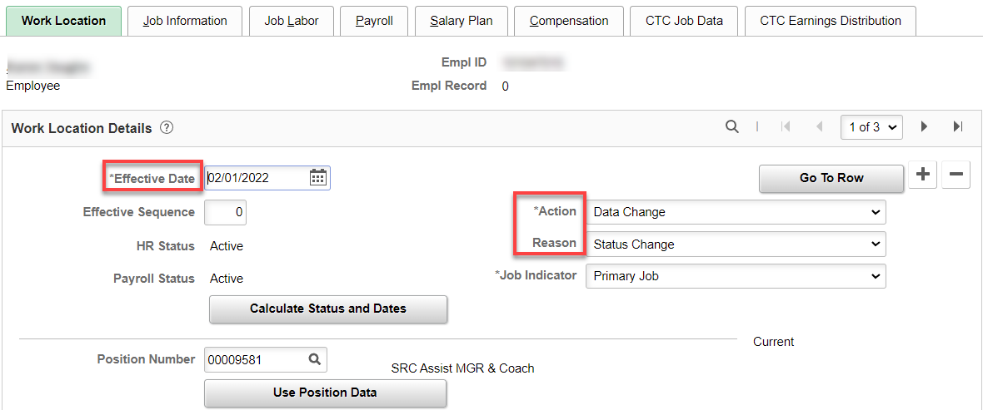

Job Information tab: change Standard Hours and FTE. Refresh and change FTE back to what it should be, if necessary.

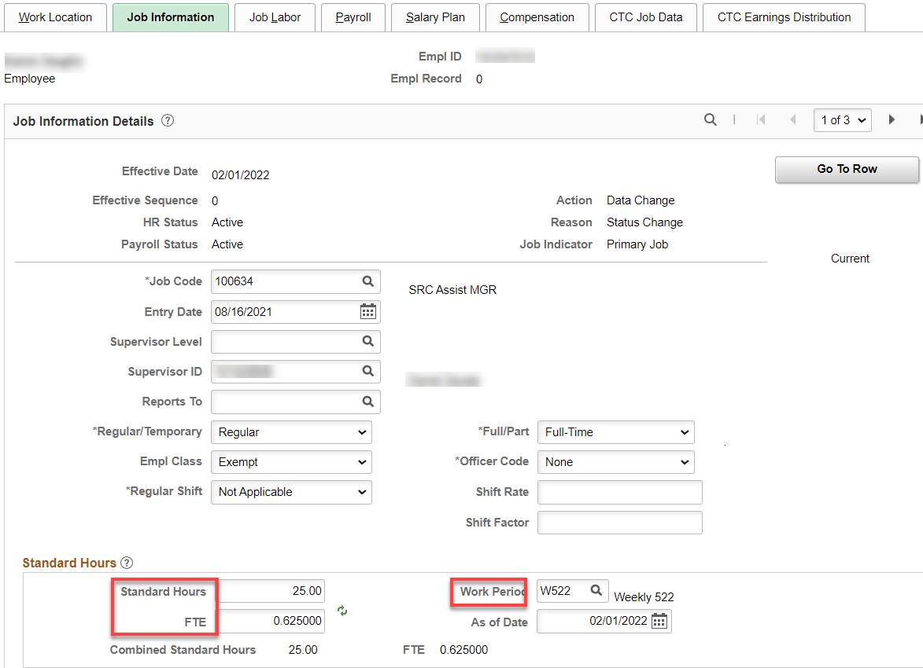

Job Labor tab: Shouldn’t be any changes.

Payroll tab: should be the same if it is exempt to exempt.

Salary Plan tab: nothing for exempt.

Compensation tab: Enter annual salary if FT 12 month, leave the Frequency at S and hit Calculate Compensation.

If less than full year, salary must be calculated by daily rate. Calculate salary for the days worked until the change in percent of FT, then check salary already paid. If there is a difference, it must be added or subtracted using a PSHUP. In this example, the rate already paid is short what is owed.

Example in this case: $50,180/261=$192.26 x 121 days = $23,263.46 (amount paid through 01B) minus amount paid $23,062.05 (2096.55 x 11 pay periods) = $201.41 (PSHUP – see below).

Calculate the salary for the rest of the appointment period, enter prorated salary and change the Frequency from “S” to the number of payments left in the appointment period.

Example in this case: $50,180/261= $192.26 x 108 days left in appointment period = $20,764.08 x 62.5% (new percent of FT) = $31,362, with the number of pay periods left = 10 (C10), leaves a per pay period rate of $1,297.73.

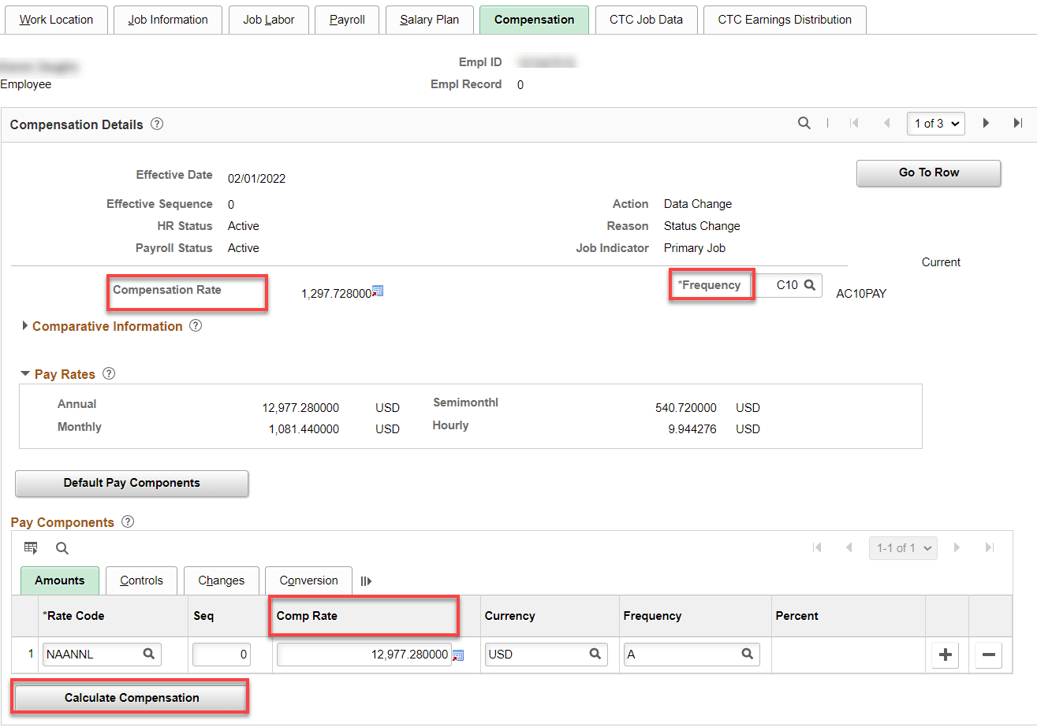

CTC Job Data tab: for this example, there is 108 days left in the appointment period, change Contract Units, Contract Begin Date and Contract End Date, if needed.

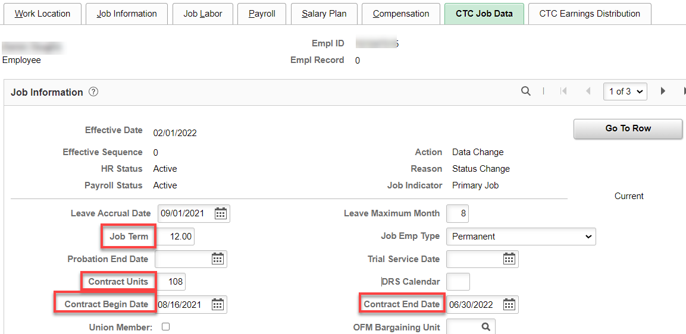

CTC Earnings Distribution tab: Enter new information, if any. Save

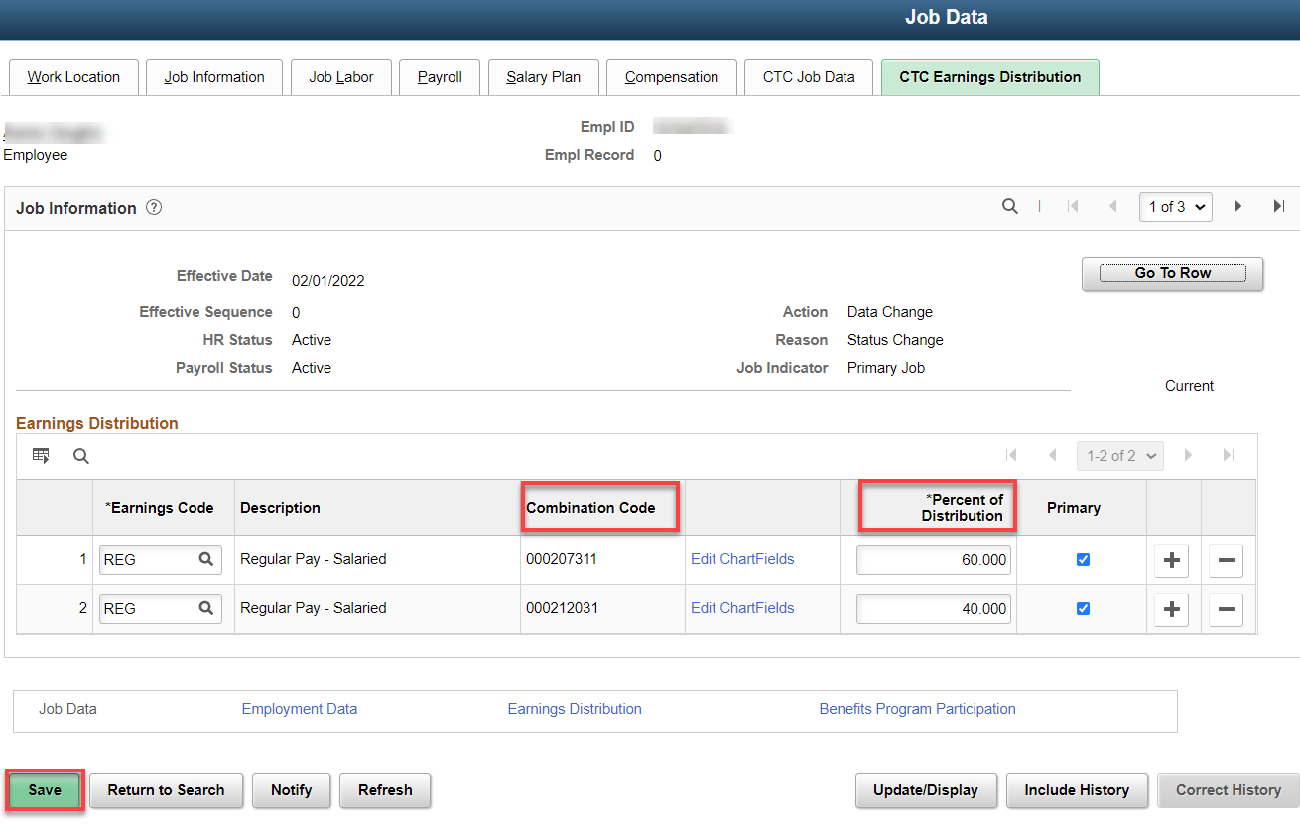

Employment Information tab: should be the same.

Time and Labor Data: should not change.

Benefit Program Participation link: no change

Benefits should be the same so no need to go there.

Here’s the PSHUP

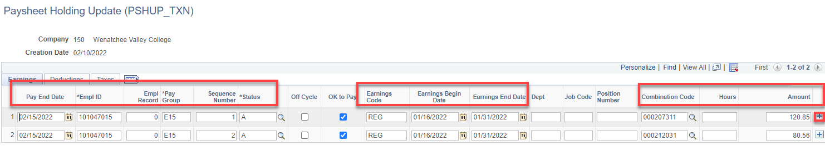

That’s it.

