Leave Max Override-Vacation

Note: Some colleges have the leave max taken down to 240 hours after that month’s accrual and some have the 240 max reduction done before that month’s accrual. BE SURE to check what your college has for the formula. If you want your formula to have accrual after the 240 reduction, this is the formula: See Ticket #119988.

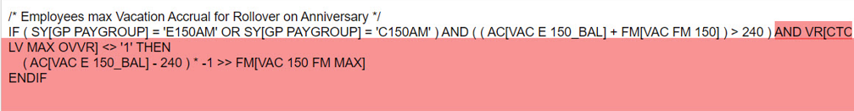

Classified Employees: changing the Leave Maximum Month will actually change the leave max month if done before the month needed to be changed (ctcLink preloads the data in early according to the experts). The example below will work for classified employees as well.

Exempt Employees: For WVC, ctcLink only looks at August for leave max, therefore, if someone is granted an extension, changing the Leave Maximum Month in CTC Job Data doesn’t work.

To override the reduction of hours to 240 in August, you must do the following:

Work Location tab: Add + a row, change the Effective date to 08/01/20XX, add Action (Data Change).

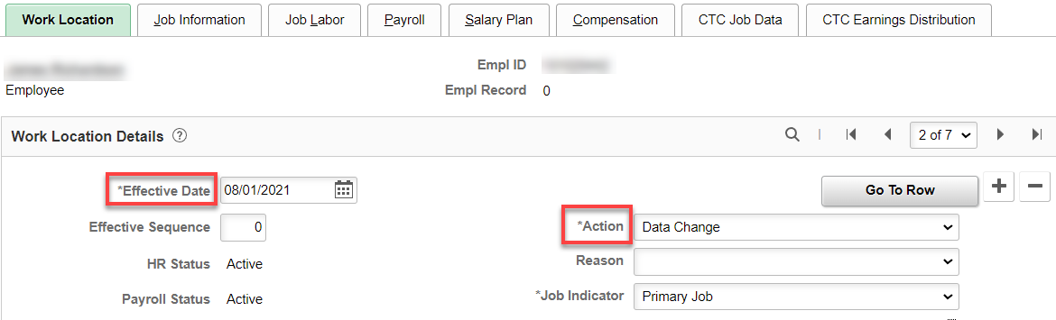

CTC Job Data tab: add a check to the Max Leave Override box. Save.

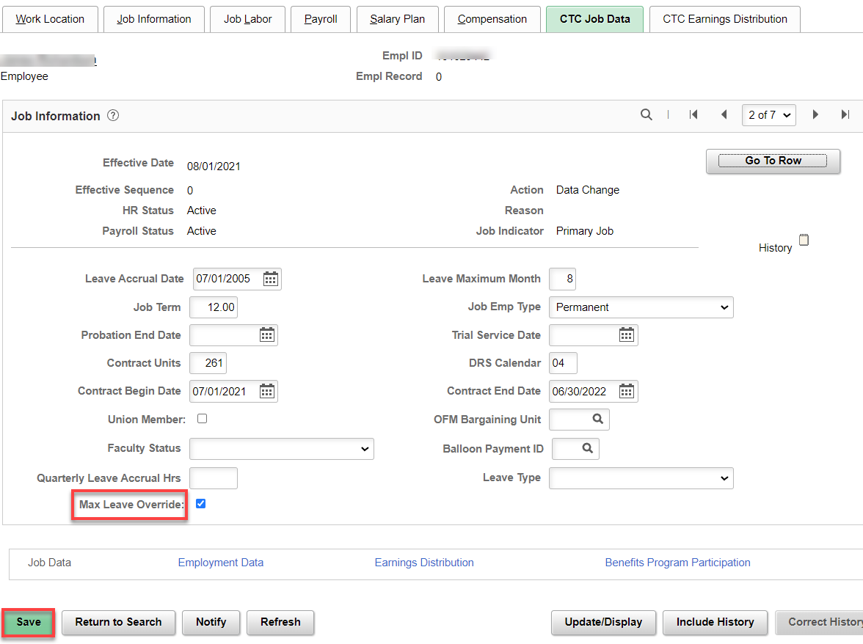

After August Leave Entitlements Run, go back to Work Location Tab

Work Location tab: Add + a row, change the Effective date to 09/01/2021, add Action (Data Change).

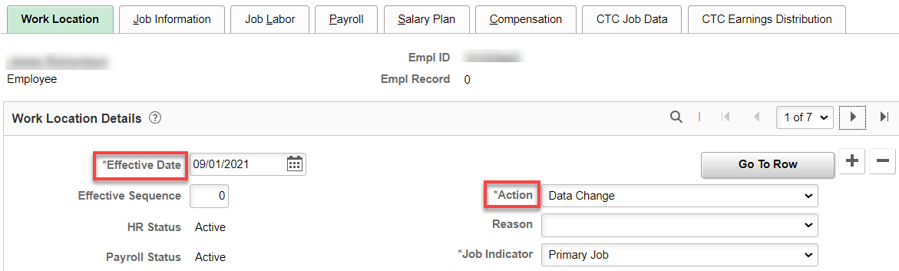

CTC Job Data tab: uncheck the Max Leave Override box. Save.

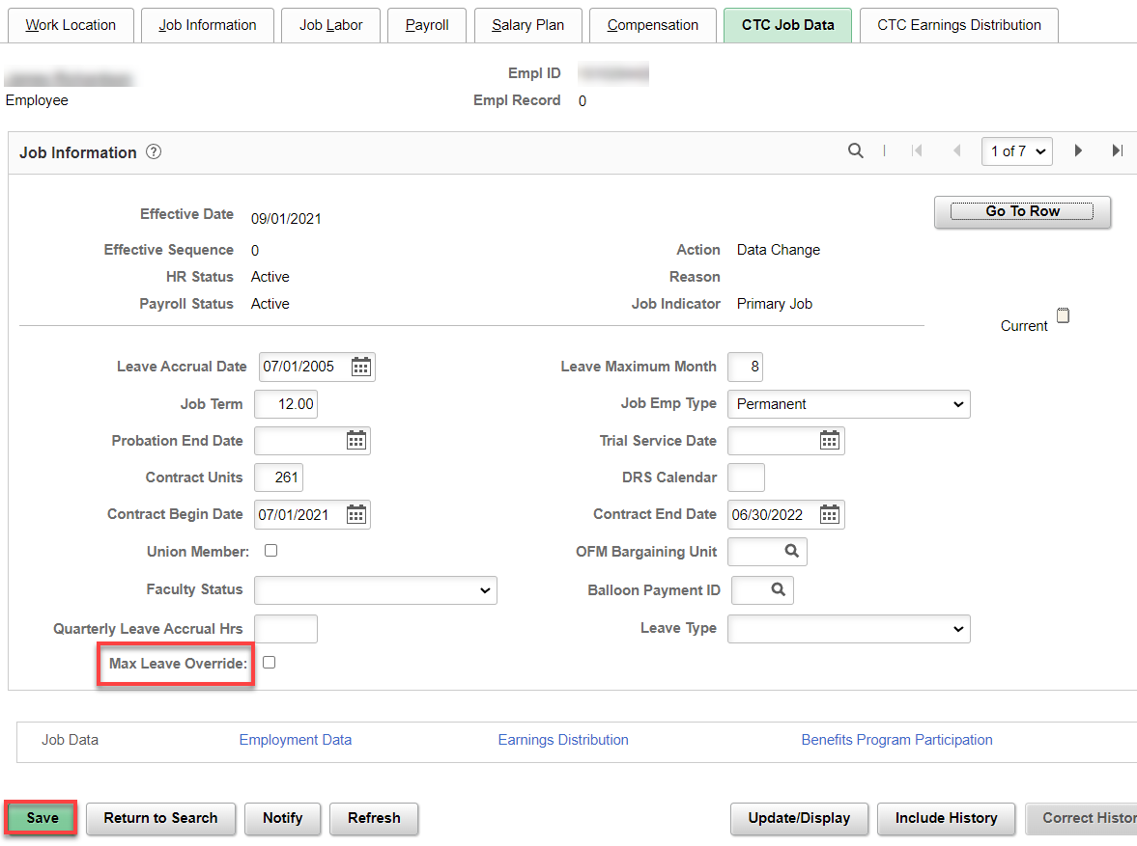

That’s it!

