Short Work Break - Job Effective Dated Row Insert

Nav>Workforce Administration>CTC Custom>CTC Processes>Create New Job Eff. Dated Row

Putting all FT Faculty on Short_Work_Break after 06B so they don’t continue to be paid.

Use 7/1 as the effective date

Create new job eff dated row

Click on Search to find an Existing Value (if there is one). You can reuse it each time.

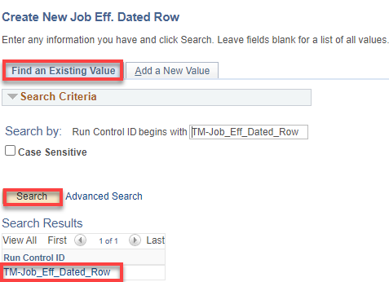

Don’t use begin and end dates now for putting them on Short Work Break.

When we bring them back in the fall, we need to put begin and end dates.
After 06B payroll processes, add Company, Effective Date (7/1 for after 06B runs), action (SWB) and Pay Group (F15 for all FT faculty). No Reason, Department or dates needed…Run

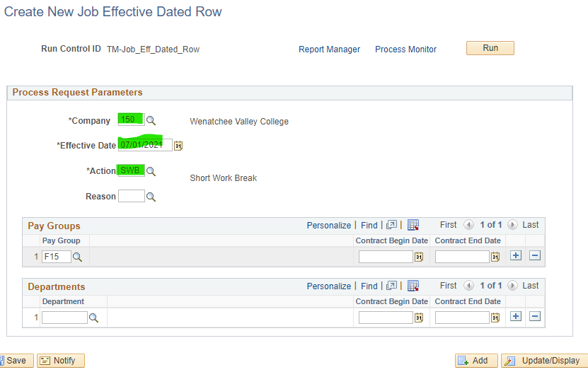

Click OK

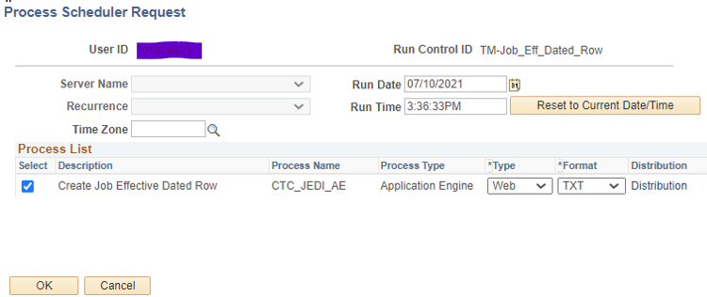

Click on Process Monitor, Refresh as needed until job processes and posts.

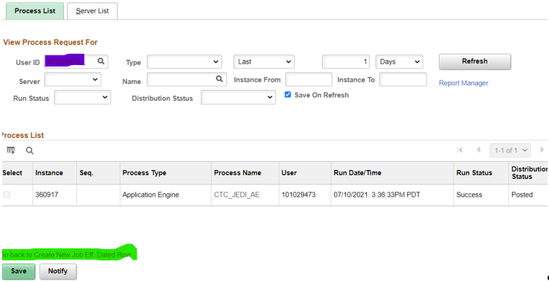

Click on Go back to Create Job Eff Dated Row hyperlink

Select the Report Manager hyperlink

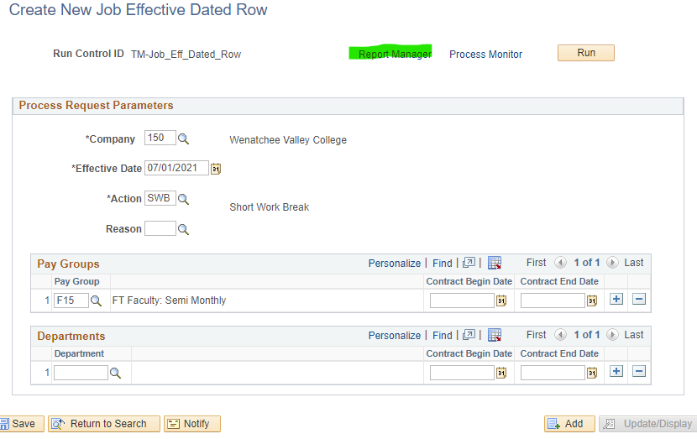

Select CTC_JEDI_AE

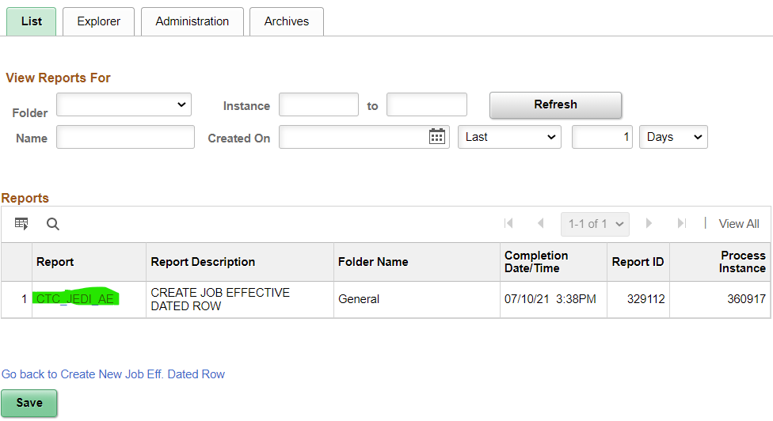

Select JOB_EFFECTIVE_DATE log

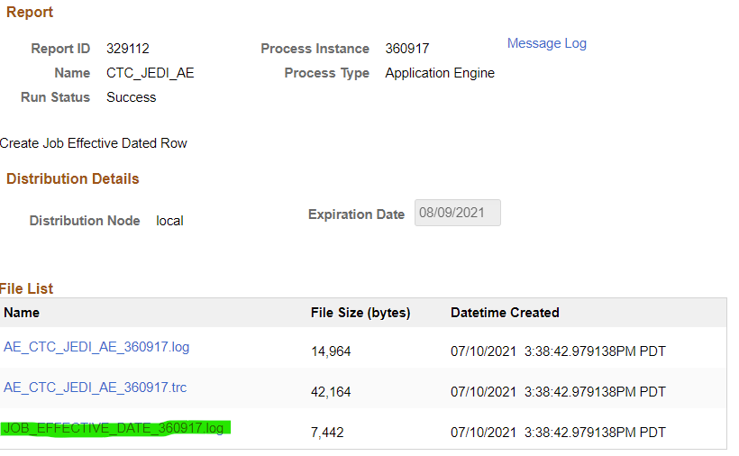

Shows file with all affected people. Check a few. Go into Job Data and remove the row for FT faculty with Ext Days for summer because they should not be on break.

Another way to get there is Administration tab, Details

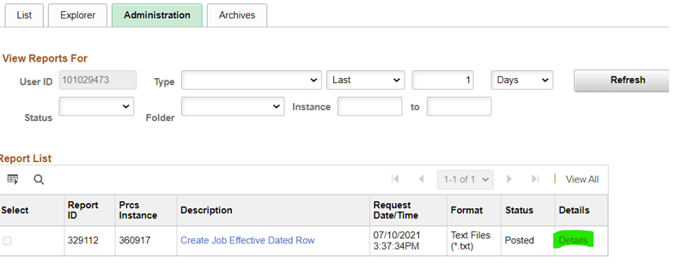

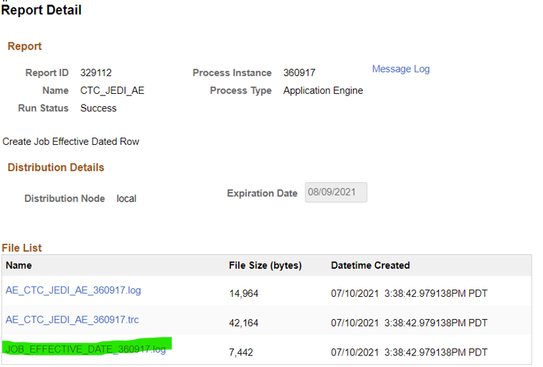

In Job Data, Work Location tab, this is what it will look like

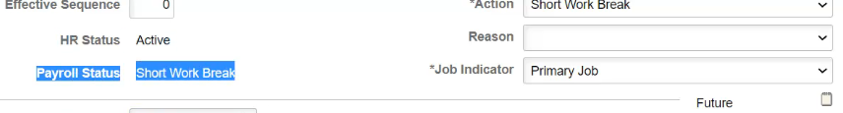

QHC_HR_CTC_JOB_DATA query shows everything about all jobs but we are looking at Pay Status and HR Status of A (filter data).

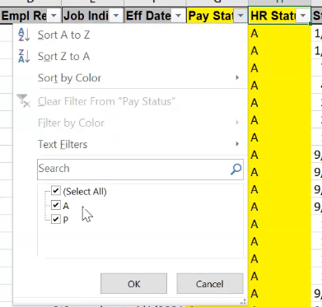

In July, it will show a W under pay status (in the query-see below).

This can be reversed

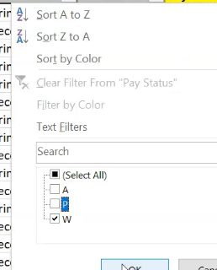

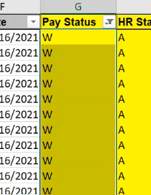

After running process, run query to see that all have a W and then go in to Job Data of the four-quarter people that have extended daily jobs and remove that row from that job. At the end of the summer, for the four-quarter people, go back into their jobs and inactivate or better yet, terminate that job.

That’s it

Bringing FT Faculty back 9/1 (see Bringing FTF back from Short Work Break Documentation)

