Supervisor ID Mass Update

The QRG is really good so just follow it. There is also a QRG to Reverse a Supervisor Mass ID Update.

Use the QRG Creating a Supervisor Mass Update

Nav>Workforce Administration>CTC Custom>CTC Processes>Supervisor ID Mass Update

Just put the from supervisor to supervisor info in and Run. Save at the end.

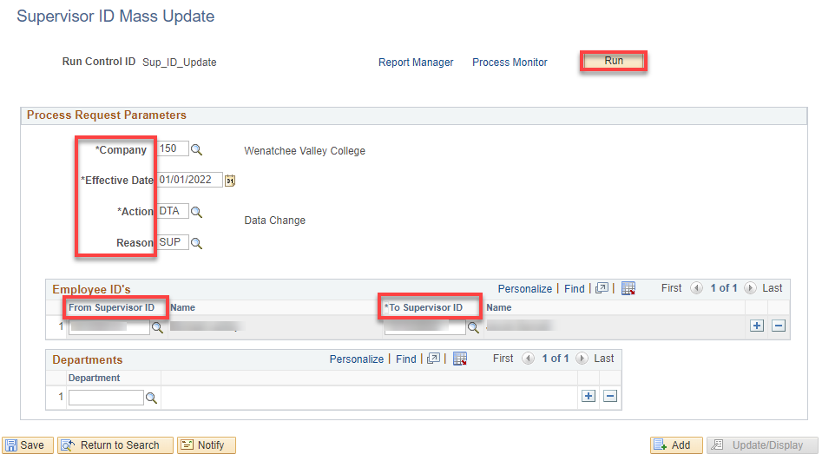

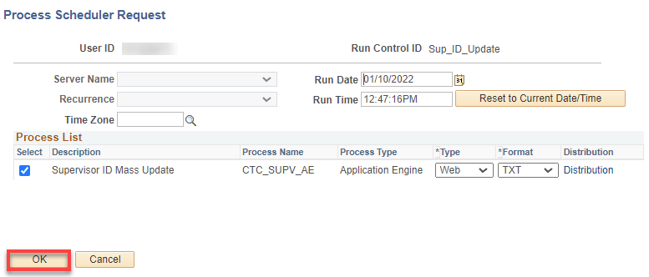

After the process posts, go to Report Manager

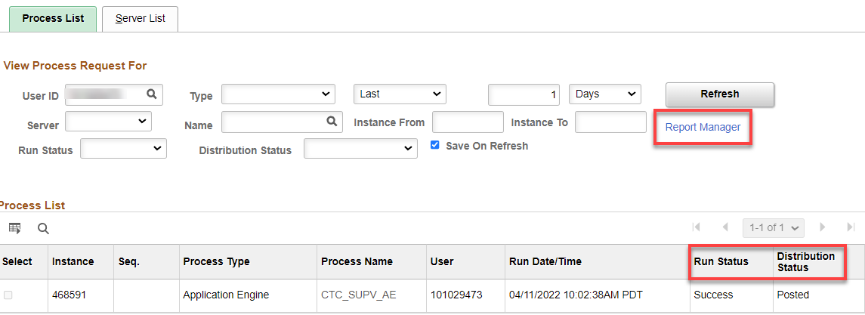

Click on the Administration tab and click on Supervisor ID Mass Update.

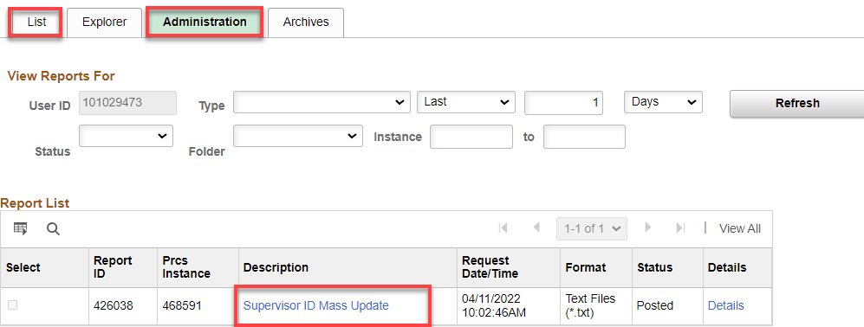

Then click on the Supervisor Mass Update XXXX.log.

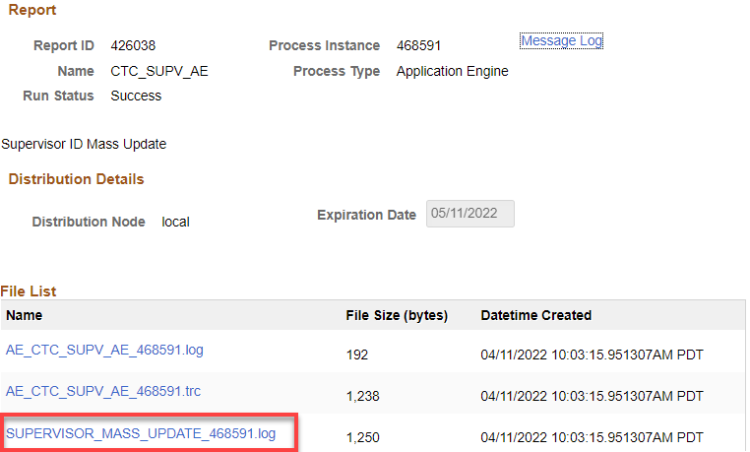

The .log gives you the information on all people changed as a result of the mass update. You may have people on the update that you need to change back. If so, you can go to Job Data, Correct History, and remove that row. Save.

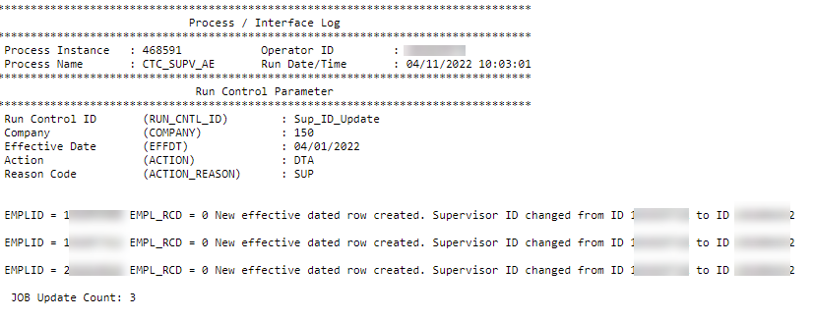

At WVC, we have a process that looks at many changes in ctcLink and one of them is supervisor changes. After a change, an email is sent out notifying folks of and who is changed. Here is an example:

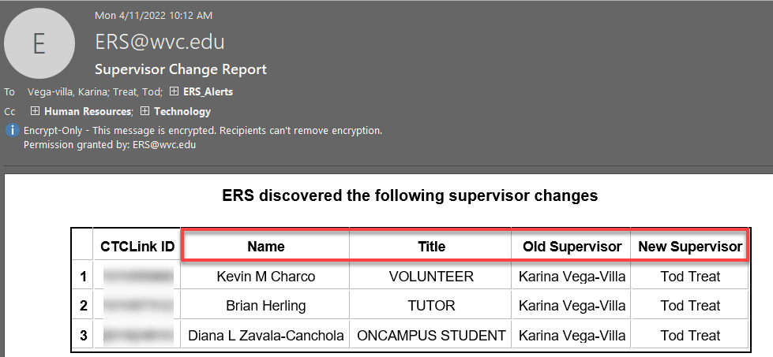

That’s it!

