Compensatory Plan Enrollment - to see if EE is enrolled in the correct compensatory time off plan.

Nav>Time and Labor>Enroll Time Reporters>Comp Plan Enrollment OR Time & Labor tile

Add a Row if necessary, Effective Date, Compensatory Time Off Plan. Save.

Key:
Exempt – no comp time plan
Exempt Overtime Eligible – WACOMP1
Classified – WPEACMP

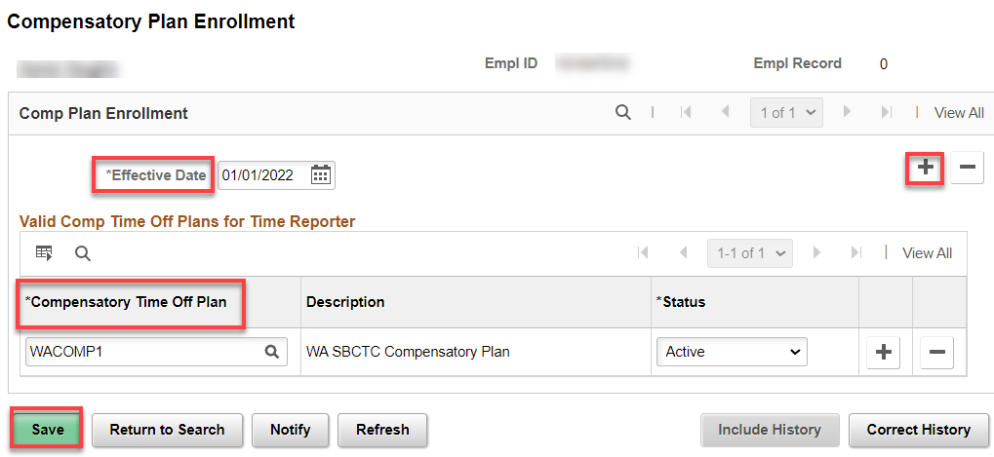

That’s it

