**Reporting Time - Timesheets**

*If you are a time reported your supervisor may ask you to report your time daily, weekly or by pay period. Only overtime-eligible classified and exempt staff fill out timesheets salaried employee (overtime-exempt or classified-exempt from overtime), do not report hours worked).*

**NOTE**: Time is processed periodically, but at minimum overnight. Time entered may not be visible to the employee or manager in other screens until the overnight processing has occurred.

Reporting the number of hours you worked is done in Employee Self Service.

**First, log in to ctcLink. And press the Time tile.**

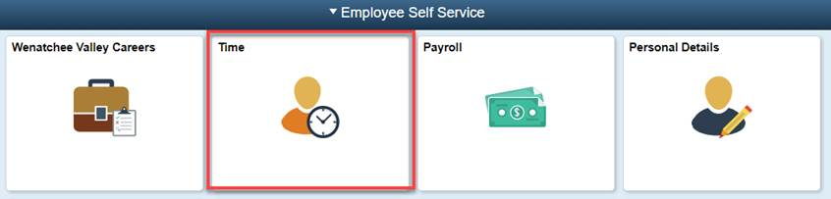

**To enter time there are three ways:**

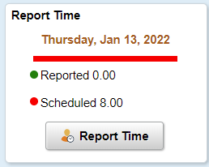1. Using the Report Time tile to see one day at a time:

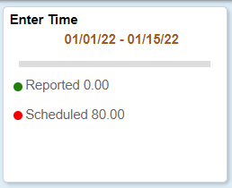2. Using the Enter Time tile which shows a week at a time:

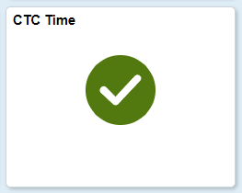

3. Using the CTC Time tile which allows you to see your weekly schedule or calendar period, and much more (this is my favorite 😊):

**Note:** see below (last page) for information on the different Time Reporting Codes.

**Report Time**

**This is the only tile available if you are using ctcLink on a mobile device.** This is also the recommended way to enter time using assistive technology, whether you are using a mobile device or desktop.

1. The date appears at the top. Use the arrows to the left and right of the date to go back or forward a day and enter time.
2. Select an option from the Time Reporting Code drop down menu.
3. Enter the number of hours for that particular Time Reporting Code. Most of the time you are reporting one code and your full hours. Sometimes you may be reporting 01 Regular hours worked in addition to sick time or some other absence. **Note**: If an absence has been entered prior to entering time, you must add + a row.
4. Submit. **Note**: each day you Submit time your supervisor will be notified (process runs nightly) and can go and approve time.
5. View your submitted hours.

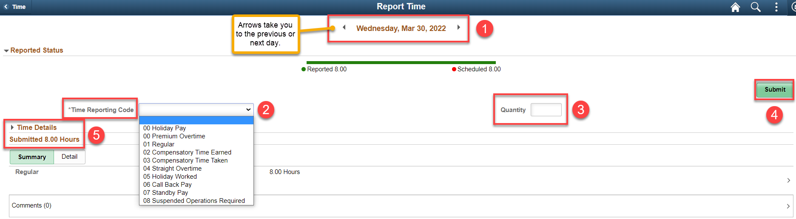

**Enter Time**

The Enter Time tile allows you to enter time a week at a time.

1. The top section displays a full pay-period, with arrows to change to a different time-period, however, you are only able to see one week at a time.
2. Select an option from the Time Reporting Code drop down menu.
3. Enter the number of hours for that particular Time Reporting Code. Most of the time you are reporting one code and your full hours. Sometimes you may be reporting 01 Regular hours worked in addition to sick time or some other absence. **Note**: approved leave time is automatically filled in. Use the + to add a row for regular time or other Time Reporting Codes as necessary.
4. Submit. Each time you hit Submit, a notification will be sent to your supervisor to approve (there is no save button ☹). Notifications are sent to the supervisor nightly.
5. View your submitted hours.

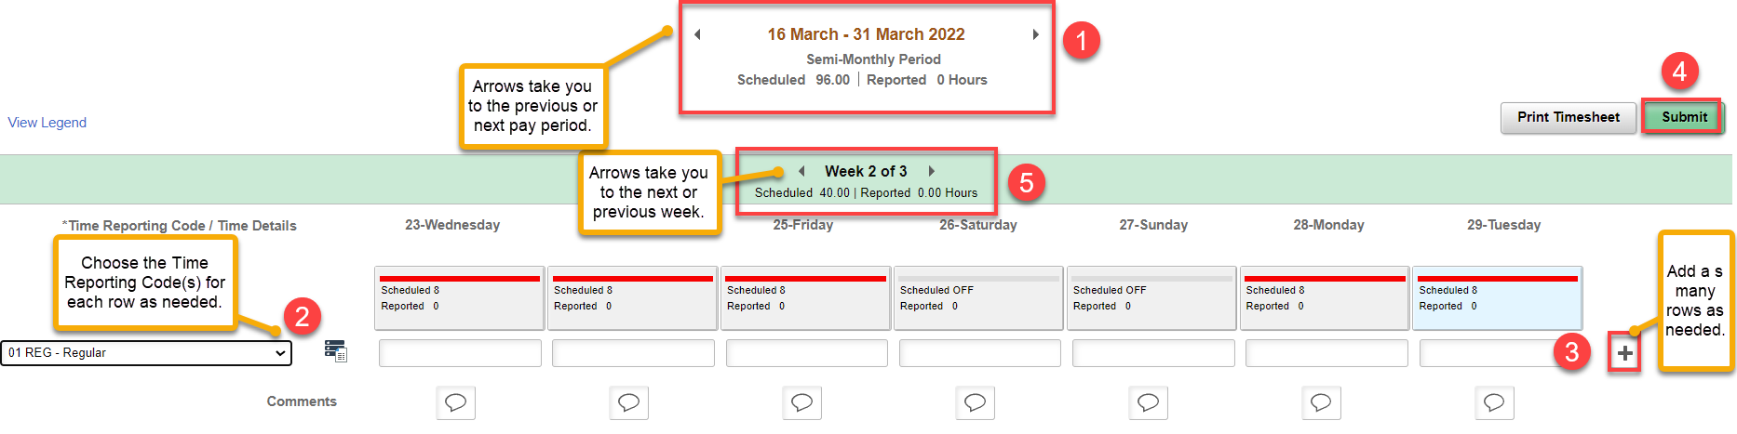

The Enter Time tile also allows you to enter comments.

If reported hours are above 40 for the week, the system will automatically convert the extra hours to premium overtime.

**Timesheet**

1. You can View By Week or Calendar Period (Calendar Period because it shows the whole pay period).
2. You can move to Previous Week or Next Week and other options like Print.
3. Enter the number of hours for that particular Time Reporting Code. Most of the time you are reporting one code and your full hours. Sometimes you may be reporting 01 Regular hours worked in addition to sick time or some other absence. **Note**: approved leave time is automatically filled in. Use the + to add a row for regular time or other Time Reporting Codes as necessary.
4. When you are done adding time for the day, week or pay period, hit Submit. Each time you hit Submit, a notification will be sent to your supervisor to approve (there is no save button ☹). Notifications are sent to the supervisor nightly.
5. The Timesheet also shows Reported Time Status and Payable Time (available *after* supervisor approves).

If reported hours are above 40 for the week, the system will automatically convert the extra hours to premium overtime.

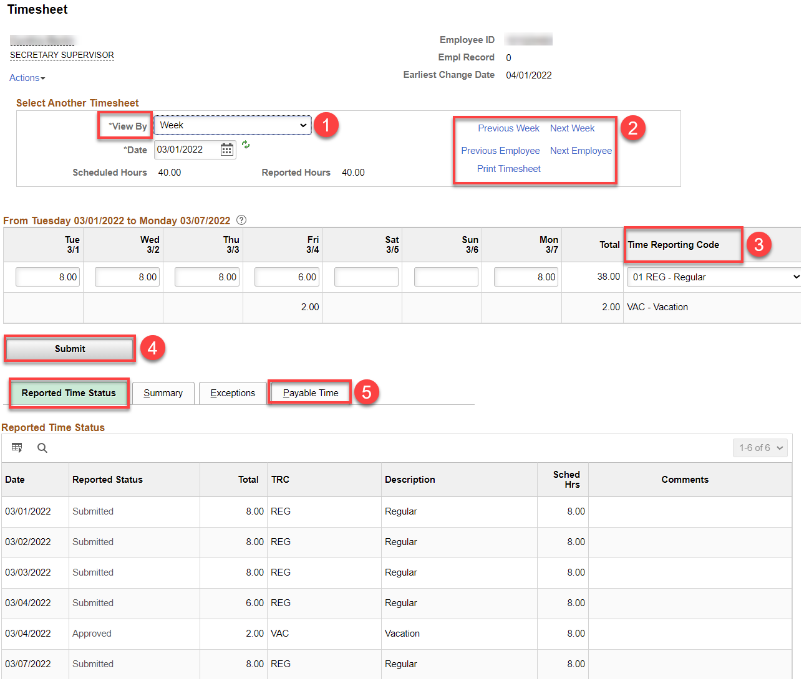

**Time Reporting Codes (TRC) - how and when to use**

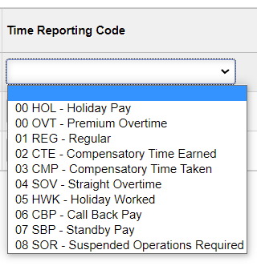

**Holiday Reporting**

1. If you are normally scheduled to work on the day the holiday falls on, you must report the number of hours you normally work on the holiday (e.g. 8 for 8x5M-F); if you work 4 or 9 or 10, etc., report that number on the holiday.
2. If the holiday falls on a day you are not scheduled to work (e.g., if the holiday is on a Friday and your work schedule is 4x10 M-TH), you would leave the holiday blank and arrange with your supervisor to take a different day off that week (leaving the scheduled hours in that day). **Note**: If you work on the holiday and it is not part of your regular schedule (Friday in the example above), put the number of hours worked on the holiday and it will pay you time and one-half for the hours worked, or follow #3 below.
3. If you work on a holiday, add + a row and put in the number of hours worked and use Time Reporting Code HWK (pay is time and one half).
4. If you are not in pay status for any of your regular scheduled hours the day before a holiday, then you are not eligible for the holiday. Add + a row, put in the number of hours scheduled for the holiday and a Time Reporting Code of HNE.

**Premium Overtime**

If you are in pay status for more than your regular 40-hour shift and you report the extra hours under REG, ctcLink will automatically convert the extra hours to Premium Overtime OT you can add + a row and add the extra hours and choose OVT – Premium Overtime TRC.

**Regular**

The Regular TRC is for reporting regular hours worked.

**Compensatory Time Earned**

The Compensatory Time Earned TRC is an employee choice to use instead of Premium Overtime.

**Compensatory Time Taken**

The Compensatory Time Taken TRC is used when you are taking time off instead of using vacation time.

**Straight Overtime**

The Straight Overtime TRC is only used for overtime-eligible employees that are less than full time. If time is worked beyond the regular schedule (e.g., 20), the extra hours can be left on the Reg TRC or an extra row can be added to report the hours as straight overtime.

**Call Back Pay**

The Call Back Pay TRC is only used by classified employees that are called in early or called back to work after leaving, per the classified staff collective bargaining agreement (CBA).

**Standby Pay**

The Stand By Pay TRC is only used when a classified employee is designated to be on standby per the classified staff CBA.

**Suspended Operations Required**

The Suspended Operations Required TRC is only used when the college is under suspended operations and a classified employee is required to work, per the CBA.

That’s it! 😊