Running Request Batch Approval Process (the QRG is really good)

If you need to approve a timesheets or approve all timesheets without the supervisor approving themselves, you can run a Request Batch Approval Process. It’s really easy.

Nav>Time & Labor tile>Request Batch Approval Process

If this is the first time running this process, choose Add a New Value and put in a Run control ID (if this is not the first time, you can Search and reuse a Run Control ID).

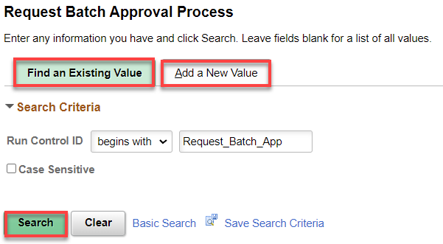

If you are running this for one or just a few employees, put in their Empl ID(S) (add + as many rows as you wish). You have the choice to Include or Exclude employees. Put the correct payroll dates in, Save, Run.

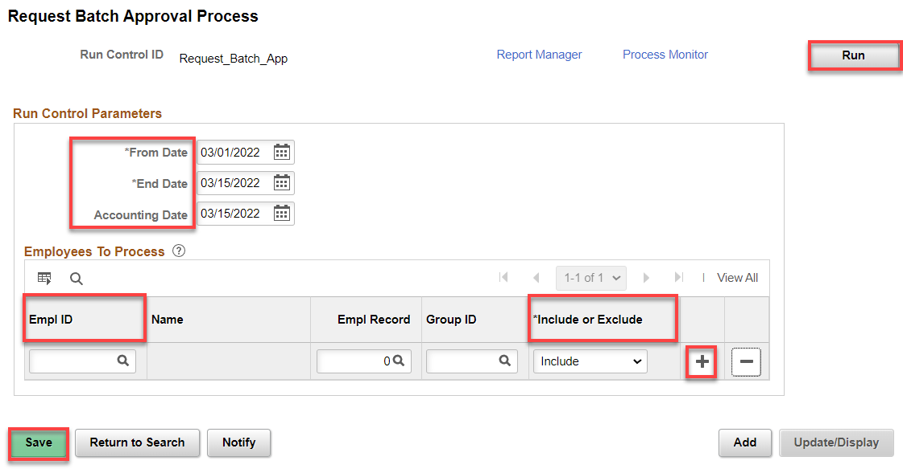

To run a process for all, click on the search tool under Group ID.

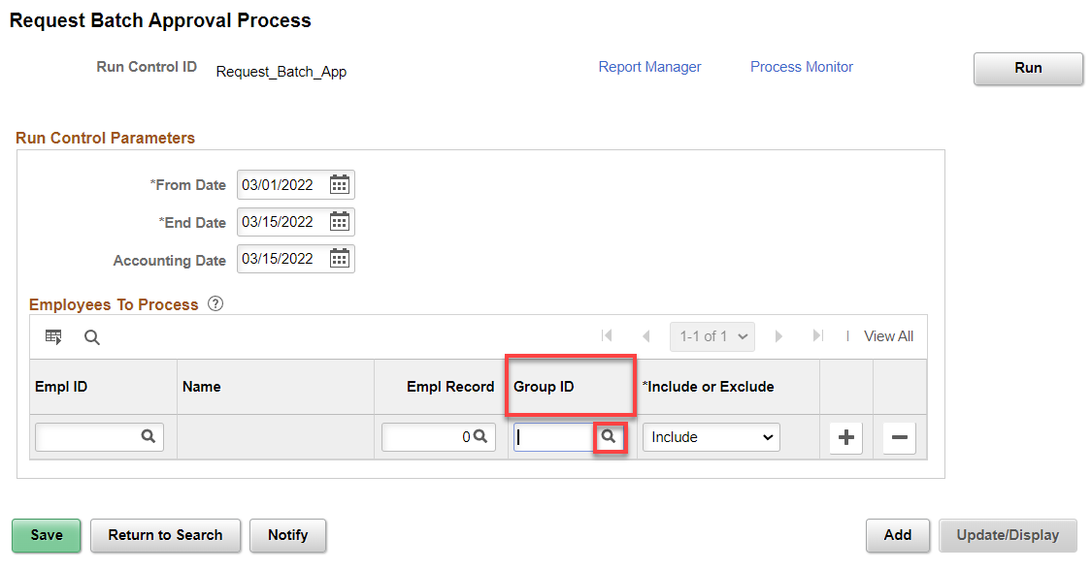

Choose the Group, Save and Run. To go back to running individual employees, delete (minus –) the row.

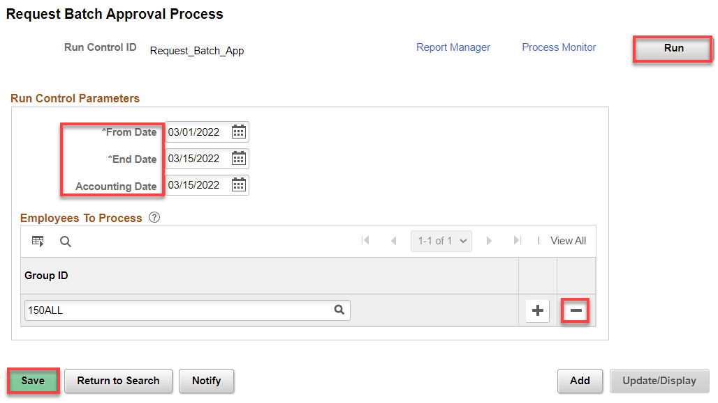

ick OK.
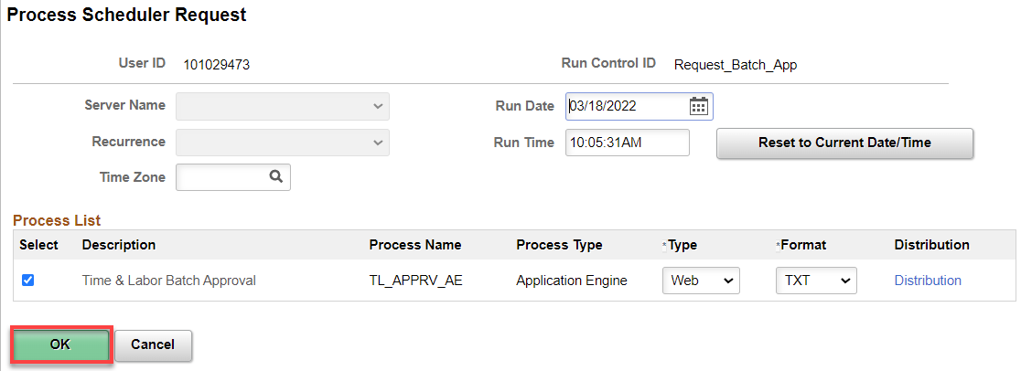

Click on Process Monitor, Refresh as needed (by now you know the drill). To see the if everything processed, click on the Details hyperlink and then the View Log/Trace hyperlink.

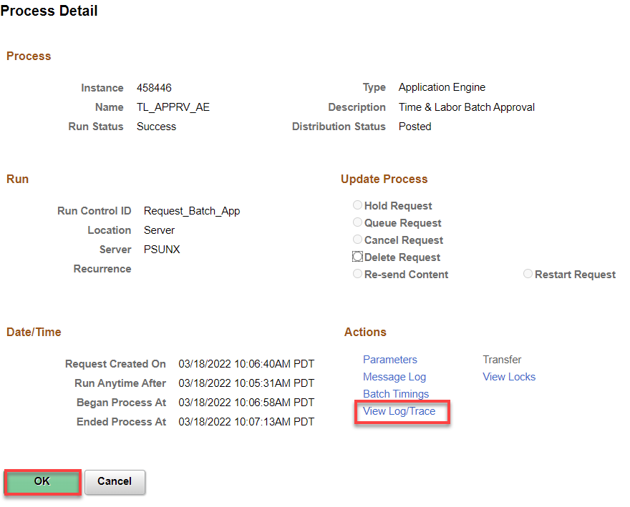

And then the File List .log.

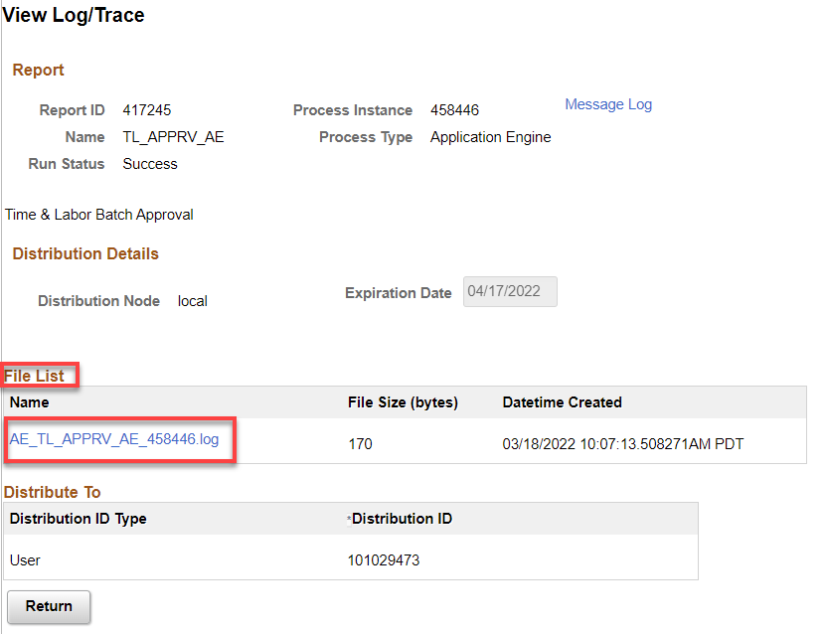

You should make sure you see that the process ended normally.

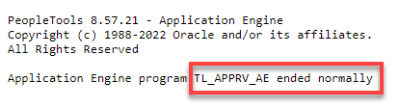

That’s It!

