Making a Variety of Changes to Timesheets - DRAFT

Run Request Time Administration

Anytime a change is made to a timesheet and is needed to be approved right away by the supervisor, run Request Time Administration (see (T&L-Request Time Administration documentation) and the supervisor will receive an email immediately.

Run TA Process

If there is a problem with a timesheet like a HOL denied, run a TA process (see T&L-TA Process to Change Hours documentation).

Run Refresh Dynamic Group Process

This process runs nightly for all the dynamic groups. When a time reporter is newly enrolled and the timesheet is to be filled soon after on the same day, this process can be run ad-hoc by the college time and labor admins. (see T&L-Running Refresh Dynamic Groups Process documentation).

Approving Timesheets

HR can approve a single timesheet or all unapproved timesheets by running Request Batch Approval Process (se (T&L-Running Batch Approval Process documentation).

Wrong Time Reporting Code Added

If someone put in the wrong Time Reporting Code (TRC), HR can change the code and ctcLink will look back and correct the mistake. ctcLink will automatically subtract the amount of the incorrect TRC if deleted OR replaced by another TRC.

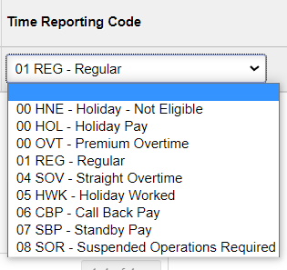

Adding Time for an Employee

HR can add hours for an active employee and ctcLink will “look back” a maximum of six months.

If the EE did not get paid, payroll may have unchecked “OK to Pay” on the paysheet, thus closing the hours forever. When this happens, payroll will have to add the hours and pay on a payline.

Timesheet is Greyed out

If the timesheet is greyed out so you cannot put time in, you need to adjust the Time Reporter Data in Job Data. Add + a row,, if needed or use Correct History and change/correct Effective Date and it will adjust through the overnight process (you may have to adjust the start date and/or the entry date in Modify a Person as well).

If you need the employee to have access immediately, run Refresh Dynamic Groups (see T&L-Running Refresh Dynamic Group Process documentation) and then run Request Time Administration Process.

That’s it for now!

