Wenatchee Valley College Venue Information & Rental Rates
WVC rents based on a one hour minimum, up to four hours, and over four hours. Equipment rental fees and personnel charges may also apply. For more information or to schedule your next event, please visit our website for room scheduling accommodations. Standard rates are published. Government/Educational and Nonprofit rates are available after submission of request. All pricing is subject to change. Capacity maximums are subject to room layout.

Location Overview |  | Location Overview
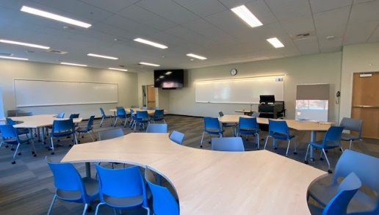 | General Classrooms  General classrooms are equipped with a teaching station that includes a computer, projector, document camera, and screen. Classrooms are “as is” layout.  Capacity: 40  Flat Rate:  ≤ 4Hours (1 hr. min.): $30.00  >4 Hours: $55.00 | 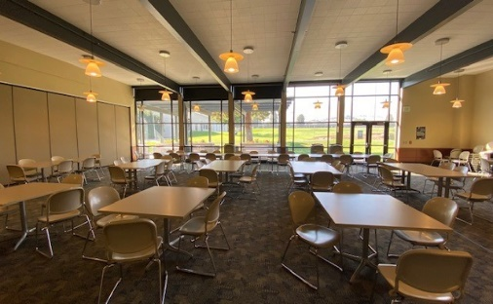 | Cafeteria Dining Room  Van Tassell Center (VTC) 5015  With floor-to-ceiling windows, the cafeteria offers great natural light and is a versatile space that is perfect for banquets, tabling, workshops, large meetings, conferences, and forums. Special configurations available.  Capacity: 150  Flat Rate:  ≤ 4Hours (1 hr. min.): $100.00  >4 Hours: $150.00
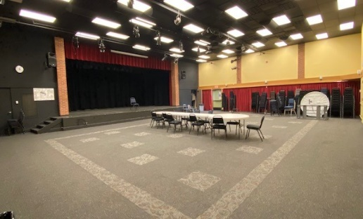 | Wells Hall (WEL) Theater  WEL1068  An ideal space for lectures, banquets, forums, meetings, and gatherings. The room's open floor plan is capable of multiple set ups. Includes a stage, full projection screen, and sound system.  Capacity: 168  Flat Rate:  ≤ 4Hours (1 hr. min.): $100.00  >4 Hours: $150.00 | 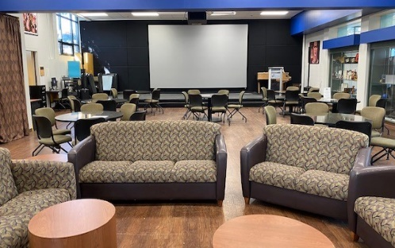 | Student Center Lounge  Van Tassell Center (VTC) 5004  Located in Van Tassell Center. Available to rent in limited capacity with prior approval from Student Life. Various layouts available.  Capacity: 140  Flat Rate:  ≤ 4Hours (1 hr. min.): $75.00  >4 Hours: $125.00
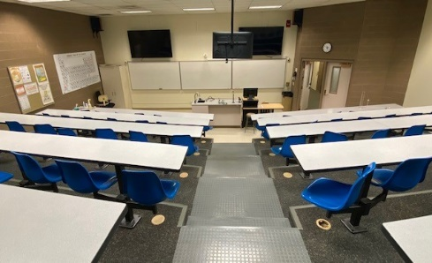 | Eller-Fox (EFS) Lecture Hall  EFS3015  Suited for presentations, lectures and speakers. Equipped with a computer console and projector.  Capacity: 70  Flat Rate:  ≤ 4Hours (1 hr. min.): $75.00  >4 Hours: $125.00 | 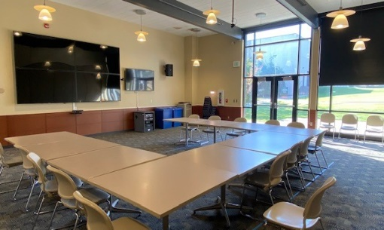 | Cafeteria Conference Room  Van Tassell Center (VTC) 5015A  Multi-purpose room located within the cafeteria. Equipped with floor-to-ceiling windows that offer natural light. Perfect for small gatherings or banquets.  Capacity: 32  Flat Rate:  ≤ 4Hours (1 hr. min.): $75.00  >4 Hours: $125.00

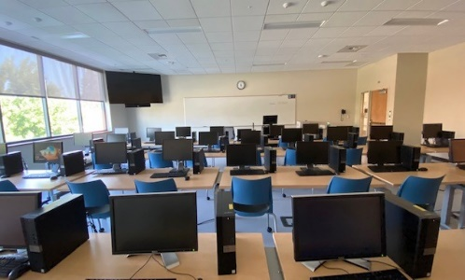 | Computer Labs  WVC computer labs are ideal for software trainings, workshops, testing and a variety of tutorials. They include Internet access and an instructor station.  Capacity: 30  Flat Rate:  ≤ 4Hours (1 hr. min.): $40.00  >4 Hours: $75.00 | 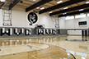 | Smith Gymnasium  GYM4007  Our gymnasium is available for events, tournaments, and practices. For more information and fees, please contact Athletics at 509-682-6771.  Capacity: 800  Flat Rate:  ≤ 4Hours (1 hr. min.): $125.00  >4 Hours: $650.00
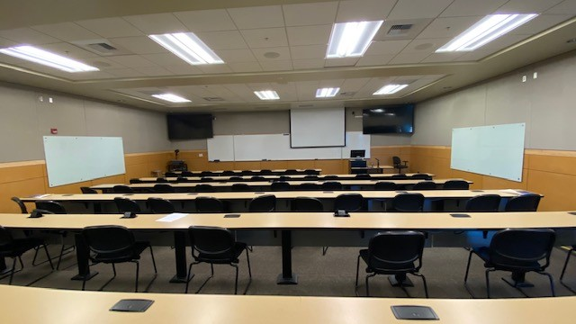 | Wenatchi Hall (WTI) Lecture  WTI 2105 and 2106  Wenatchi Hall lecture halls are equipped with ITV, multiple TVs, document cameras, and multimedia stations and can accommodate various presentations.  Capacity: 80  Flat Rate:  ≤ 4Hours (1 hr. min.): $75.00  >4 Hours: $125.00 | 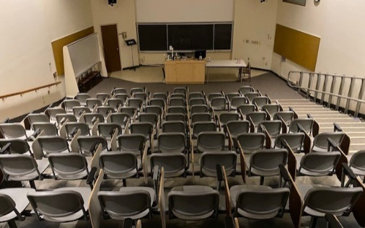 | Brown Library Lyceum  BLM9100  The Lyceum in the Brown Library is suited for presentations, lectures, and seminars. It is equipped with a computer console and projector.  Capacity: 94  Flat Rate:  ≤ 4Hours (1 hr. min.): $75.00  >4 Hours: $125.00
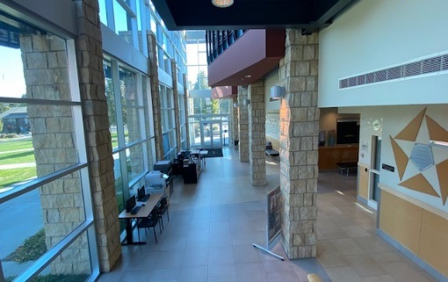 | Wenatchi Hall Atrium  The Wenatchi Hall atrium is a bright, open space lit by three floors of floor-to-ceiling windows. This flexible lobby is well suited for registrations, networking, or vendor tabling needs.  Capacity: 200  Flat Rate:  ≤ 4Hours (1 hr. min.): $50.00  >4 Hours: $50.00 | 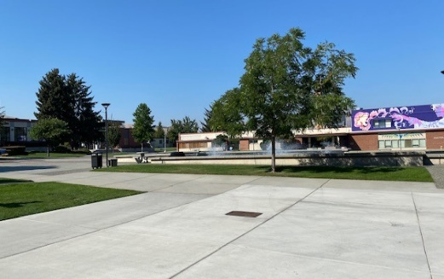 | Fountain Area  The fountain area is suitable for fun fundraisers, open-air banquets, or vendor fairs.  Capacity: 500  Flat Rate:  ≤ 4Hours (1 hr. min.): $75.00  >4 Hours: $125.00
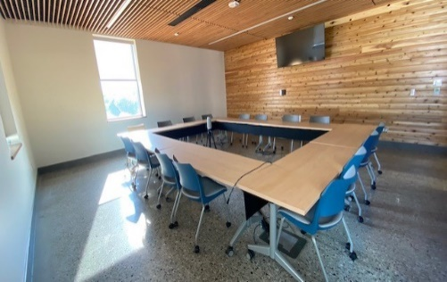 | General Conference Rooms  Conference rooms offer an intimate gathering space in a traditional boardroom setup. These rooms accommodate ITV, multimedia, and various presentations and meetings.  Capacity: 20  Flat Rate:  ≤ 4Hours (1 hr. min.): $75.00  >4 Hours: $125.00 | 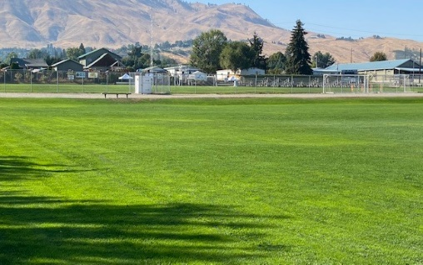 | Athletic Fields  Our soccer fields, softball field, and baseball stadium are available for events, tournaments, and practices. For more information and fees, please contact Athletics at 509-682-6771.  Capacity: 500  Flat Rate:  ≤ 4Hours (1 hr. min.): $75.00 - $125.00  >4 Hours: $150.00 - $350.00
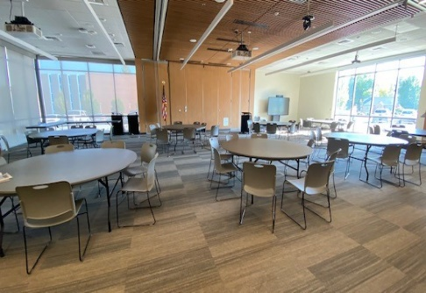 | Mish ee twie (MET) Conference Center MET1103  The Conference Center’s open floor plan is capable of hosting multiple set-ups, including classroom, banquet, and hollow square. The full projection and sound system make it ideal for lectures or large meetings.  Capacity: 200  Hourly Rate:  ≤ 4Hours (1 hr. min.): $138.00  >4 Hours: $124.00 | 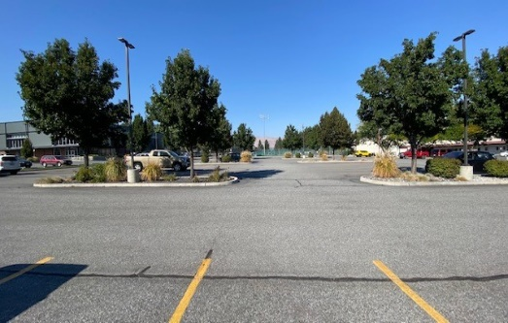 | Parking Lots  Seven main campus parking lots are conveniently located near campus. Perfect for community drives and outside events.  Capacity: 500  Flat Rate:  ≤ 4Hours (1 hr. min.): $75.00  >4 Hours: $125.00
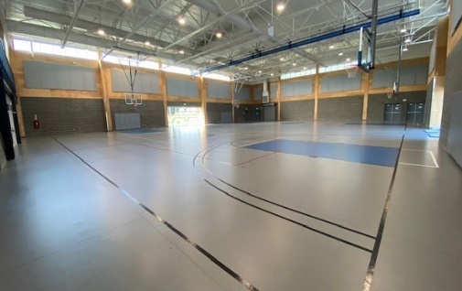 | Student Rec Center (SRC) 4514A and B  The main floor is home to a double court gymnasium, a multi-use studio for yoga, dance, and other group activities. The second floor mezzanine contains state-of-the-art cardiovascular equipment, free weights, and other free movement training. For more information, visit the SRC website. | 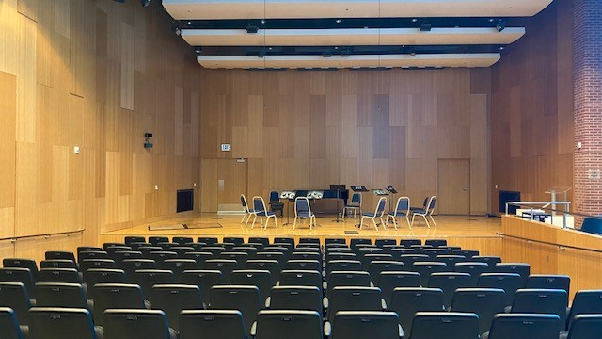 | Music and Art Center (MAC) Grove Recital Hall  MAC1575  The Grove Recital Hall is the crown jewel of the MAC. The space boasts pristine acoustics, a fully equipped soundboard, stage lighting, and a Steinway. Theater style seating with lecture set up.  Capacity: 160  Flat Rate:  ≤ 4Hours (1 hr. min.): $150.00  >4 Hours: $275.00
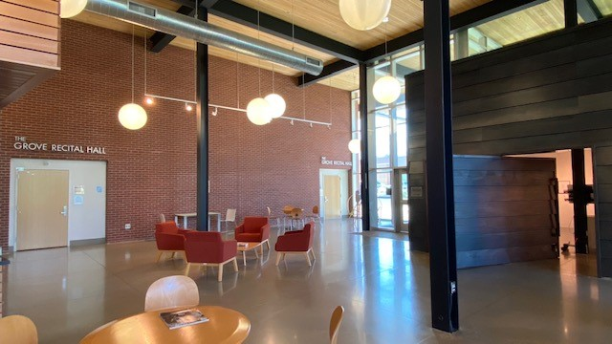 | Music and Art Center Grove Lobby MAC1501  The Grove Lobby is the entryway to both The Grove Recital Hall and The MAC Gallery. This spacious, creative space is available for receptions, ticketing, and tabling.  Capacity: 160  Flat Rate:  ≤ 4Hours (1 hr. min.): $75.00  >4 Hours: $75.00 | 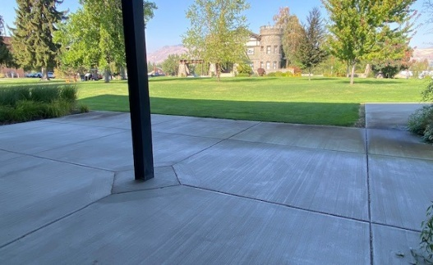 | MAC Patio  The MAC Patio and surrounding lawns provide a welcome space to host an outdoor gathering. Located on the north side of the building, directly across from the historic Wells House. The patio is home to rotating student art displays and provides a shaded area for BBQs, picnics, and any number of outdoor gatherings.  Capacity: 100  Flat Rate:  ≤ 4Hours (1 hr. min.): $50.00  >4 Hours: $50.00
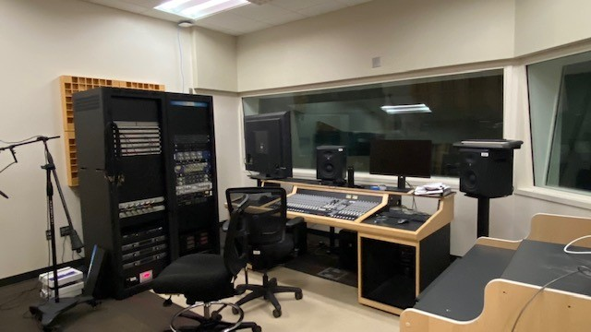 | MAC Sorom Recording Studio  MAC1564  A state-of-the-art recording studio with a full range of acoustics, recording equipment, multiple instruments, and an isolation booth. The amenities in the studio are variable and can be changed to suit recording/artist needs.  Capacity: 6  Flat Rate:  (1 hr. min.): $300.00 | 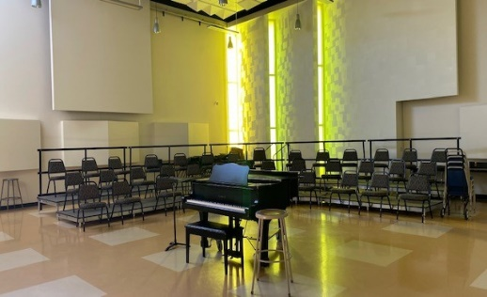 | MAC Sparks Rehearsal Studio  MAC1569  The Sparks Rehearsal Space houses the WVC choirs and ensembles. The vast open space has beautiful natural lighting, vaulted ceilings, three-tier platforms for large group rehearsal/seating, a grand piano, adjustable acoustics, and moveable surfaces for teaching and presenting.  Capacity: 80  Flat Rate:  ≤ 4Hours (1 hr. min.): $100.00  >4 Hours: $150.00

