Absence Request – Cancel & Re-Submit The QRG is Great

Purpose: Use this document as a reference to Cancel Absence Request and Resubmitting Absence Request for the same day.

Cancel Absence Request
Navigation: Employee Self Service (Homepage) > Time (Tile) > Cancel Absence (Tile)

- On the Employee Self Service page, select the Time tile.

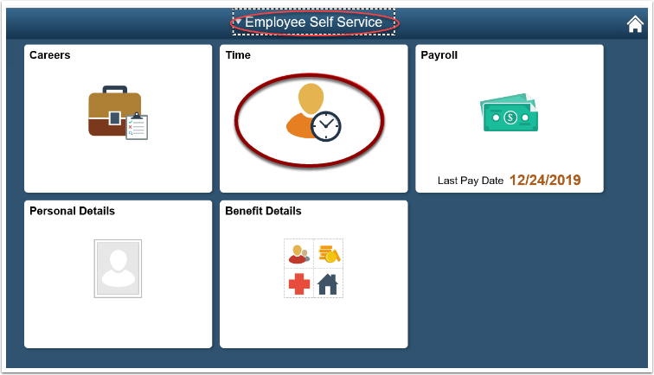

- On the Time page, select the Cancel Absence tile.

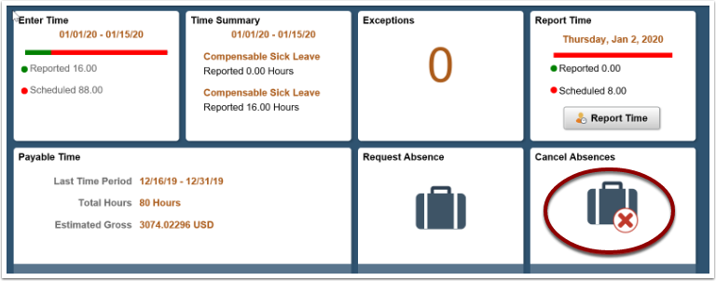

- On the Cancel Absence page, select the arrow on the right side of the date of request you choose to cancel.
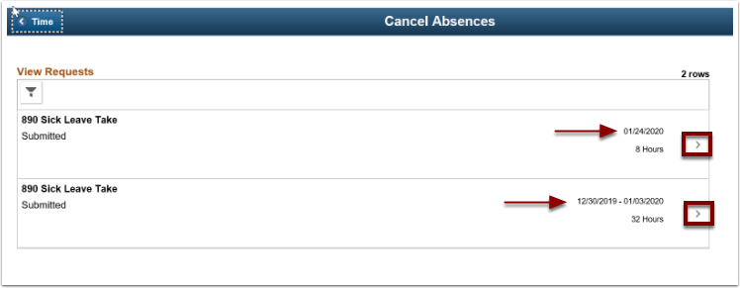

- The Request Details page will display. On this page, select the Cancel Absence button and when you see a message, select the Yes button.
- Next, select the Return to Cancel Absences link in the upper left-hand corner.
- The process to cancel an absence request is now complete.

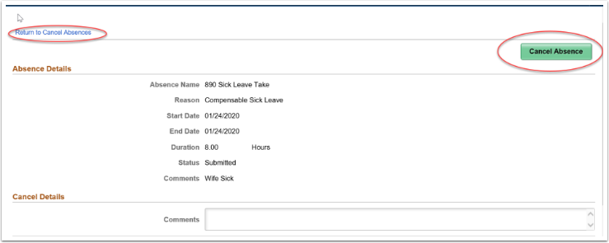

Re-Submitting an Absence Request for the Same Day

- Navigate back to the Time page. From the page, select the View Requests tile.

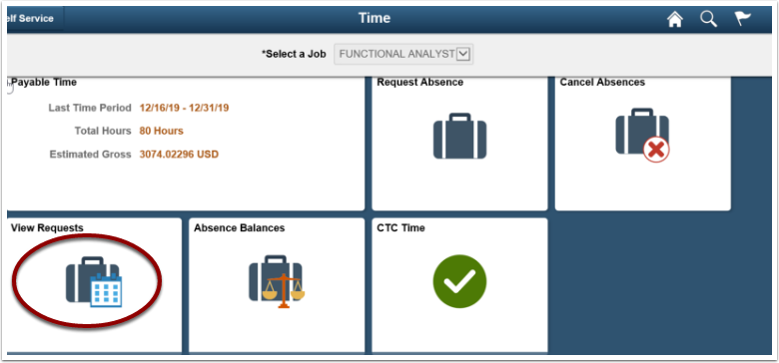

- On the View Requests page, select Canceled Absence Request that you wish to re-submit (for the same day).

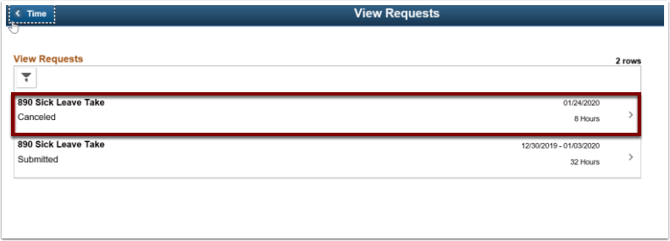

- The Request Details will show a status of Canceled.

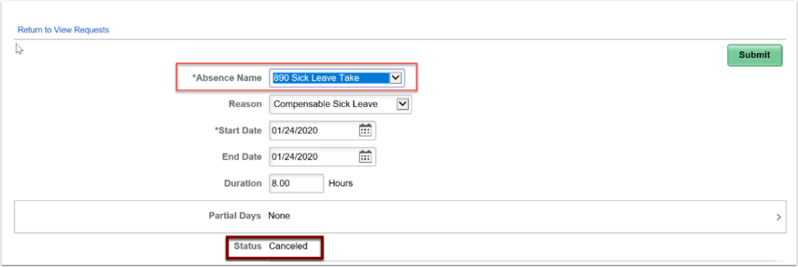

- Make changes to the request then select the Submit button. The status will change from Canceled to Submitted.
- The process to re-submit a canceled absence request (for the same day) is now complete.

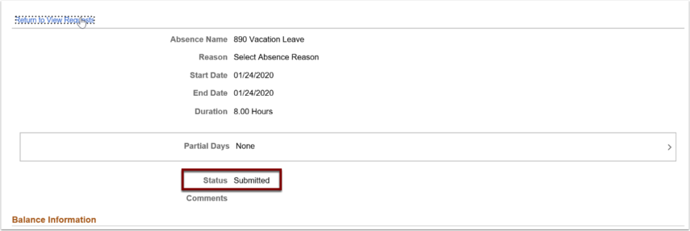

That’s it!

