**[Running Absence Balance Report for all Leave Types](https://ctclinkreferencecenter.ctclink.us/m/79716/l/1751200-run-absence-balance-report)- QRG is great.**

Nav>Global Payroll & Absence Mgmt>CTC Custom>CTC Reports>Absence Balance Reports

This report shows all leave balances, takes, accruals, adjustments and ending balances by a variety of criteria you choose (monthly, multiple months, etc.)

If this is the first time running this report, click on Add a New Value; if not, click on Search

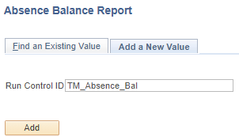

Lots of options here but if you just want one month for all employees, here is what to put. Must be a previous month that has leave entitlements and takes completed.

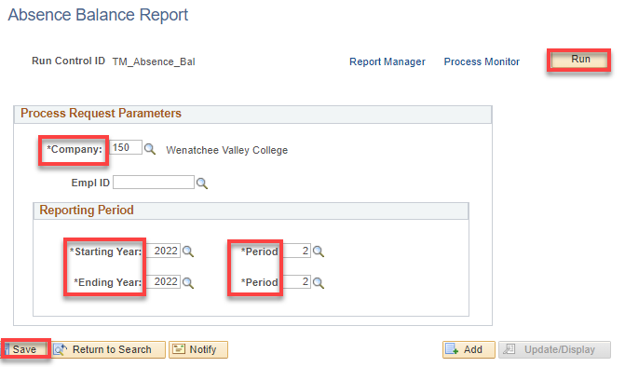

Click OK.

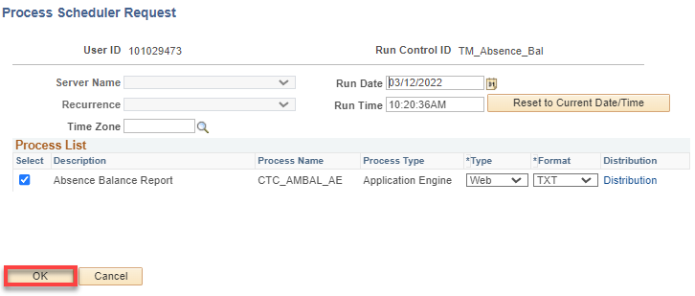

Save, Run, go to Process Monitor

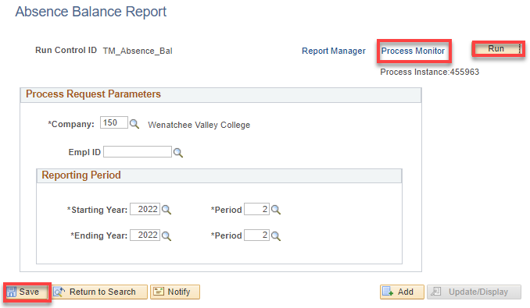

Refresh as necessary until Success and Posted. Click to Report Manager.

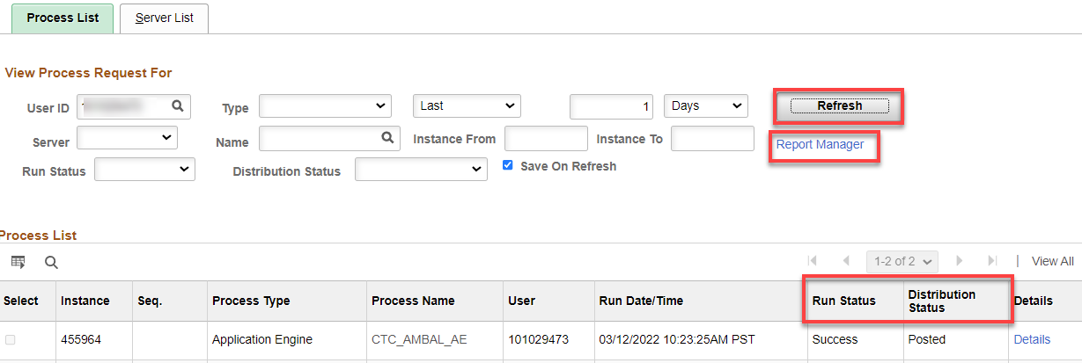

Click on the .xlsx file.

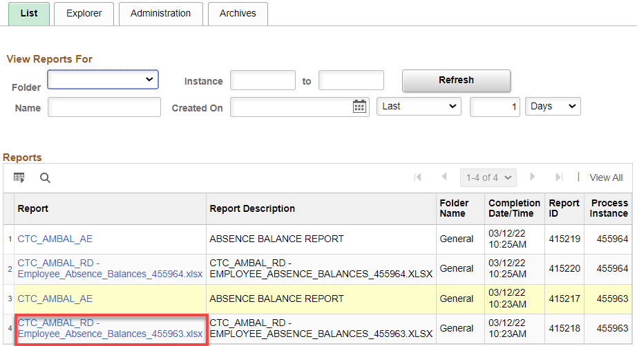

Click on the .xlsx file

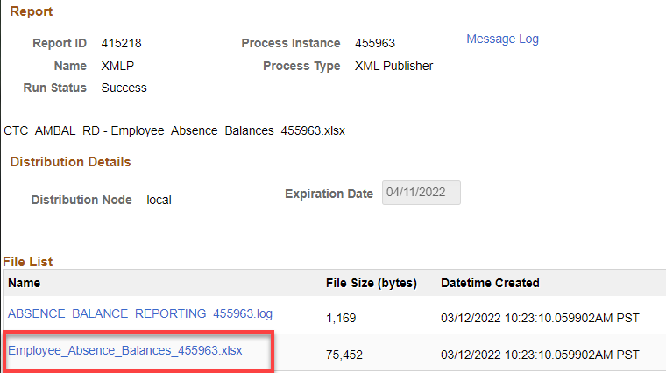

This is what the report shows for the employee(s), month(s).

**Leave Code Definitions**

That’s it! 😊