Entering & Processing Shared Leave

The Shared Leave page allows users to make a record of the leave donation; it does not actually perform the process. In order to adjust leave for employees related to shared leave, follow the instructions on the 9.2 Correcting or Reversing Leave Balances/Running the Absence Management Off Cycle on Demand Process QRG.

Step 1 – Entering Shared Leave

Nav>Global Payroll Absence Management>CTC Custom>Shared Leave

Add a New Value – I use the last name of the person needing leave

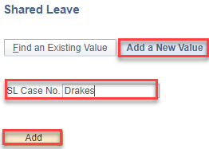

Add recipient ID, Donor ID, Element Name, correct Empl Record, Donated Hours and check Approved, Denied or Adjusted, Save.

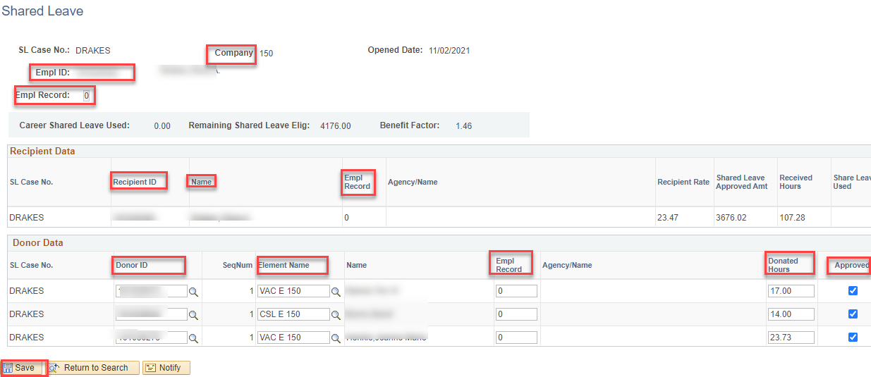

Enter more donors by adding + a row.

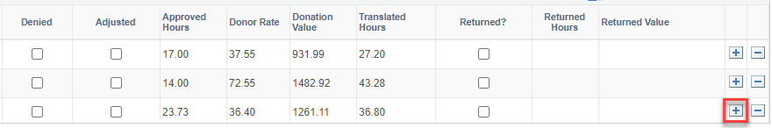

Step 2 – Entering Absence Balance Adjustment for Donor & Recipient

Nav>Global Payroll Absence Management>Payee Data>Adjust Balances Absence

Donor(s): enter Empl ID, Search and select the Last Finalized Entitlement Calendar (e.g., for 12A and 12B payroll, choose Nov. ENT (ENT2021M11 in this case).

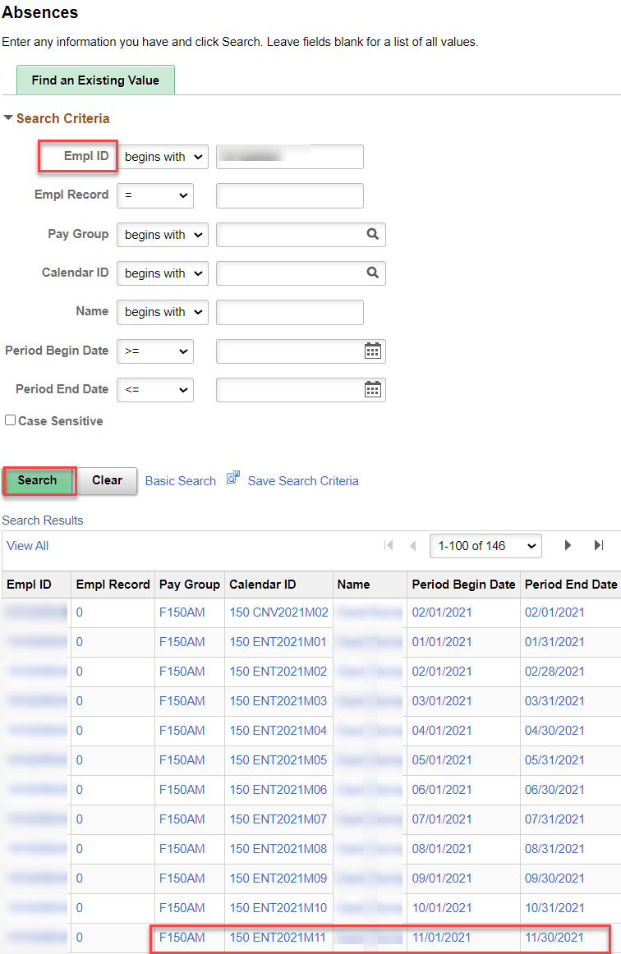

Enter the Element Name and Balance Adjustment (negative in this case), Comment (optional), Save.

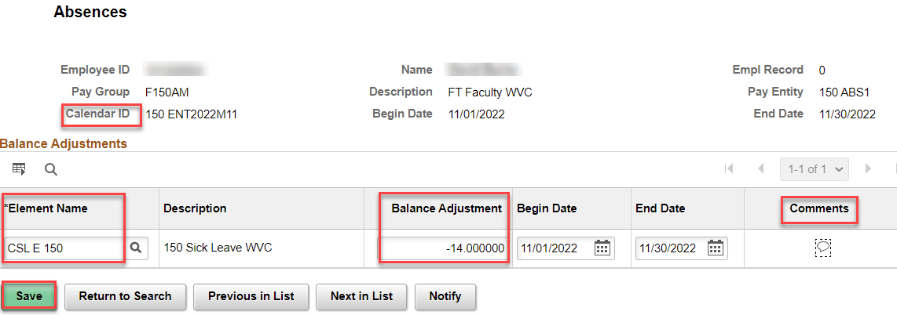

Recipient: Enter the Element Name (SBCTC SLV), Balance Adjustment (positive in this case), Save.

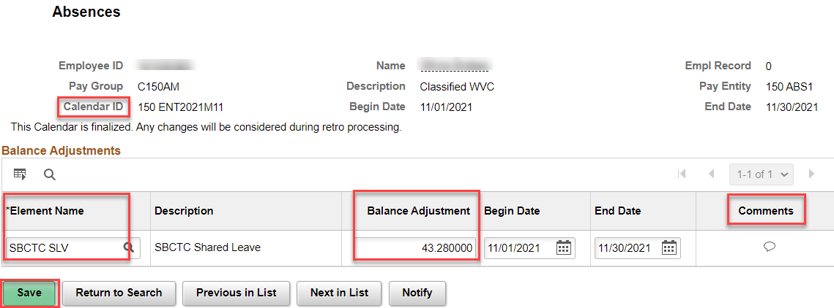

Step 3 – Running Off Cycle Process Adjustments

If you can’t let the adjustments run during the regular Entitlement run, then run an Off Cycle On Demand Process. See Absence-Run Off-Cycle On Demand Process documentation.

BEFORE PAYROLL RUNS EACH PAY PERIOD, GO INTO EACH ABSENCE EVENT AND CHANGE THE CSL (or VAC) TO “SHARED LEAVE TAKE.” A Time & Labor administrator will need do this action; it is not available to the employee.

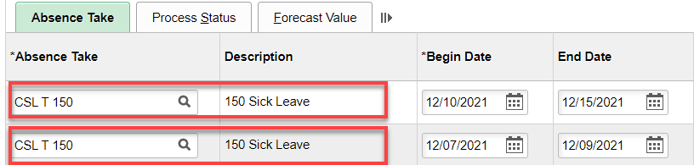

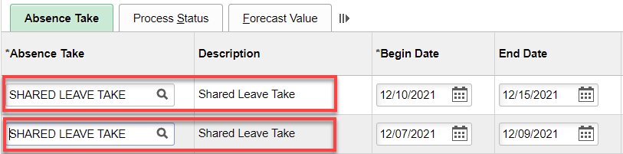

Save.

This will send what is needed to payroll.

That’s it!

Returning Shared Leave

I hope I did this right…No QRG.

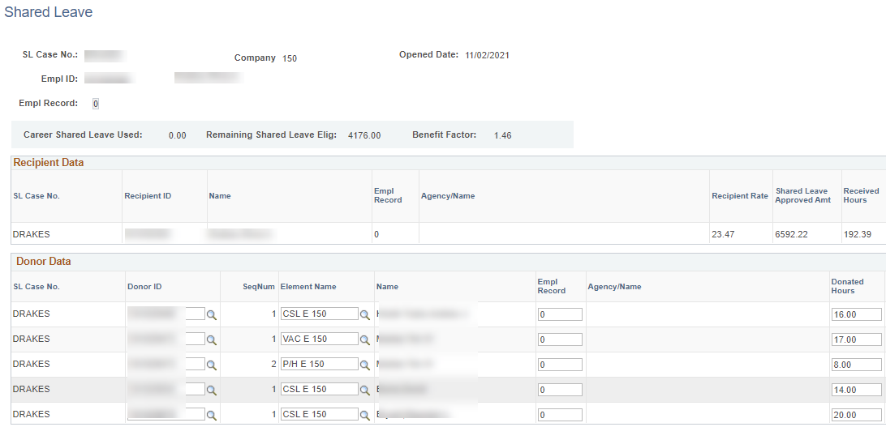

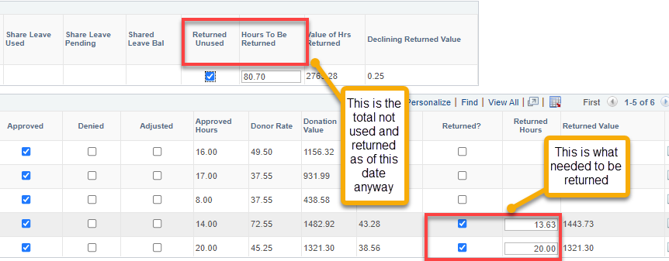

The next step is to adjust the leave balances like in Step 2 above.

Entering Absence Balance Adjustment for Donor & Recipient

Nav>Global Payroll Absence Management>Payee Data>Adjust Balances Absence

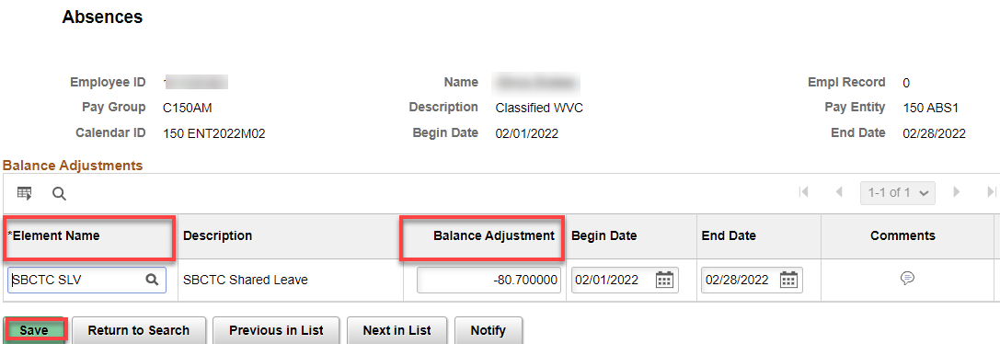

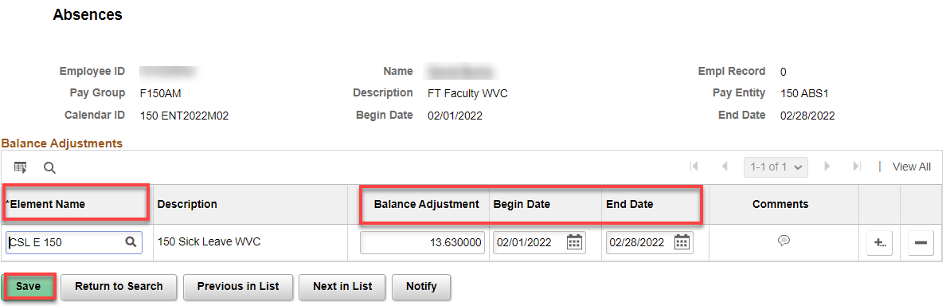

That’s it!

