Absence-Transfer Balances from one Empl Record to Another

Check Balances and Empl Records(subtract any that haven’t been finalized).

Nav>Workforce Administrator>Absence Administration Tile>Review Absence Events and then Absence

Add Search Criteria, Search

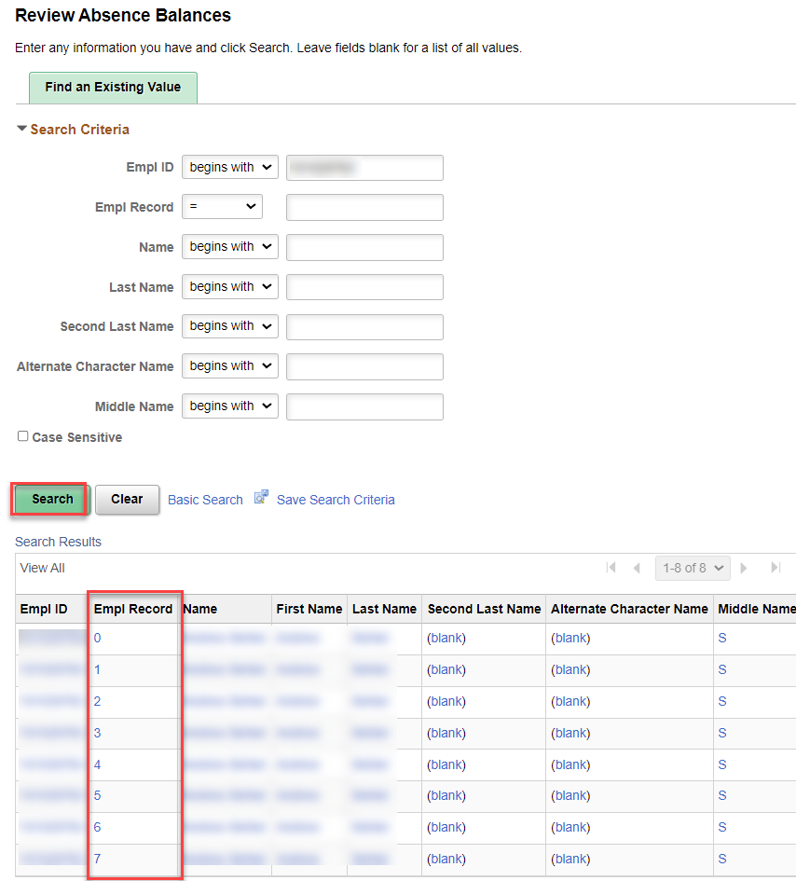

Click on the first Empl Record and then Next in List until you find all Empl Records with Absence Balances. Note Empl Records and balances to adjust.
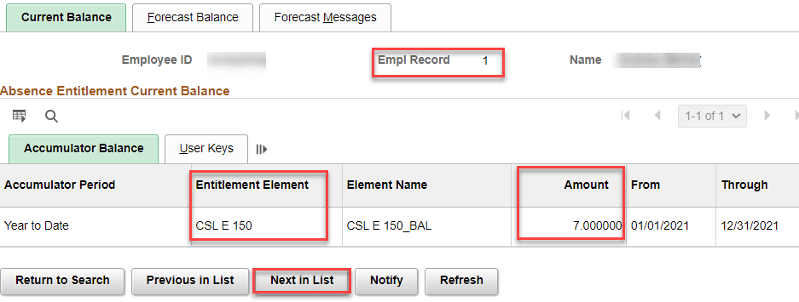

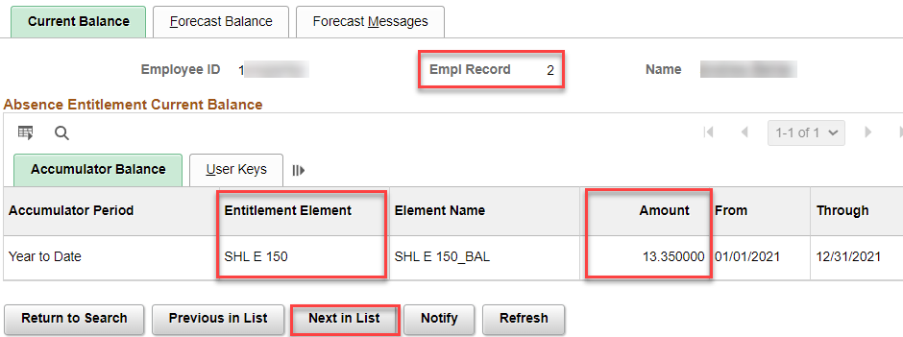

Adjust Balances

Nav>Global Payroll & Absence MGMT

I know that I want to move 7.00 hours of CSL from Empl Record 1 and 13.35 hours of SHL from Empl Record 2 to Empl Record 7. Use the ENT Calendar that will run next (in this case, the December Entitlement run (ENT2021M12).

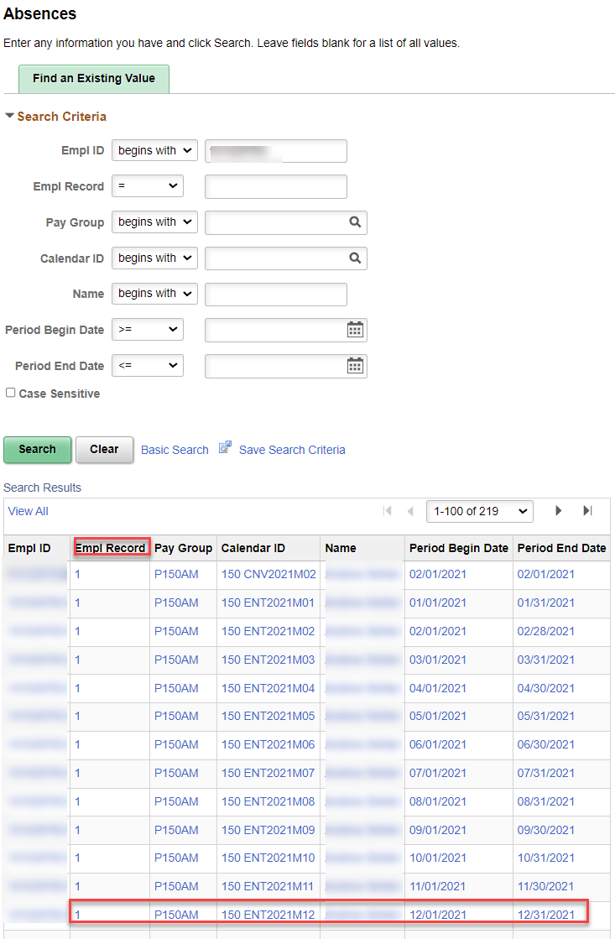

OR, to save seeing a lot of records, I put the Calendar ID I want.

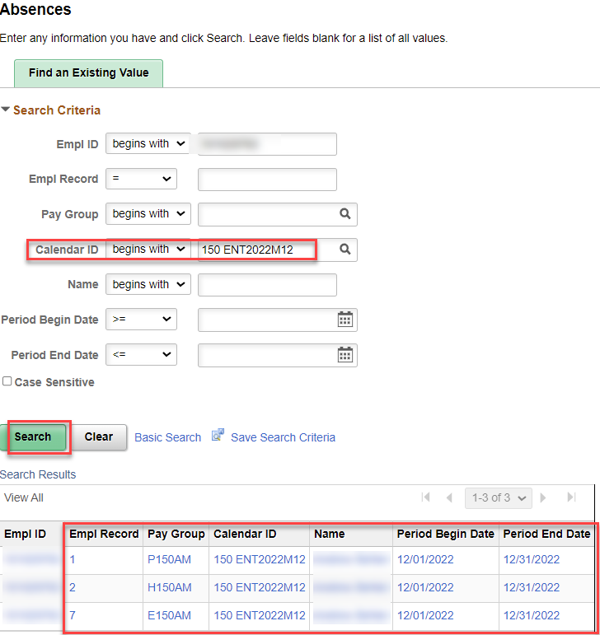

Click on ENT2021M12 for the Empl Record you want and add the (minus) adjustment, add comment, if applicable, Save. Click Return to Search to make other adjustments.

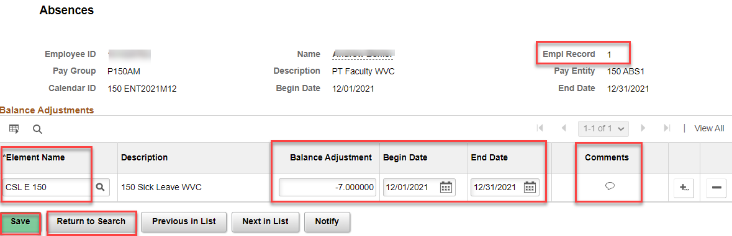

Find the next Empl Record for adjustment. Click on ENT2021M12 and add the (minus) adjustment, add comment, if applicable, Save. Click Return to Search to make other adjustments.

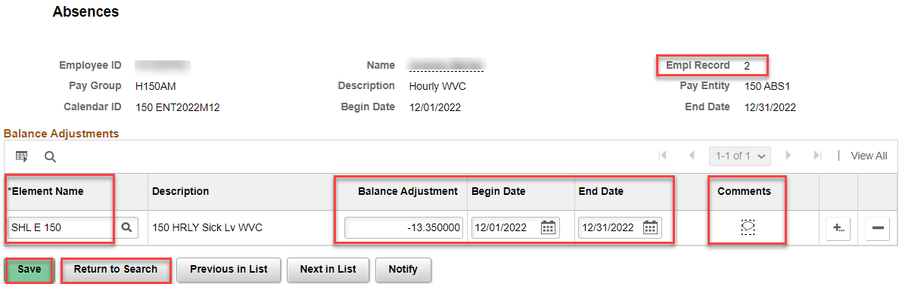

Now, apply the positive balances to the Empl Record you want.

Add + as many rows as needed, enter Element Name, Balance Adjustment(s), Begin and End Dates, Comment if you choose, Save.

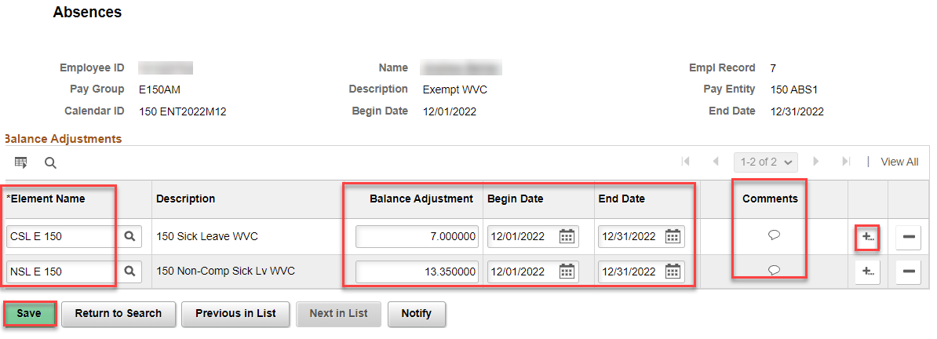

During the absence recalculation process, the system will reduce the balance in Empl Record 1 and 2 and add the balance to Empl Record 7. You can let it process normally or run an Off Cycle on Demand process.

That’s it!

