Add A New Employee Instance

Nav>Workforce Administration>Job Information>Add Employment Instance

Temp FT Faculty

Work Location tab: Add effective Date (if even pay periods, put the beginning of the pay period), Reason, Company, Position Number, Department, Department Entry Date (first day of the quarter).

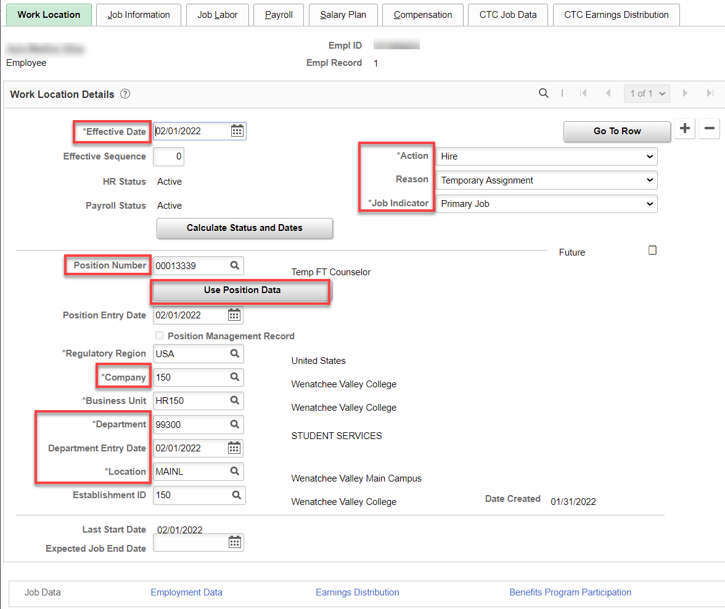

Job Information tab: Add Job Code, Supervisor ID, Temporary, Full-Time, Empl Class (Faculty), Work Period (D175 for FT) correct FTE back to 1.00, if necessary.

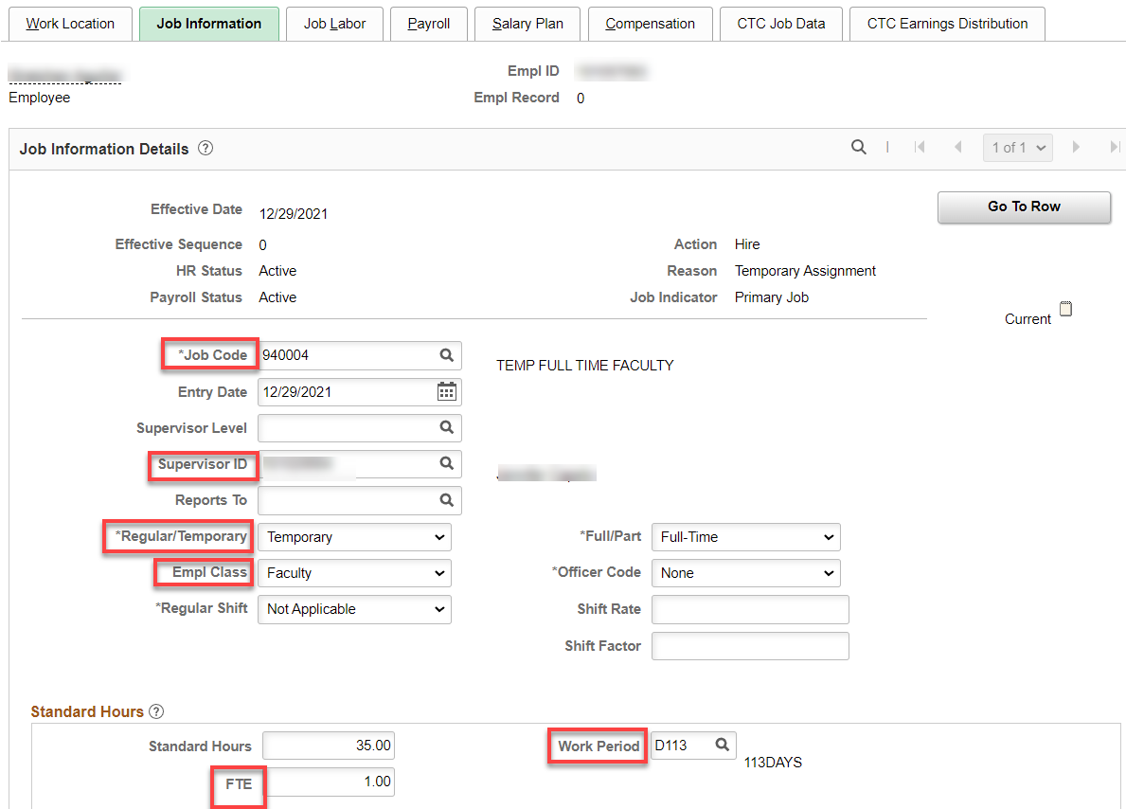

Job Labor tab: Union code auto fills

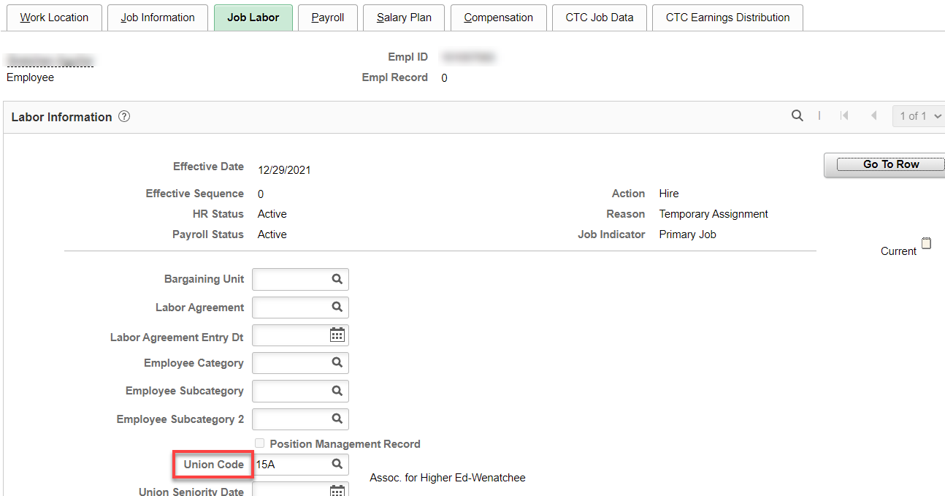
Payroll tab: set Absence System to Absence Management and add Pay Group (F15)

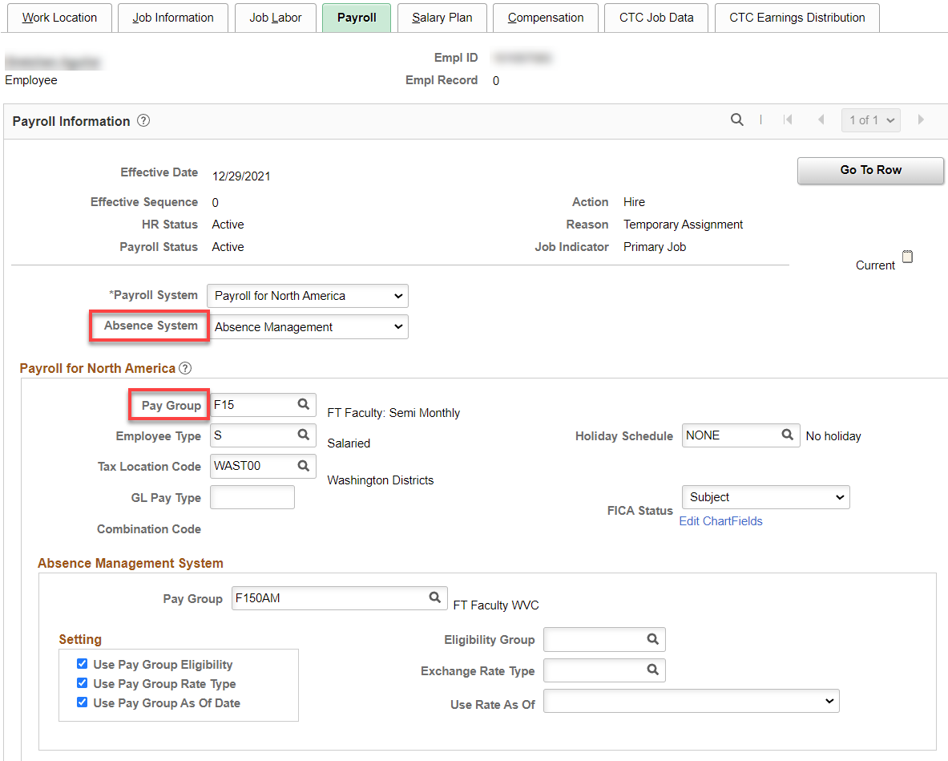

Salary Plan tab: Nothing to fill in.

Compensation tab: Add Rate Code (NAANNL), Comp Rate (annual salary if FT academic year), leave the Frequency at S if there is a Balloon Payment ID, (C20 if no Balloon) and hit Calculate Compensation.

If less than full time, enter prorated salary and change the Frequency from “S” to the number of payments left in the academic year.

Example of prorated salary: $63,342/175= $361.95 x 91.33 days left in academic year = $33,056.89, with the number of payment of 10 or (C10), hit Calculate Compensation.

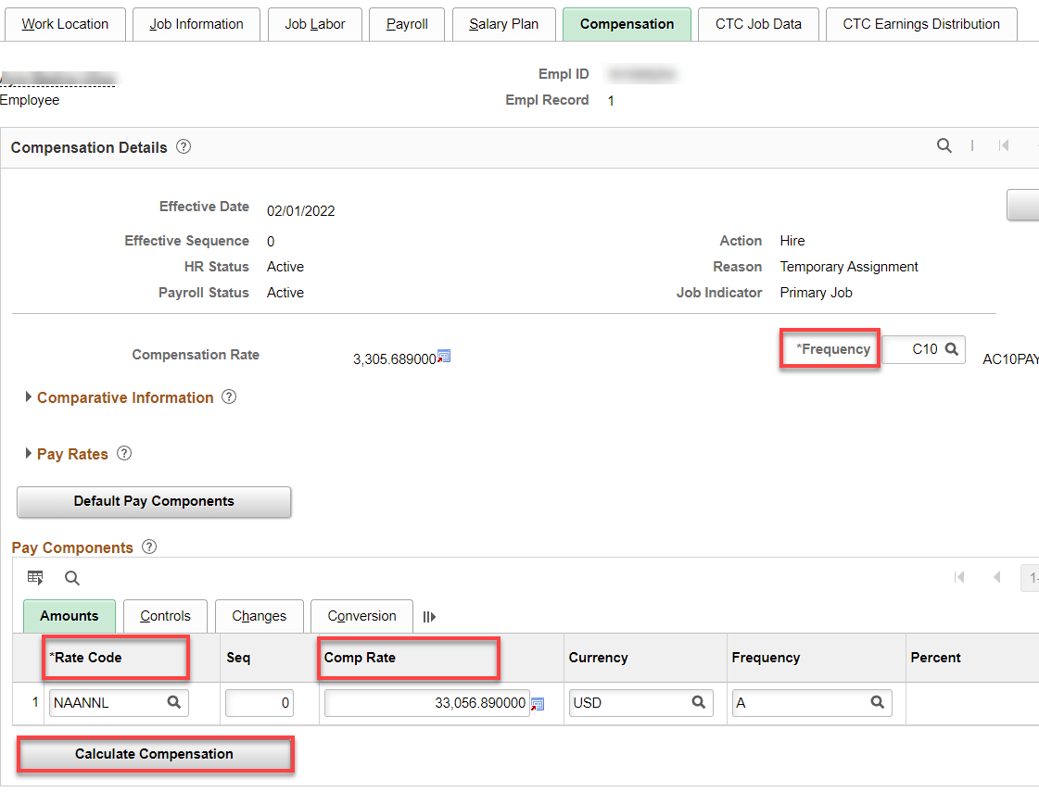

CTC Job Data tab: Add Leave Accrual Date, Job Term, Job Employment Type, Contract Units, DRS Calendar, Contract Begin and End Dates, Balloon Payment ID (B6), if applicable.

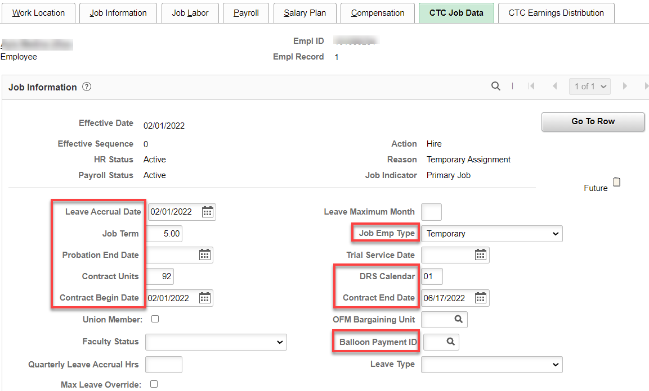

CTC Earnings Distribution tab: Add Earnings Code (FTF), Percent(s) of Distribution, set all to Primary, click on Edit Chart Fields and enter Combo Code(s).

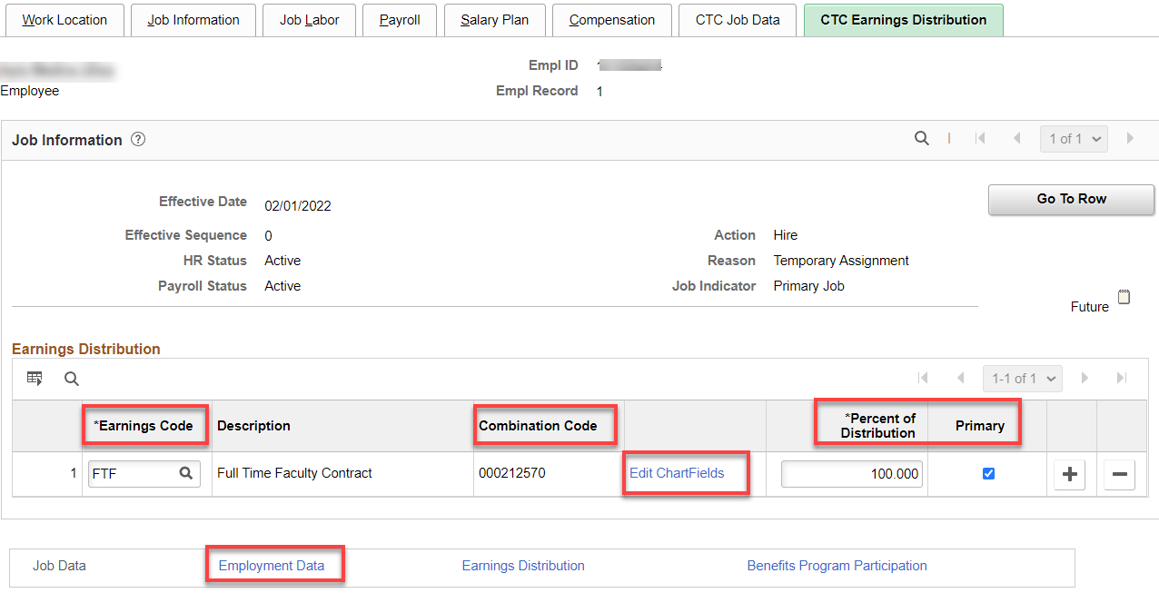

Click on Employment Data link.

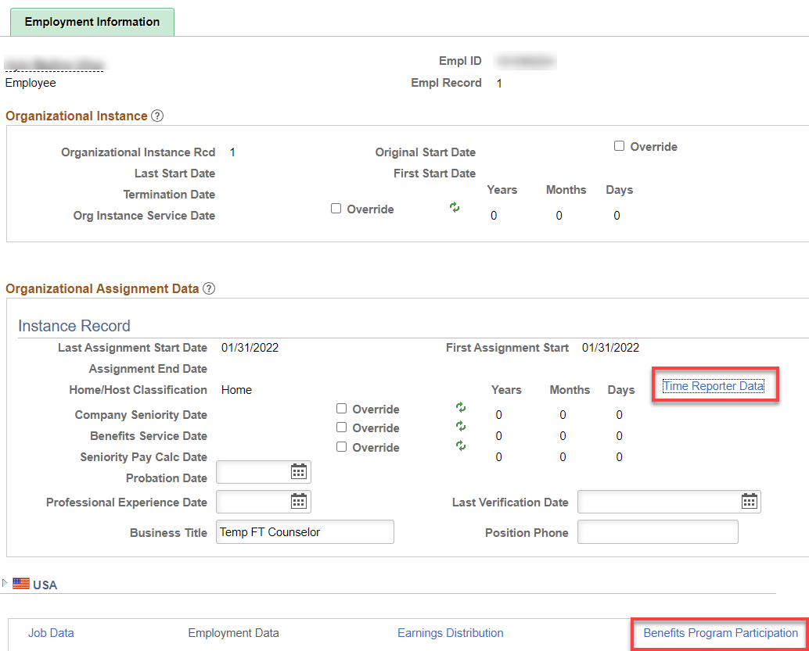

Click on Time Reporter Data, Effective Date should already be the beginning of the pay period, Time Reporter Type should already be Elapsed Time Reporter, add Elapsed Time Template. Workgroup & Taskgroup, click OK.

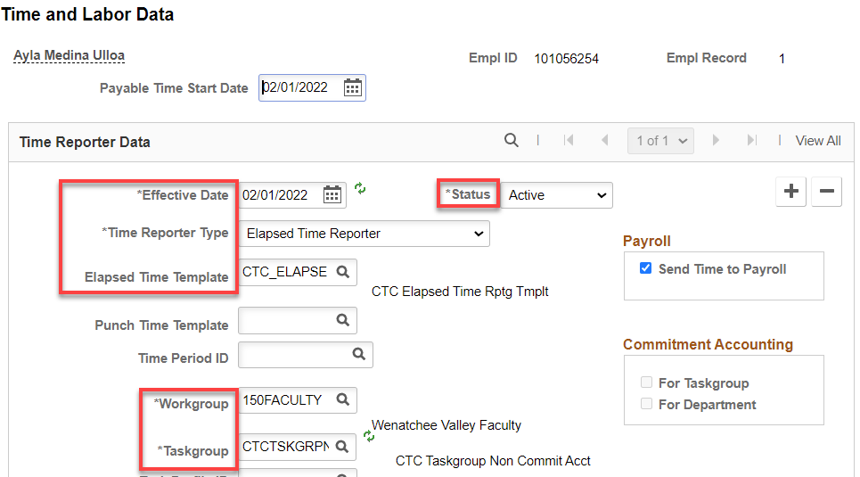

Click on Benefit Program Participation Link. Add Benefit Record Number, if benefits don’t start until a later date, add + a row on Benefit Program Participation Details, add effective date, Save/OK.

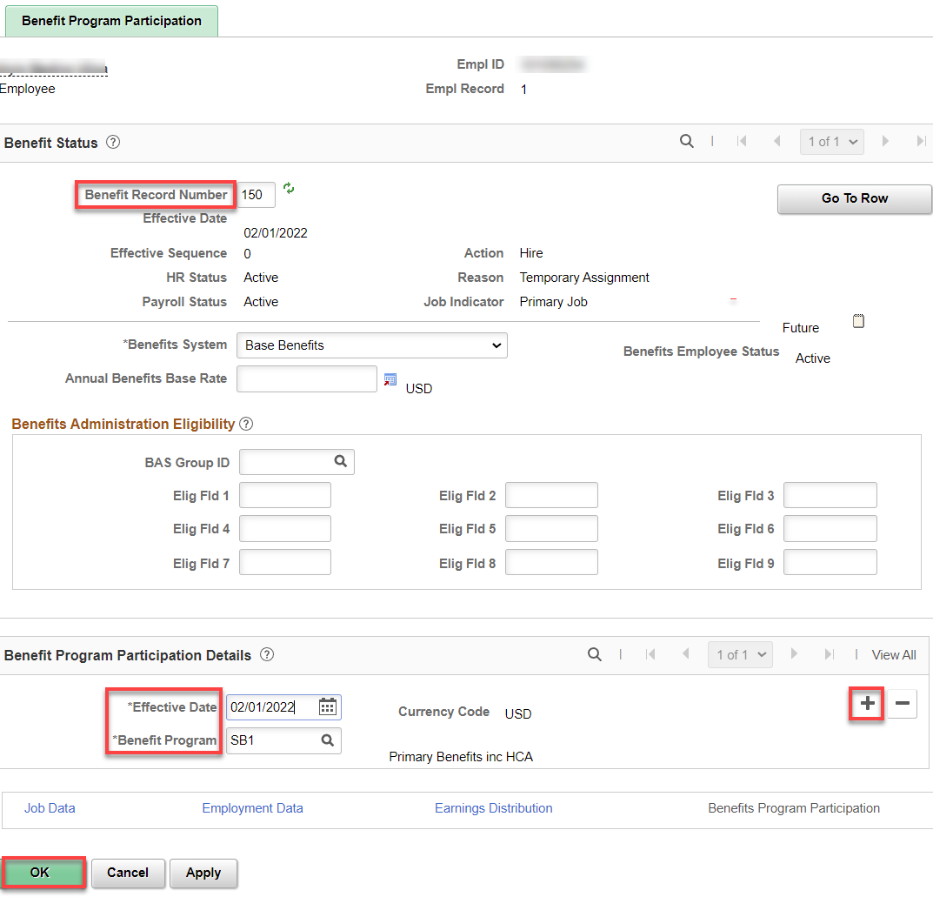

Assign ACA Status – Nav>Benefits>CTC Custom>Assign ACA Status

If they work more than 130 hours, use the 1st of the current month, otherwise, use the 1st of the next month.

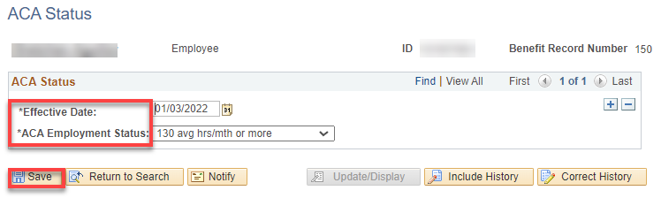

That’s it!

