DRS Calendars – The QRG is GREAT! – Adding New or Changing existing Calendars

Nav>Set Up HCM>CTC Custom>DRS Calendars

Adding a New Value

Add a New Value tab: add Company and Calendar ID (choose what you want two digits). I used 01 for FT faculty and 03 for PTF.

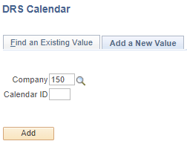

Adding a new year or Editing DRS Calendars

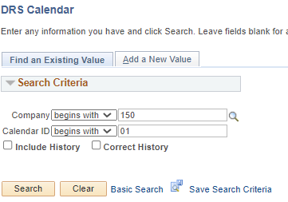

Full Time Faculty

Add + a row for a new year, count all working days in the academic year (and summer), for FT faculty, that means each day they are paid, advising, dean days, etc., not just teaching days. Correct History can be used to edit.

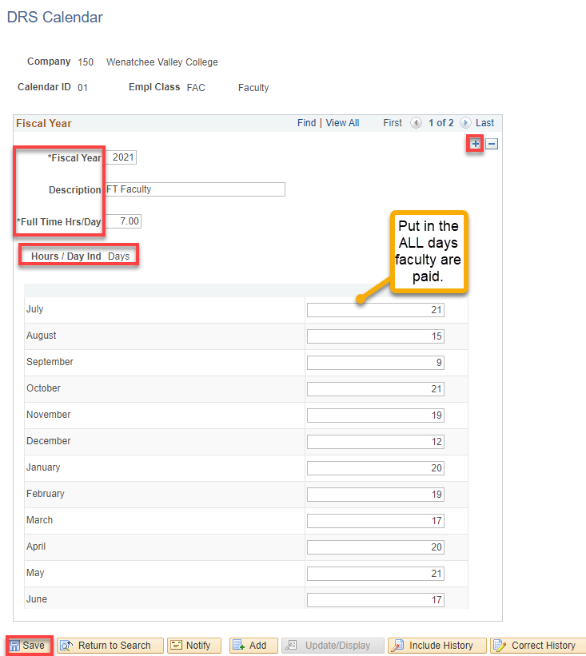

Part Time Faculty

For PT faculty, count all teaching days, including final exams. For June (or other months), where there is oftentimes spring quarter and summer quarter in the same month, I was told by a functional analyst that spoke with DRS that all days in June, no matter what quarter, needs to be counted for the month.

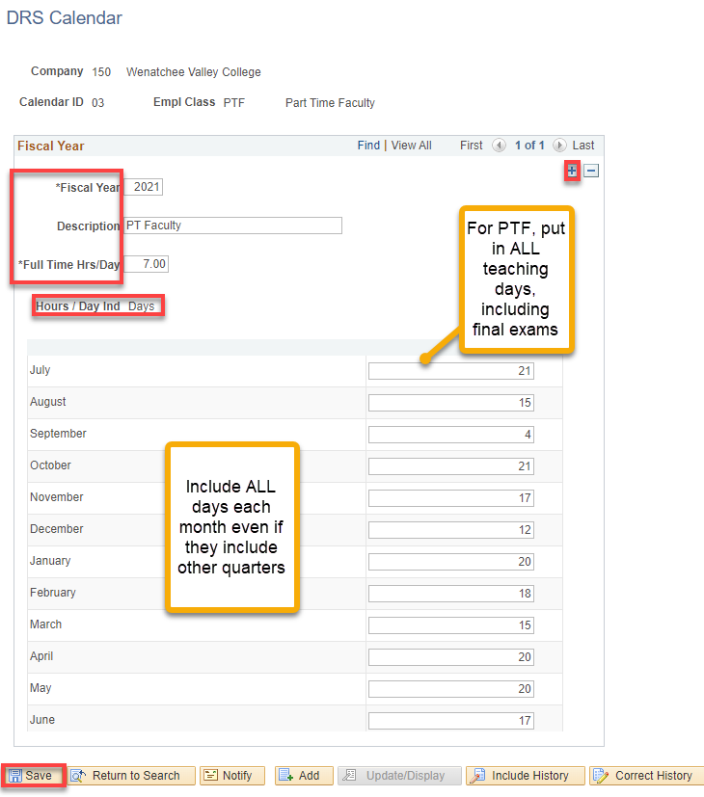

That’s it!

