Covid-19 Employee Vaccination Attestation & Immunization Update

Employee

Nav>Employee Self Service>Immunization Attestation tile

Employee must add their Vaccination Details before HR can verify.

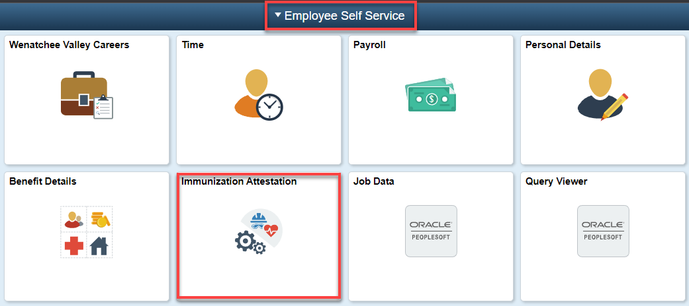

Add the Vaccination details of the 1st dose, add + a row for the 2nd dose, answer the Self Attestation questions, Submit.

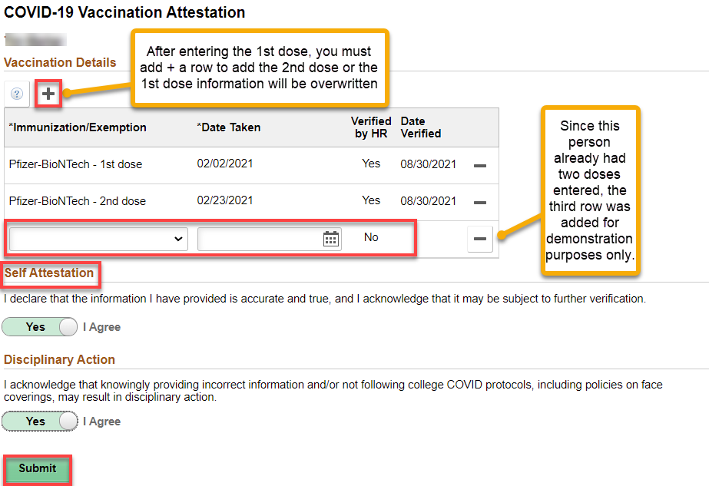
HR Office

Nav>Workforce Administrator>HR Administration tile

After employee has added their Vaccination Details in Employee Self Service, they must contact HR via Zoom or in person so HR personnel can verify the Vaccination Details.

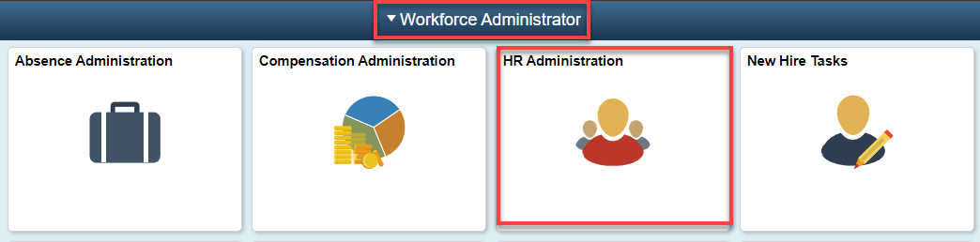

Click on Immunization and Health and Search for the employee

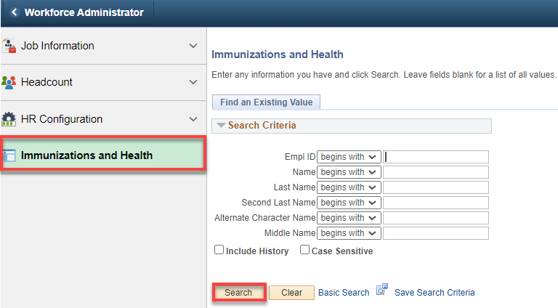

Review the Immunization Card from the employee, update the Immunization Status of each Immunization Number, Save.

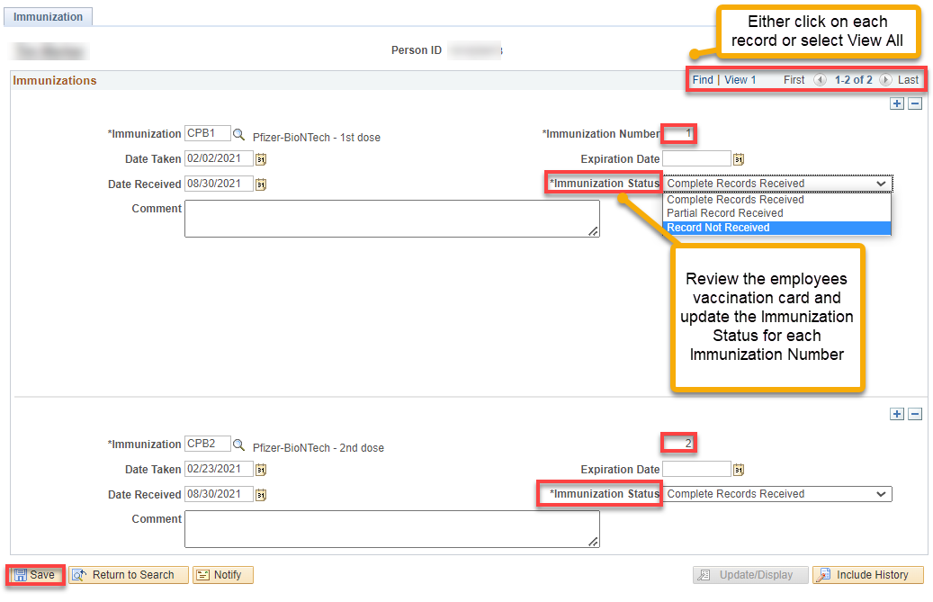

That’s it!

