Changing/Updating a Combo Code

EFFECTIVE DATING IN THE FUTURE DOESN’T WORK FOR MOST THINGS IN ctcLink and combo codes are no different (at least for now) – You must wait until the payroll period you want the combo code changed and then make the change. If you do it ahead of payroll, payroll will use the new combo code .

Job Data>Work Location tab: Add + a row.

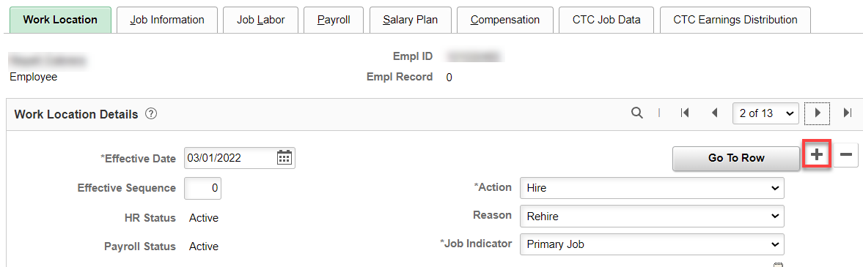

Change the effective date, Action (Earnings Distribution Change), Reason (Combination Code Update).

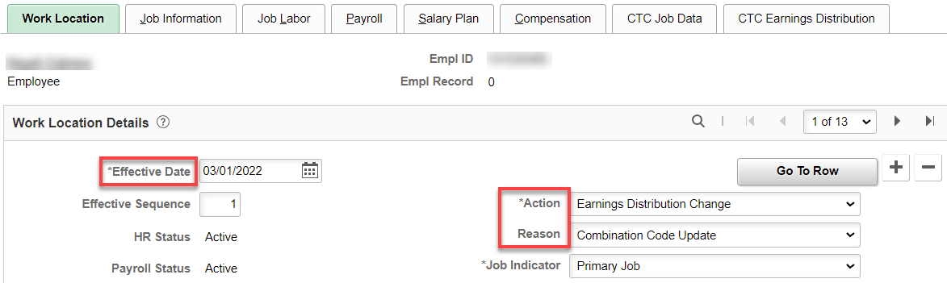

Go to CTC Earnings Distribution tab: Change Percent of Distribution, if applicable, click on Edit ChartFields link. Add + more rows if necessary.

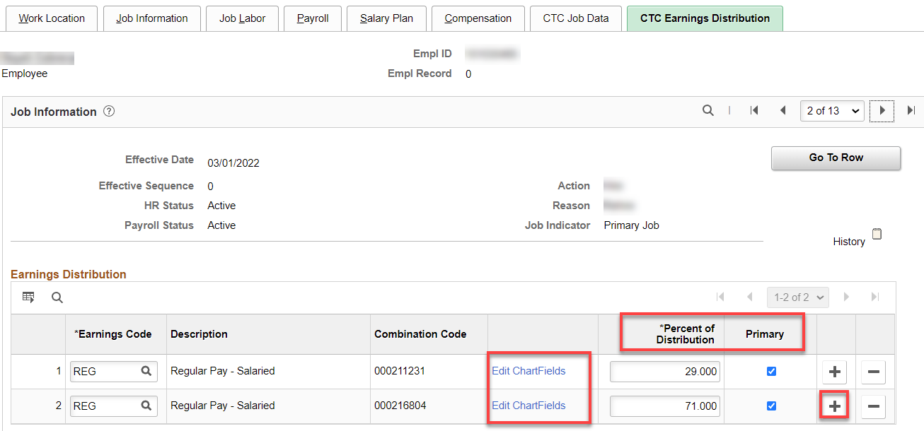
Input the correct or new combo code, select OK. Repeat if more than one new code

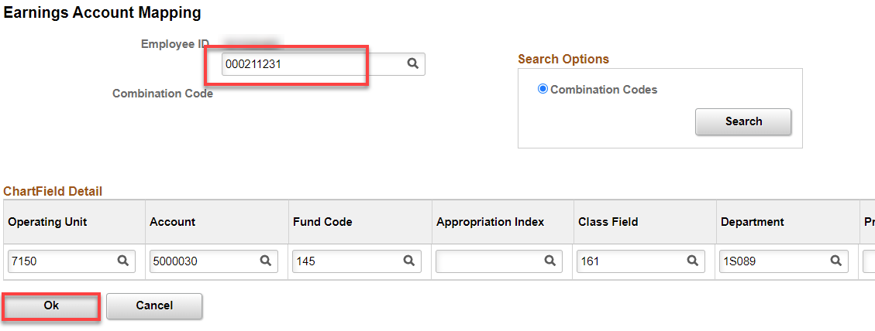

Select Save

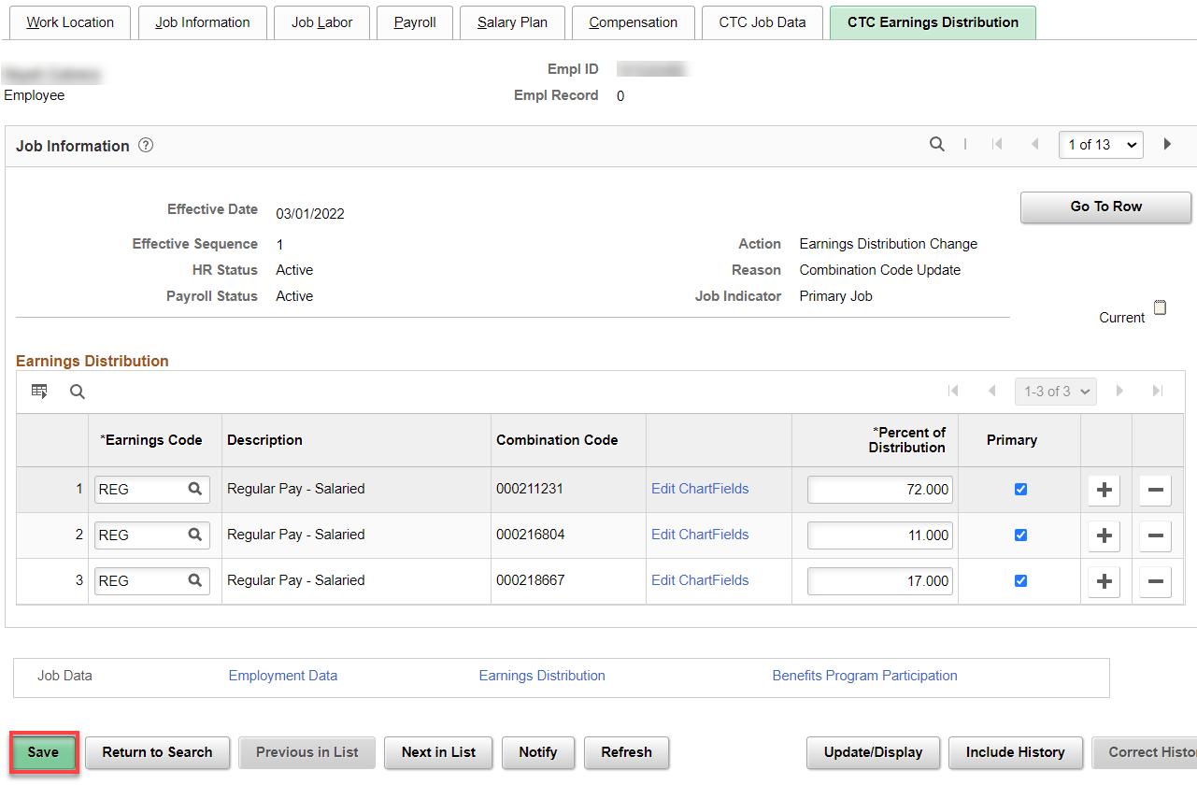

That’s it!

