Compensation for Exempt on Cyclic Contracts

Work Location tab: Add + a row, Effective Date (for the person below, their last contract day was 6/15 so they are currently on a Leave of Absence), Action and Reason.

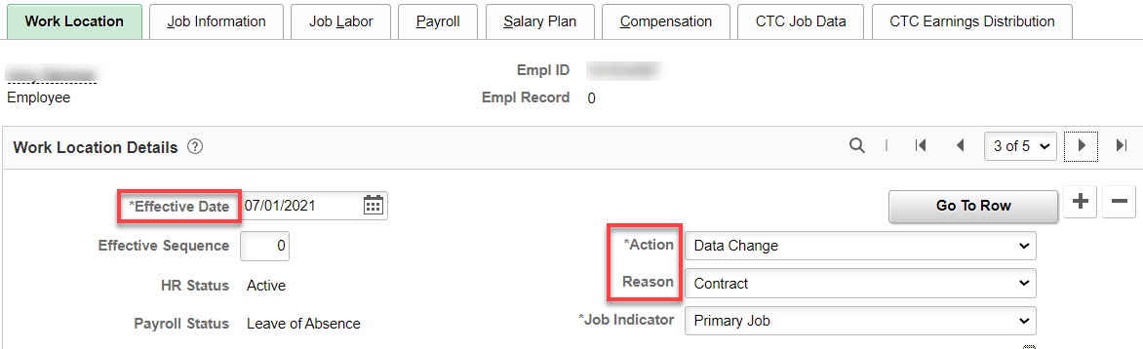

Compensation tab: Figure compensation for the appointment period, Add Comp Rate and Frequency, click Calculate Compensation, Save.

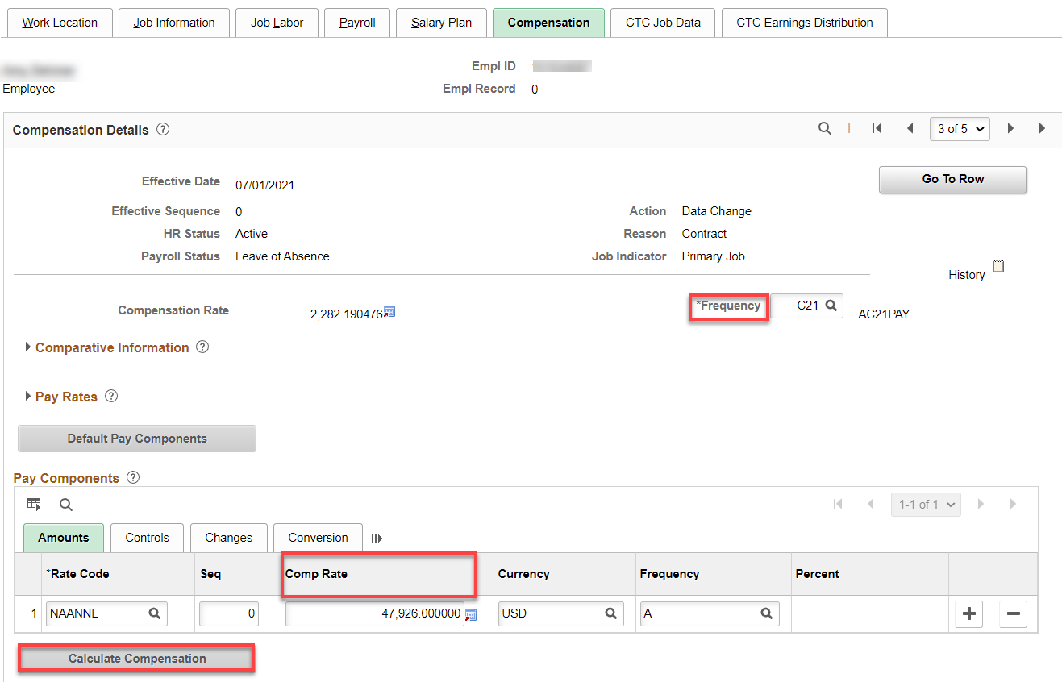

This is covered in Cyclic Leave of Absence-Classified or Exempt documentation, however, I’ve added it here. DO NOT forget to bring them back from Leave of Absence.

Taking Off Leave of Absence: Add + a row, Effective Date, Action (Return from Leave), Reason (Return from Leave) – (I’ve requested a Return from Cyclic Leave Reason be added), Save.

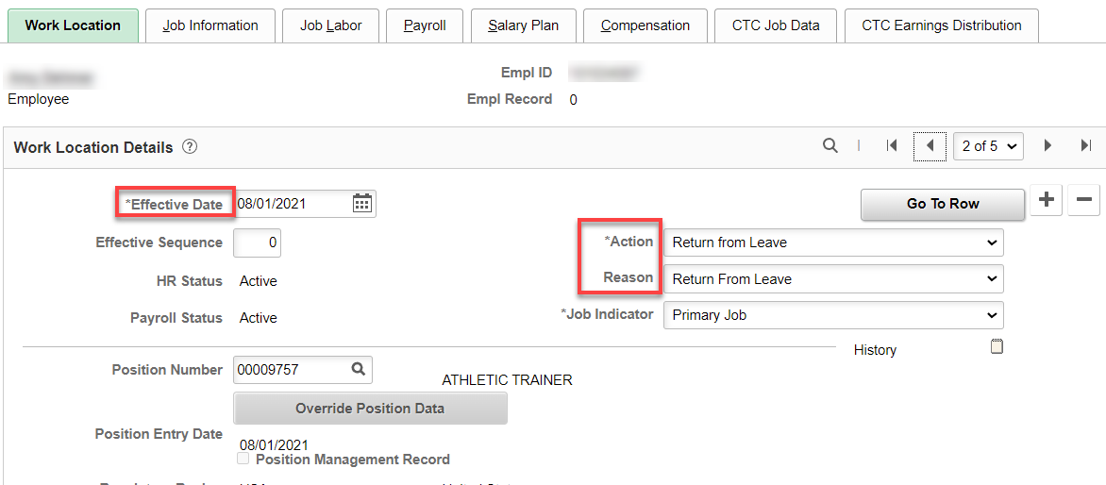

That’s it!

