Reclassifying a Position with New Job Code

Job Data

In Position Management, if you clicked Yes to automatically add a row in Job Data, go through each tab to update (see some screens below). AS OF 4/6/22, automatic updates do not work.

If you clicked No in Position Data, manually make the change (see below)

Work Location tab: Add + a row

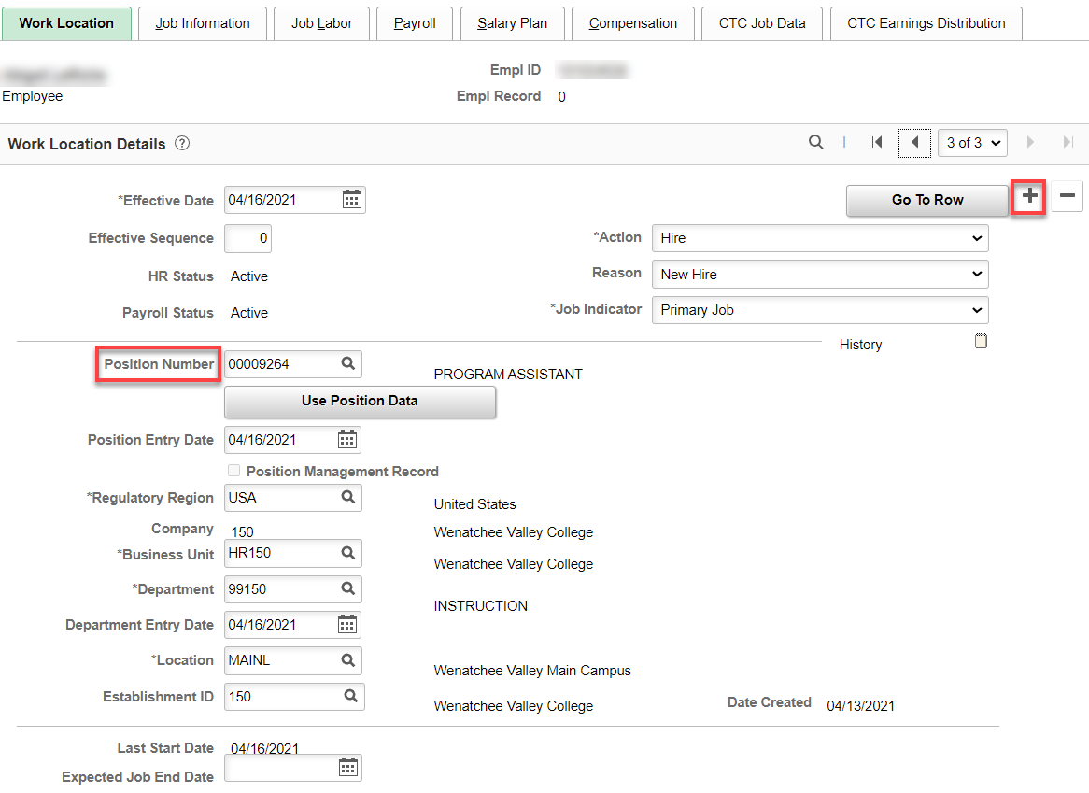

As soon as I added the row and Effective Date, the position changed from Program Assistant to Administrative Assistant 3. Change the Action and then click on Use Position Data.

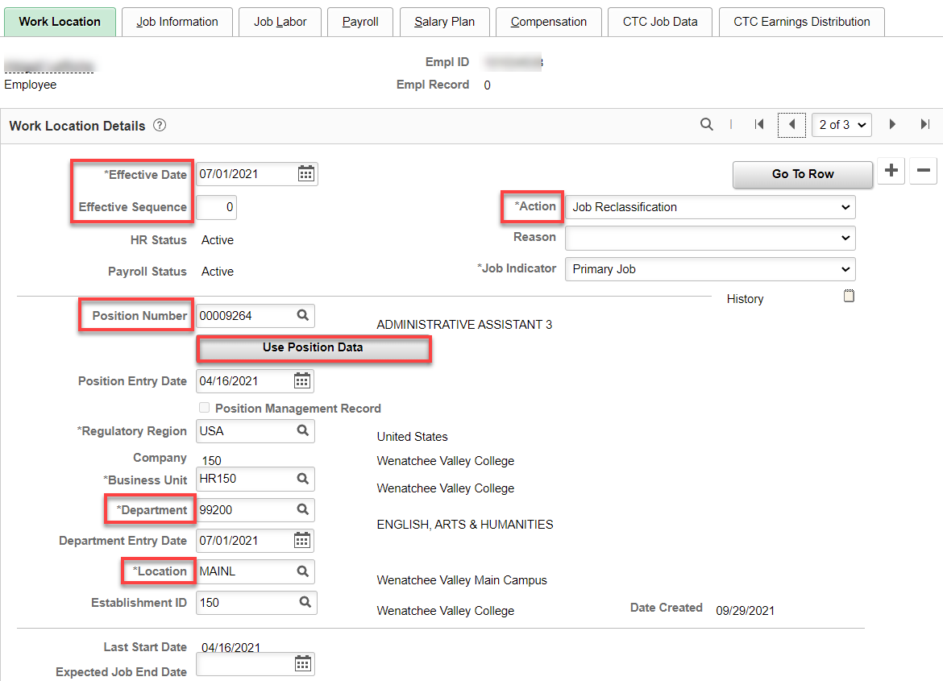

Job Information tab: Change Supervisor ID (if needed), Empl Class (Classified), Regular Shift (if paid shift differential, choose Evening), Work Period (W522), check FTE (should be 1.00 if FT) – If Position Data still has W for Workweek, you will have to change it to W522, which changes the FTE so it has to be changed back to 1.00.

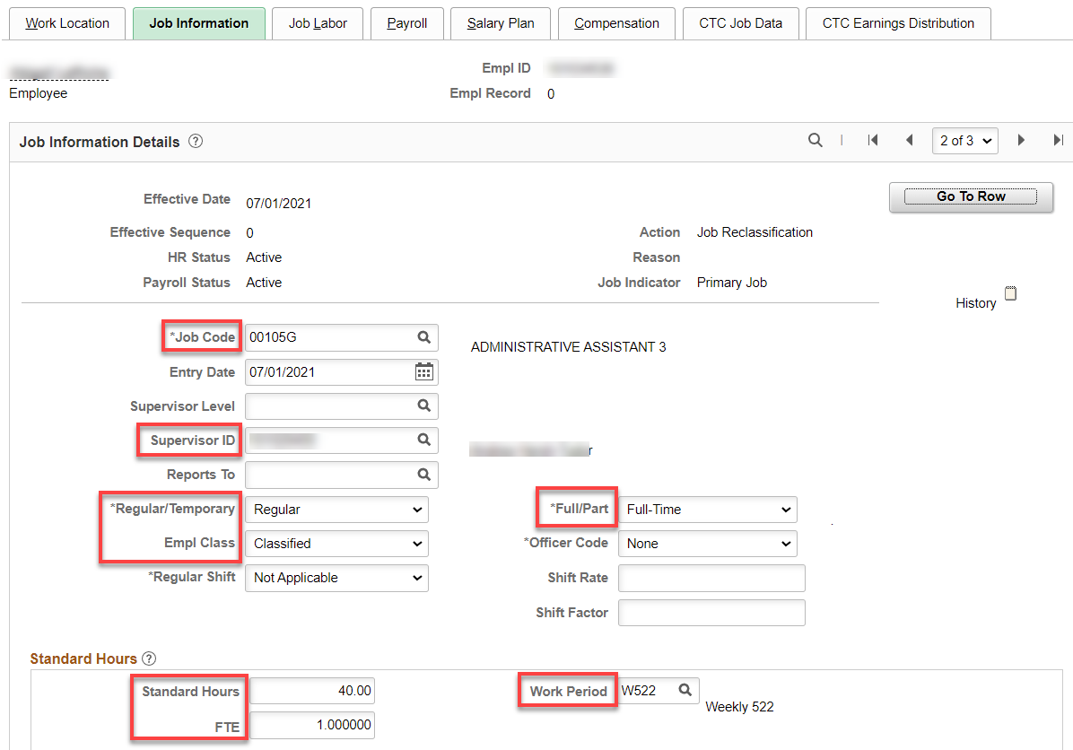

Job Labor tab: Union Code and Union Seniority Date should not change (update if needed).

Payroll tab: Nothing should change.

Salary Plan tab: All you should need to enter is Step and change Step Entry Date back to the prior job Step Entry Date (Month and Day plus current year if the Grade changed-click on the next row to see the date).

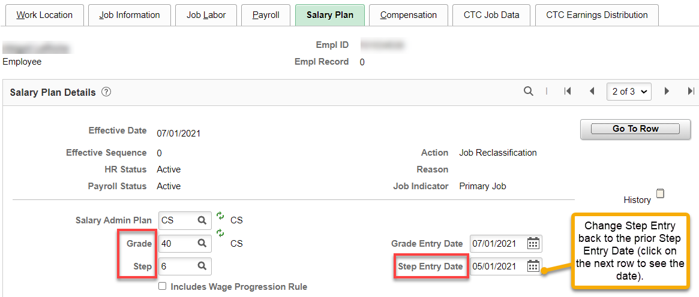

Compensation tab: change Comp Rate and click Calculate Compensation. If retro pay needs calculated, do so and add a PSHUP.

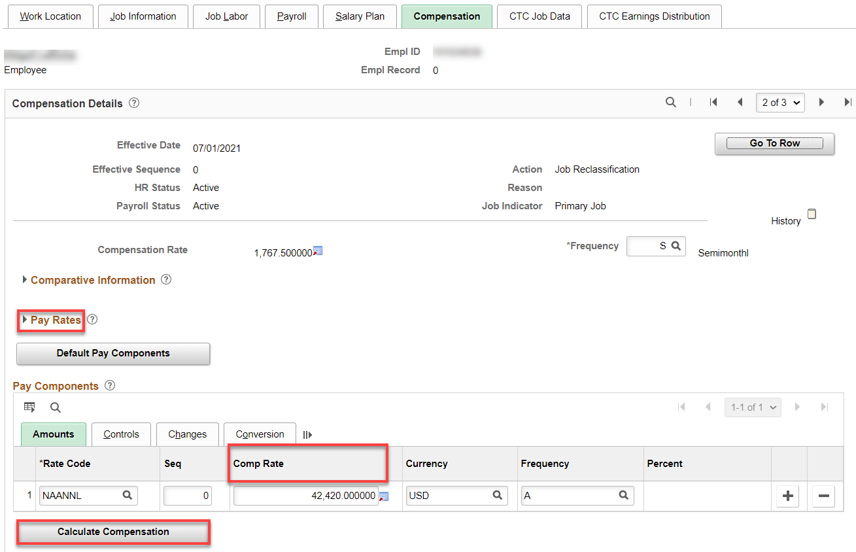

CTC Job Data tab: Everything should be the same as before but check things like Job Term (if less than 12), Job Emp Type, Union Member check box and OFM Bargaining Unit (in case the reallocation changes anything).

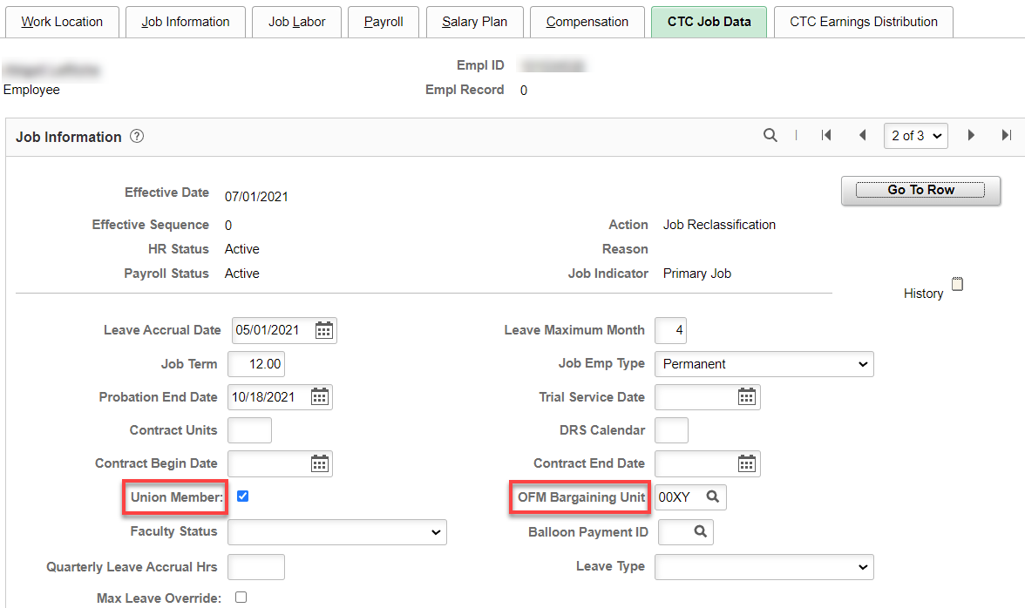

CTC Earnings Distribution tab: update if needed.

Click Employment Data – no change

Benefit Program Participation – no change

Retirement Program – no change

Work Schedule? Change if needed.

That’s it!

