Add or Change Tenure Status for FT Faculty (All FT faculty must be entered for IPEDS)

Add Tenure Information

Nav>Workforce Development>Faculty Events>Calculate Tenure>Create Tenure Data

First, Search for the Faculty Member (must be active)

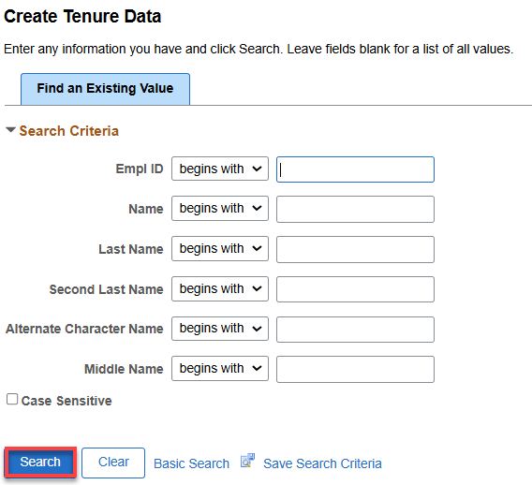

Add New FT Faculty (Non-Tenure)

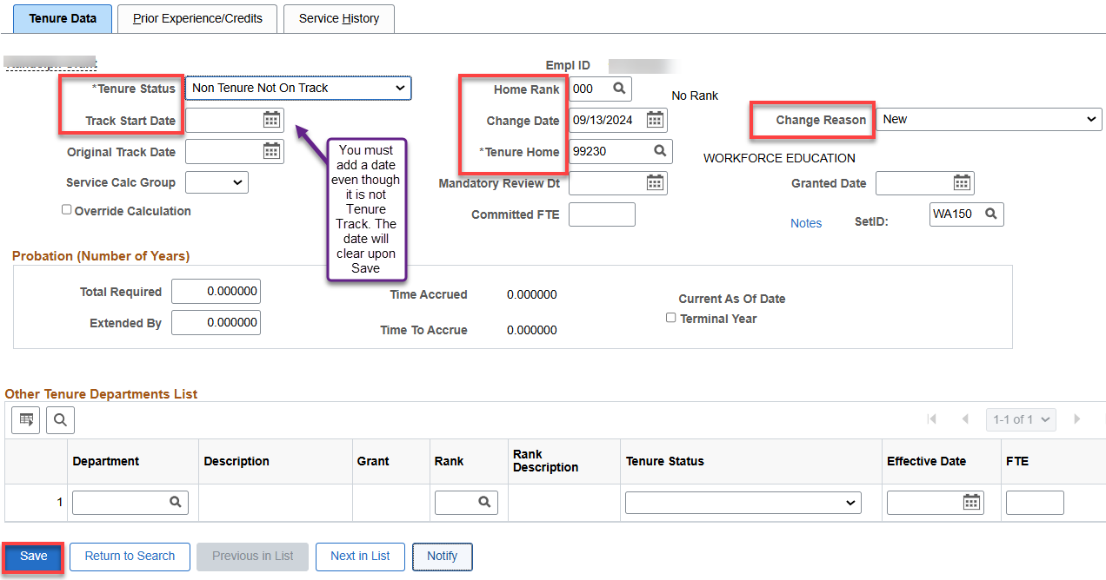

Add New FT Faculty (Tenure-Track)

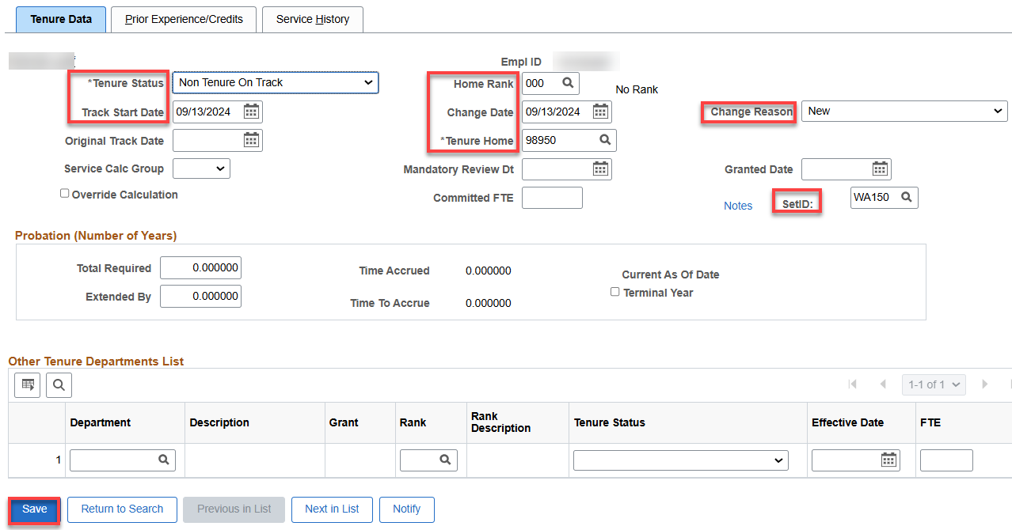

Change FT Faculty (from Tenure tract to retired or phased retirement)

Before Change

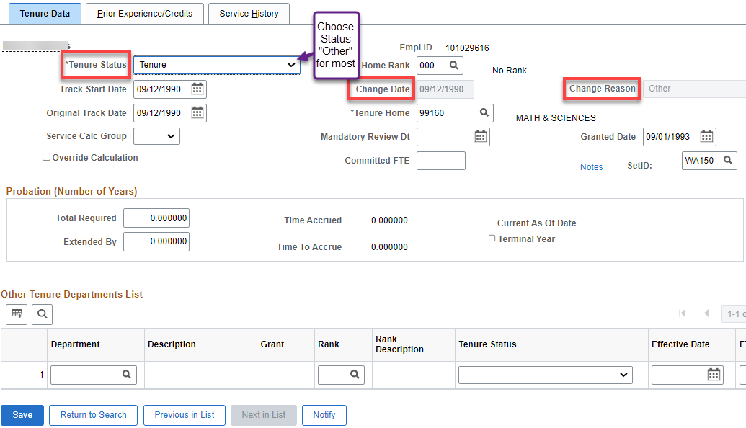

After Change

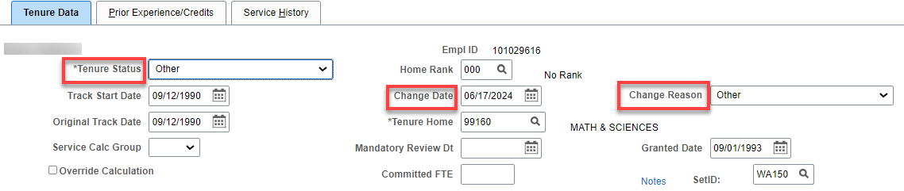

Change FT Faculty (from Tenure tract to Denied Tenure)

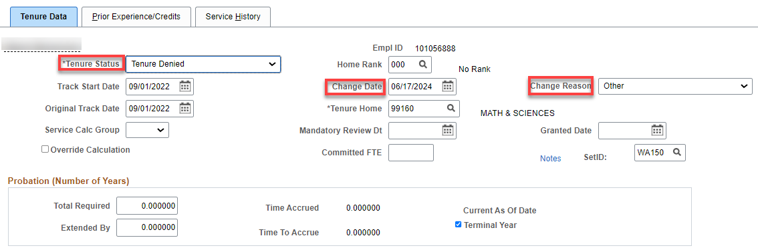

That’s it!

