Update State Tax Data QRG is great but in reality, you will come across mostly students from other states that when you are putting in their employment instance, ctcLink will warn you that their state tax data is other than Washington.

So, just go to Nav>Payroll for North America>Employee Pay Data USA>Tax Information>Update Employee Tax Data

State Tax Data tab: Add + a row.

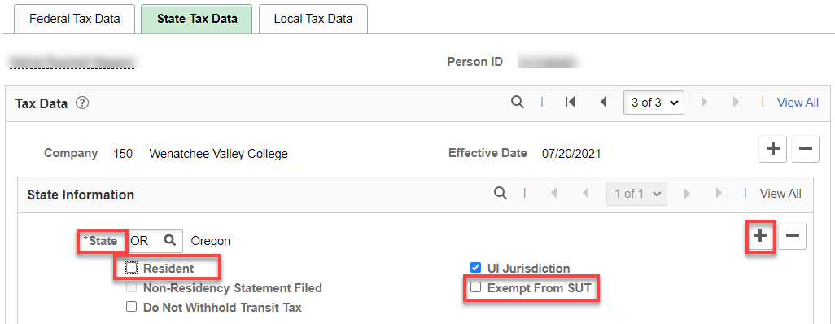

Change State to WA, check Resident, check Exempt from SUT, if it’s unchecked, save.

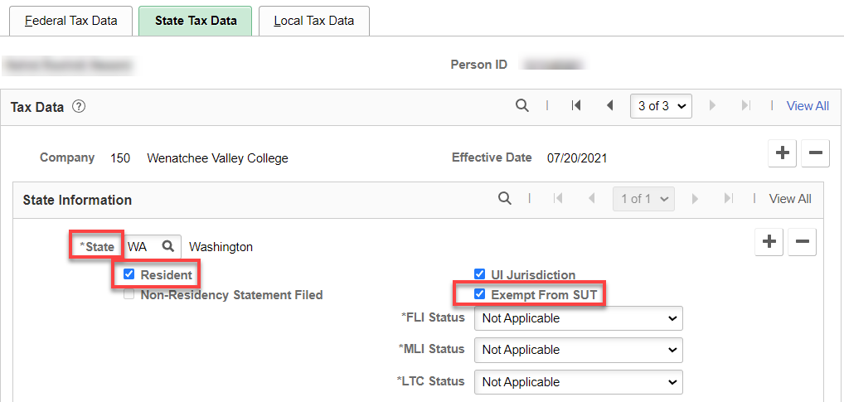

What I actually did on this particular person since the first record was correct, I just used Correct History and deleted the first row with the Oregon information.

That’s it!

