[**View/Download/Print W-2/W-2C Form for Employee**](https://ctclinkreferencecenter.ctclink.us/m/79727/l/1144125-9-2-view-w-2-w-2c-form-for-an-employee-and-download-or-print) – **(the QRG is great!)**

**Nav>Payroll for North America>US Annual Processing>Create W-2 Data>View W-2/W-2C Forms**

The **View W-2/W-2c Forms** search page displays.

1. Enter the **Empl ID** or appropriate **Name** field(s).
2. Select the **Search** button.

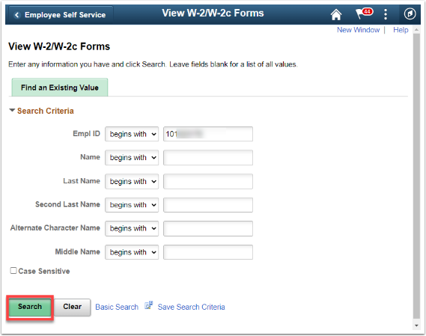

The **View W-2/W-2c Forms** page displays.

1. The forms for the most recent tax year will display. To view other years, select **View a Different Tax Year** link.

[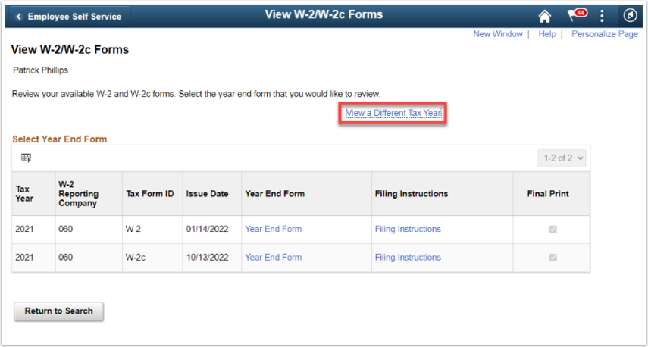](https://media.screensteps.com/image_assets/assets/005/984/768/original/ff4bdb53-7f1d-4f6e-a682-9b4990ab36fe.png)

The **Select** **Tax Year** list displays.

1. Select the desired year from the list.
2. Otherwise, select the **Return to Search** button.

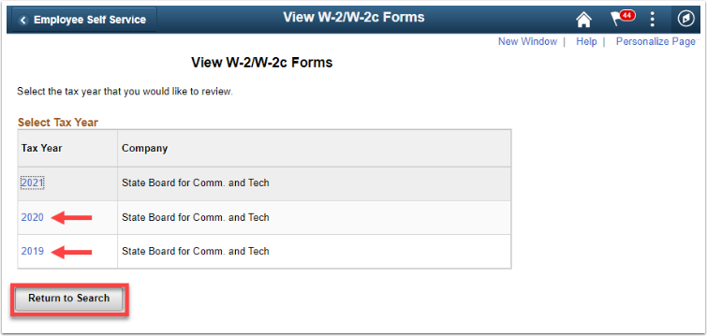

1. From the list of **Tax Form IDs (***W-2*or *W-2c***)**, select the **Year End Form** that you wish to view.
2. Select **Filing Instructions** for the appropriate tax form to view the filing instructions.

[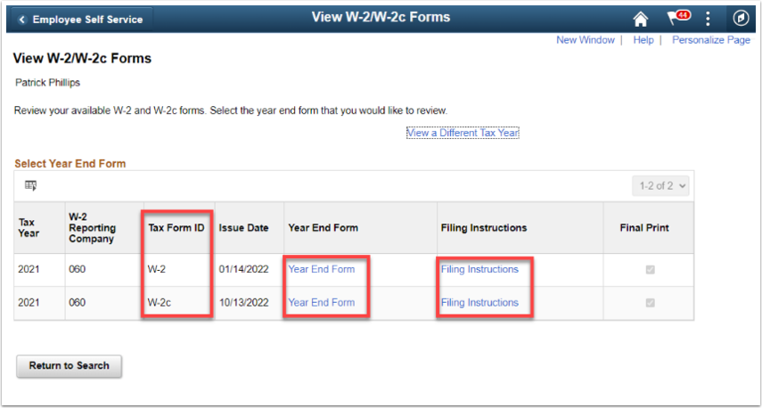](https://media.screensteps.com/image_assets/assets/005/984/772/original/fbd70e26-2670-4f0a-85cf-1358caecf691.png)

1. The respective PDF document will open and could be downloaded and/or printed.  
   Below is an example of the W-2 **Year End Form**.
2. To close the pdf window, click the **X** on the tab at the top.

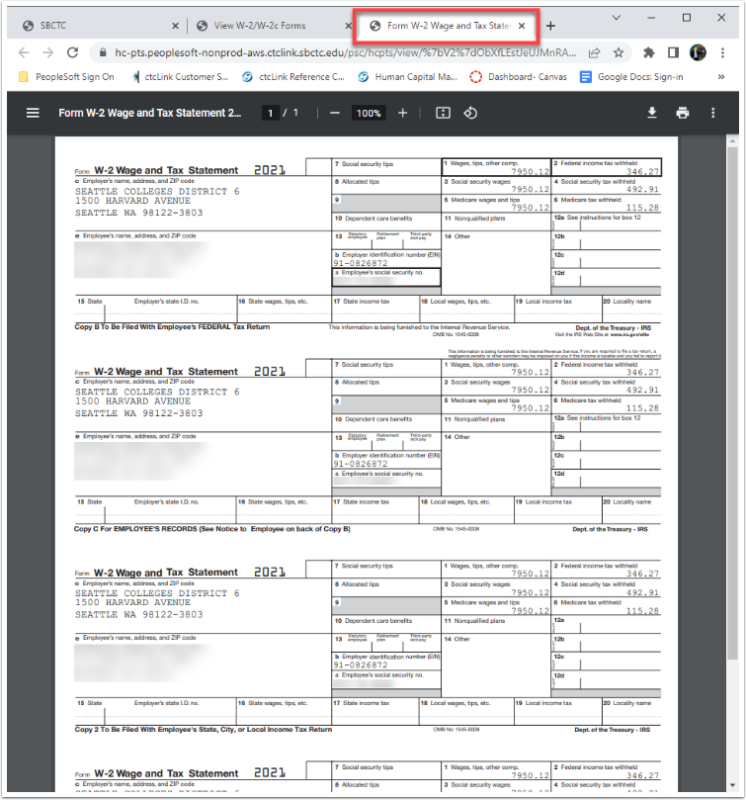

1. Below is an example of the W-2 **Filing Instructions.**
2. To close the pdf window, click the **X** on the tab at the top.

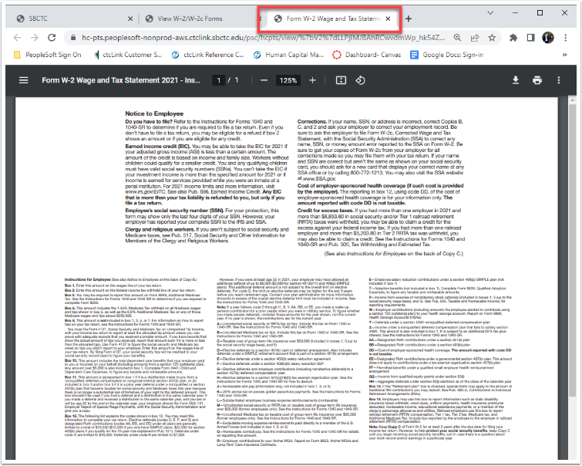

1. Below is an example of the W-2c **Year End Form**.
2. To close the pdf window, click the **X** on the tab at the top.

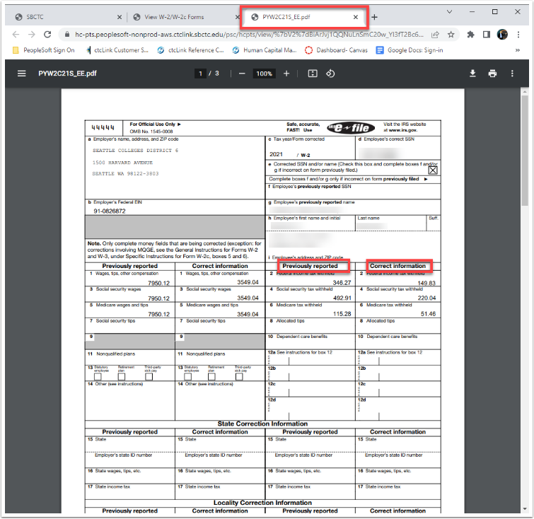

1. Below is an example of the W-2c **Filing Instructions.**
2. To close the pdf window, click the **X** on the tab at the top.

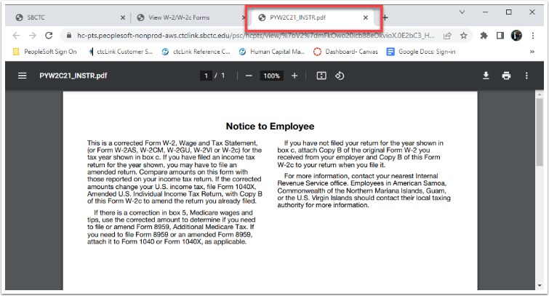

The process to view, download and print W-2/W-2c Forms is now complete.

That’s it! 😊