AFTER START DATE
Assign Work Schedule - Nav>Time and Labor>Enroll Time Reporters>Assign Work Schedule OR Workforce Administrator, Time & Labor Admin Tile, Enroll/Maintain TL Data>Assign Work Schedule

In order for leave to accrue and holidays to work correctly, a work schedule must be assigned from Use Default Schedule to Select Predefined Schedule.

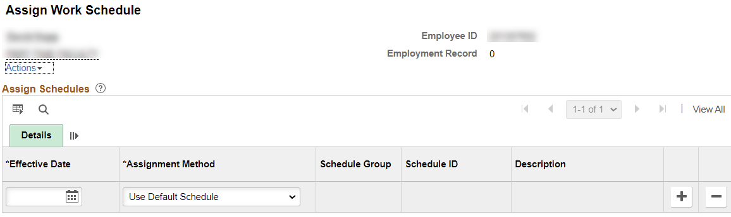

Add Effective Date (Start Date), Assignment method (change from Use Default Schedule to Select Predefined Schedule, Schedule Group (WACTC) and the schedule ID (choose from a long list or if it is 5 8s M-F, put in 8X5 to narrow the search). You can see the schedule by clicking on Show Schedule or add a new schedule (in the future) by adding a row.

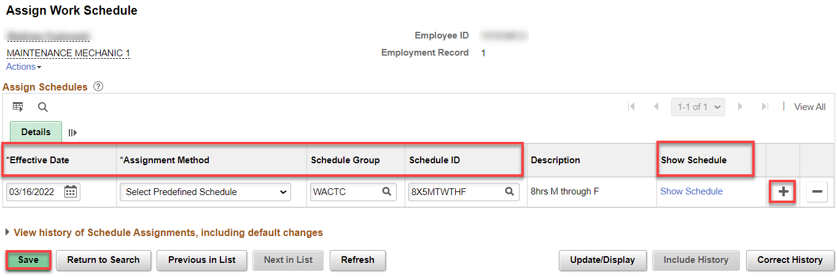

Note: If a workweek changes and needs to be immediately changed so a person can use it, run Refresh Dynamic Groups Process (see Running Refresh Dynamic Group Process documentation) and then run Request Time Administration Process.

ANYTIME

Change a Work Schedule

To change a work schedule, just add + a row and put in the new schedule with an Effective Date of the beginning of a workweek.

Note: If a workweek changes and needs to be immediately changed so a person can use it, run Refresh Dynamic Groups Process (see Running Refresh Dynamic Group Process documentation) and then run Request Time Administration Process.

That’s it!

