Comp Time Payout – End of Fiscal Year

Run QHC_PY_Comp_Payout_Report

Nav>to Timesheet for employee

View by Calendar
Check to see if the employee already has put in comp time for the month of June.
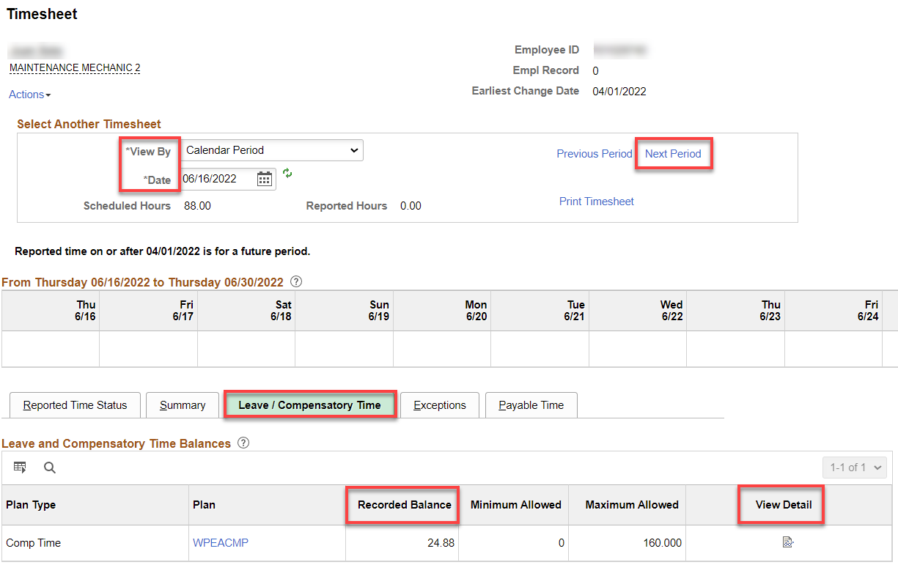

If there is a comp time taken and still has a balance, click on next pay period “Next Period” and it will show the balance needing paid out.

If more needs to be paid out, Add+ a row

Put in the balance on 6/30, choose 00 CTC Comp Time Payout (CTP will payout up to the balance - it’s not like the 15-hour max like other things). Submit.

Go back and check View Details

Run Time Admin process
Go back to timesheet

If an employee has comp time earned from 6/16-6/30, it’s ok to let that go into the next year.

If the employee is inactive, and if we want to pay them, the payout will have to be made by PSHUP. Normally, the balances will be removed when an employee leaves.

That’s it!

